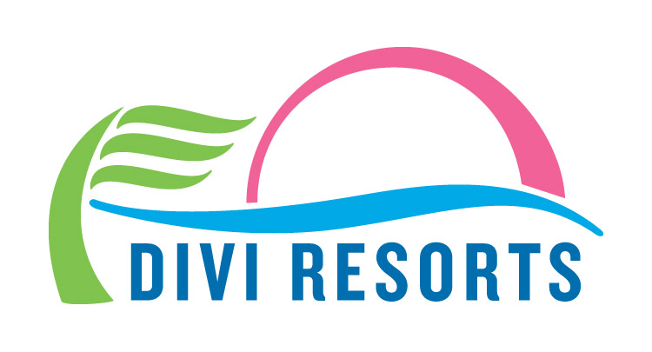

Contact: Alyssa Smith
Phone: (919) 419-2039
Alyssa.smith@diviresorts.com

Save up to 55% Off Divi Resorts’ Top Caribbean Destinations
With rates as low as $100 per night, there’s no better time to book your stay!

CHAPEL HILL, NC— Spring is right around the corner, and Divi Resorts has sprung into action to give travelers the best savings of the season! For 99 hours only, from March 1-4, those searching for a tropical Caribbean vacation can save up to 55% off Divi Resorts’ top destinations.

“Spring is a time of renewal and we love getting Caribbean enthusiasts to the islands whether it’s their first trip or their tenth,” said Marco Galaverna, Divi Resorts President & COO. “With several of our resorts recently undergoing renovations and improvements, we think it’s a great time to show travelers our regeneration and offer some much needed sunshine, rest and rejuvenation!”

With charming Caribbean locations on the magical islands of Aruba, Bonaire, Barbados, and St. Maarten, Divi Resorts provides a wide variety of on-site amenities, including elegant restaurants with mouthwatering menus, lively bars with unlimited libations, fabulous freshwater pools, sports courts, spas and more! Divi’s all-suite accommodations are perfect for couples on the hunt for a romantic getaway and families searching for some time away from it all. Plus, with Divi’s Stay and Eat Free Program* and Treasures of the Caribbean Kids Club, even the youngest of guests will have plenty to do, at a fraction of the cost.

For those searching for Caribbean bliss, deals on room only and all-inclusive stays are as follows:

- Divi Dutch Village Beach Resort on Aruba – up to 50% off - rates start at $121 per night, room only or $158 per person, per night all-inclusive

- Divi Village Golf & Beach Resort on Aruba – up to 50% off - rates start at $125 per night, room only or $163 per person, per night all-inclusive

- Divi Aruba Phoenix Beach Resort on Aruba – up to 55% off - rates start at $178 per night room only

- Divi Flamingo Beach Resort & Casino on Bonaire – up to 55% off - rates start at $100 per night room only or $153 per person, per night all-inclusive

- Divi Southwinds Beach Resort on Barbados – up to 55% off - rates start at $103 per night room only

- Divi Little Bay Beach Resort on St. Maarten – up to 50% off - rates start at $135 per night room only or $167 per person, per night all-inclusive

This limited time offer runs from March 1st, 2018 at 12:00 a.m. through March 4th, 2018 at 11:59 p.m. EST, for travel between April 2-June 22, 2018 & September 1-December 21, 2018. For reservations, book online at www.diviresorts.com/99-hour-sale.htm or call 1-800-367-3484 (Toll-free US) or 1-919-419-3484 (International). For group reservations, please call 1-800-801-5550 or email groupsales@diviresorts.com.

Travelers can also enter for a chance to win a free 7-Night Summer Vacation at Divi Resorts as part of Divi’s 90-Day Caribbean Giveaway. A lucky winner will be selected Thursday, March 22 at 4:00 p.m. EST.

*For more information on Divi’s Stay and Eat Free Program or Treasures of the Caribbean kids club please visit http://www.diviresorts.com/kids.htm.

About Divi Resorts
Divi Resorts is the vacation expert of the Caribbean, with a collection of eight premium resorts spanning the five stunning Caribbean islands of Aruba, Barbados, Bonaire, St. Croix, and St. Maarten. For more information on Divi Resorts, call 1-800-367-3484 or visit www.diviresorts.com.

Sale Terms & Conditions
This offer applies to reservations made March 1-4, 2018 for travel between April 2-June 22, 2018 & September 1-December 21, 2018. Discount based on rack pricing. All-inclusive rates based on double occupancy. Taxes & services charges NOT included, except for All-Inclusive packages. 3-night minimum stay required. No maximum night stay is required. Restrictions & blackout dates apply. Full payment is required at time of reservation. Cancellations must be received at least 7 days prior to arrival for refund. Flight cancellations are subject to airline cancellation policies. Divi Resorts is not responsible for changes in airfare pricing. Offer is subject to availability and may be discontinued at any time. Offer valid on new reservations booked at a nightly rate only. Offer not valid on timeshare reservations. Cannot be combined with any other Divi special offer.

Sale Blackout Dates
All Resorts – March
Little Bay – April 2-June 22
Phoenix – April 2-May 5 & May 24-28
Village Golf – April 2-17
Dutch – April 2-June 6

