Press Release Contacts: For Immediate Release Vinitaly International
International Media Dept.
+39 045 8101447
media@vinitalytour.com
www.vinitalyinternational.com
Twitter: @VinitalyTour
Join Italian Wine Community on LinkedIn

8 “lucky” Italian Wine Ambassadors proclaimed in Chengdu, China
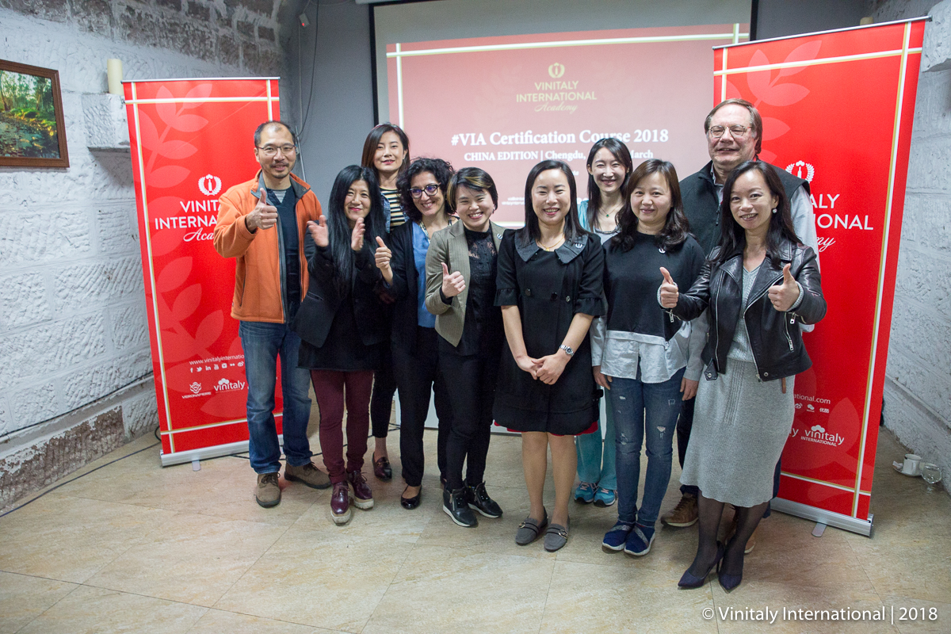
Under the good auspices of Chinese lucky number 8, the 8th edition of the Vinitaly International Academy (VIA) Certification Course in Chengdu welcomes 8 new Italian Wine Ambassadors (IWA) to the evergrowing VIA community. VIA adds another Chinese city to its map, with Chengdu being the third city in China to hold VIA courses after Beijing and Shanghai last year.

Chengdu is renowned for being the homeland of Chinese national drink Baijiu (a grain based spirit), therefore the city has a thriving beverage industry where Italian wine can shine brightly. For this reason, Chengdu was the perfect place to gather Chinese aficionados of Italian wine and spread its story of biodiversity.

The Certification Course comprised a week of training with internationally renowned wine critic Dr. Ian D’Agata and a challenging final exam held on March 20th. “I’m so honored to have taken this class and exam. The course is intensive and hard but definitely worth it!”, says Joseph Cheng, Director at Story Wine Company in Hong Kong and one of the newly proclaimed IWAs. Sylvie Xuan Zuo, wine consultant at Peng She Da International Trade Company, also confirms “Now that I’ve got the title of IWA, there’s much more out there for me to learn. I’ll do my best to make Italian wine better known in China; it’s such a beautiful shining pearl in the sea of wine.”

A unique opportunity for wine professionals to enhance their knowledge of Italian native grapes and distinctive wines, the VIA Certification Course enables all professionals to speak of Italian wine in a unified, organized, and thorough manner. Stevie Kim, Managing Director of Vinitaly International, speaks highly of the Chinese students’ commitment to Italian wine studies: “Sometimes we are criticized by the low percentage of pass rate but in the end candidates will often resit the exam. I’m always amazed by how much enthusiasm and determination exist amongst the Chinese candidates, despite the difficulties in broaching the course in English, not to mention the less familiar pronunciation of the most obscure native grapes.” Further evidence of the students’ passion for Italian wines was the fact that many of them provided tips to pair Italian wine with Chinese food from their personal and professional experiences, as recorded in the entertaining video “Best Italian Wine to Pair with Chinese Hot Pot” (https://www.youtube.com/watch?v=o2sq4y-x4JE&feature=youtu.be&a).

This VIA edition was also special as it took place alongside Vinitaly Chengdu. After the VIA lessons in the morning, in the afternoon students had the chance to talk to Italian producers showcasing their wines at Vinitaly Chengdu. Additionally, Dr. Ian D’Agata also led a compelling VIA Executive Wine Seminar on the topic of “Italian Diversity: great classics and hidden gems”, which was open to the public and attracted more than 150 engaged participants.

After the proclamation of the 8 new IWAs in Chengdu, there are now 139 VIA-certified IWAs worldwide. Currently, VIA is home to 3 IWEs and 41 IWAs from USA, and 2 IWEs and 38 IWAs from the Greater China area. After the “lucky” Chinese edition, the next VIA Certification Course comes home to Verona, Italy, from April 6th to 10th, 2018, in the lead-up to Vinitaly.

Full list of our 8 newly certified Italian Wine Ambassador Chengdu Edition 2018

- Jing Zhang, Shanghai, China, Sales Manager, EMW Fine Wines
- Joseph Cheng, Hong Kong, Director, Story Wine Company
- Yan Zeng, Senior Manager of Strategic Development at CIMIC Enric
- Ada Xiaowen Zhang, Shanghai, China, Sales Manger, Le Service Divin
- Maria Grazia Furbato, Jakarta, Indonesia, Wine Educator and Consultant, reWined
- Haixia Xu, Chengdu, China, Co-Founder of Sichuan Ocean International Trade
- Chunnju Emilia Hsiao, Taiwan, Co-Founder of Enjoyino Co.
- Sylvie Xuan Zuo, Kunming, China, Manager and Wine Consultant, Zhong Peng Shi Da International Trade Company

For more details about the VIA Certification Course and the Ambassador’s BIO see:
https://www.vinitalyinternational.com/?page_id=663

About:
Veronafiere is the leading organizer of trade shows in Italy including Vinitaly (www.vinitaly.com), the largest wine and spirits fair in the world. During its 51st edition Vinitaly counted more than 4,270 exhibitors on a 100,000+ square meter area and 128,000 visitors from 142 different countries with more than 30,000 top international buyers (up by 8%). The next edition of the fair will take place on 15 - 18 April 2018. The premier event to Vinitaly, OperaWine (www.operawine.it) “Finest Italian Wines: 100 Great Producers,” will unite international wine professionals on April 14th in the heart of Verona, offering them the unique opportunity to discover and taste the wines of the 100 Best Italian Producers, as selected by Wine Spectator. Since 1998 Vinitaly International travels to several countries such as Russia, China, USA and Hong Kong thanks to its strategic arm abroad, Vinitaly International. In February 2014 Vinitaly International launched an educational project, the Vinitaly International Academy (VIA) with the aim of divulging and broadcasting the excellence and diversity of Italian wine around the globe. VIA this year launched the fourth edition of its Certification Course and today counts 130 Italian Wine Ambassadors and 9 Italian Wine Experts.

