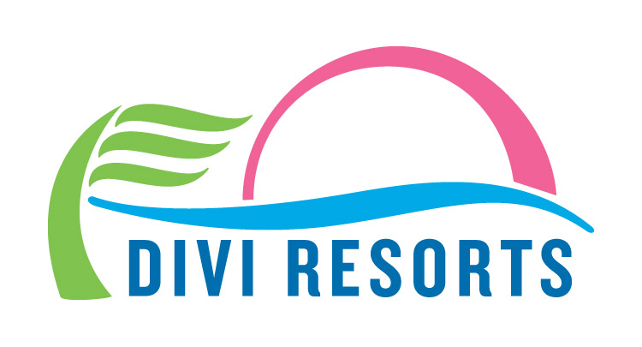

Contact: Alyssa Smith
Phone: (919) 419-2039
Alyssa.smith@diviresorts.com

Divi Resorts Sponsors Aruba’s Soul Beach Music Festival Featuring R&B Star Alicia Keys
Travelers can book special rates at Divi’s Aruba resorts and enter to win free VIP tickets!

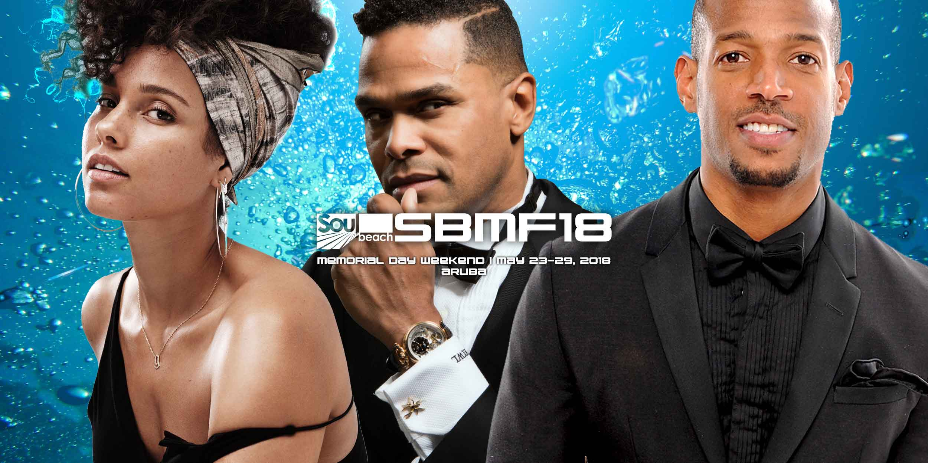

CHAPEL HILL, NC— Continuing a 5-year tradition, Divi Resorts’ Aruban destinations are once again sponsoring the ever-popular 2018 Soul Beach Music Festival taking place May 23-29. Voted one of the “Top Five Caribbean Celebrations” by USA TODAY, this year’s event features R&B legend Alicia Keys, neo soul singer-songwriter Maxwell and actor and comedian Marlon Wayans.

Boasting world-class performers and lively beach and nightclub parties, the Soul Beach Music Festival is just a short walk from Divi’s stunning Aruba properties – Divi Dutch Village Beach Resort, Divi Village Golf & Beach Resort and Divi Aruba Phoenix Beach Resort.

“Travelers searching for a fun-filled Memorial Day weekend need look no further,” said Marco Galaverna, Divi Resorts President & COO. “Our resorts are perfect for guests looking for a relaxing place to retreat at the end of an eventful day of sun, sand and stellar performances. Plus, as an added bonus, we’re giving away VIP and ticket prize packs to three lucky winners.”

The contest, which runs from now until May 14th, includes the following prizes for 1st, 2nd and 3rd place winners:

1st Place VIP Package:
- 2 Friday General Admission Comedy Show Tickets at the Renaissance Festival Plaza
- 2 Saturday & Sunday General Admission Concert Tickets
- 4 Gold Area Entry Passes at the Harbor Arena (2 Saturday/2 Sunday)
- 2 Party Pass Packages (total of 5 entries per person into 5 Official Soul Beach Music Festival After Parties 5/25-5/29) with Express Entry Access
- Bonus Tickets: 2 Friday General Admission Comedy Show Tickets at the Renaissance Festival Plaza and 2 Saturday and Sunday General Admission Concert Tickets

2nd Place Prize Package:
- 2 Friday General Admission Comedy Show Tickets at the Renaissance Festival Plaza
- 2 Saturday and Sunday General Admission Concert Tickets
- 4 Gold Area Entry Passes at the Harbor Arena (2 Saturday/2 Sunday)

3rd Place Prize Package:
- 2 Three-Night General Admission Ticket Packages for Friday Comedy Show at the Renaissance Festival Plaza
- 2 Saturday and Sunday General Admission Concert Tickets at the Harbor Arena

To enter, simply visit https://www.diviresorts.com/aruba-soul-beach.htm, and scroll to the bottom of the page for instructions. Plus, receive 500 extra entries for following @DiviResorts on Instagram.

Special room and all-inclusive rates for the Soul Beach Music Festival are as follows:

Divi Dutch Village Beach Resort:
– Studio suites as low as $159/night and 1-bedroom suites as low as $179/night
– All-Inclusive studio suites as low as $189/night per person and All-Inclusive 1-bedroom suites as low as $209/night, per person*

Divi Village Golf & Beach Resort:
– Studio suites as low as $175/night and 1-bedroom suites as low as $195/night
– All-Inclusive studio suites as low as $199/night per person and All-Inclusive 1-bedroom suites as low as $219/night, per person*

Divi Aruba Phoenix Beach Resort:
– Studio suites as low as $249/night and 1-bedroom suites as low as $269/night

“We invite you to experience an unforgettable weekend of food, fun and first-rate festivities,” said Galaverna. “But be sure to buy your tickets and book your stay today to guarantee you’ll be there, as this event sells out fast!”

For reservations, book online at https://www.diviresorts.com/aruba-soul-beach.htm or call 1-800-367-3484 (Toll-free US) or 1-919-419-3484 (International). For group reservations, please call 1-800-801-5550 or email groupsales@diviresorts.com.

*All-inclusive rates are based on double room occupancy. 3-night minimum stay required.

About Divi Resorts
Divi Resorts is the vacation expert of the Caribbean, with a collection of eight premium resorts spanning the five stunning Caribbean islands of Aruba, Barbados, Bonaire, St. Croix, and St. Maarten. For more information on Divi Resorts, call 1-800-367-3484 or visit www.diviresorts.com.

