Press Release Contacts: For Immediate Release Vinitaly International
International Media Dept.
+39 045 8101447
media@vinitalytour.com
www.vinitalyinternational.com
Twitter: @VinitalyTour
Join Italian Wine Community on LinkedIn

Education, community, and diversity:
Vinitaly International’s vision in the name of Italian wine

In the lead up to and during Vinitaly, Vinitaly International will run in Verona a number of educational and promotional initiatives with an international flair in the name of Italian wine. Aligning with Vinitialy International’s strategic mission to “promote, educate, communicate to sell one more bottle of wine” abroad, these initiatives aim to strengthen the bond between Italian wine and its international markets as well as to nurture a knowledgeable and dedicated community of international professionals who, in turn, will spread the Gospel of Italian wine.
Key elements to Vinitaly International’s vision for the promotion of Italian wine include: a commitment to training international wine professionals about the diversity of Italian wines; fostering a network of educated Italian wine enthusiasts around the world; enabling the development of global trajectories of business joining Italian producers with foreign markets. Vinitaly International implements its mission by leveraging the creative energy unleashed by its diverse, international staff.
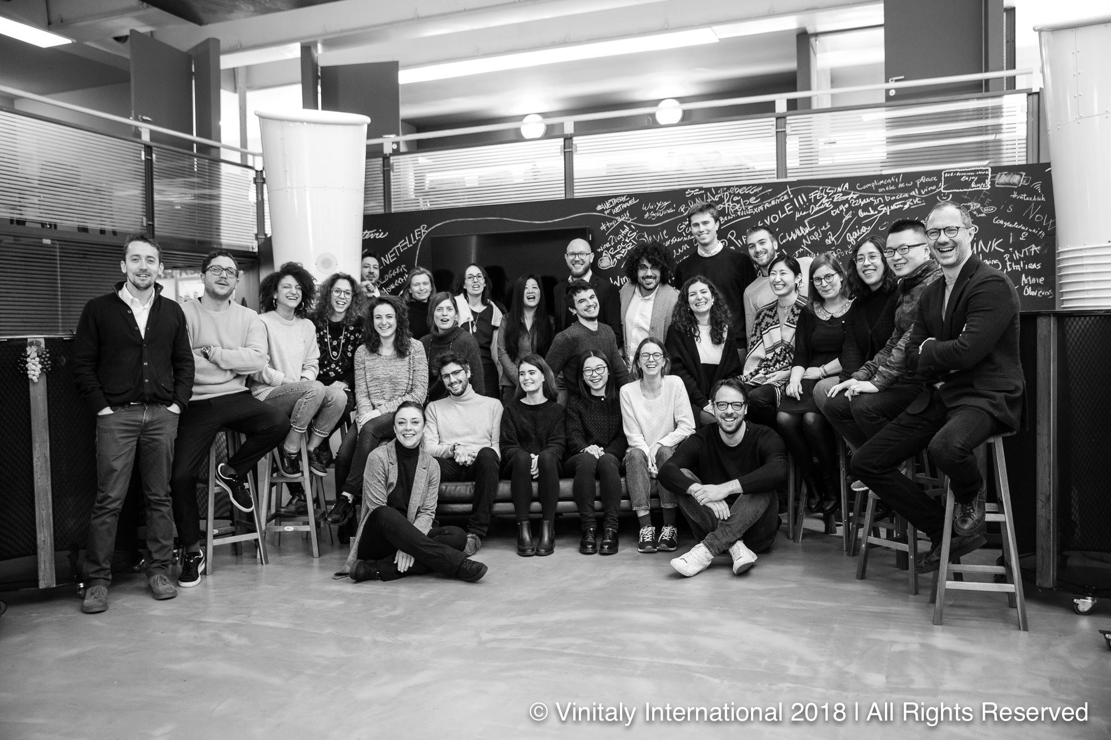
[Photograph: Vinitaly International staff at the Verona’s headquarters.]
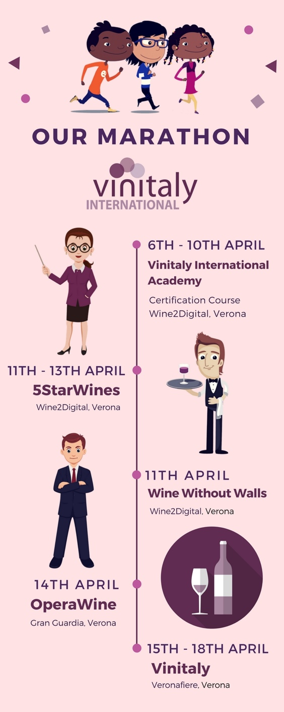

The two-weeks prior to Vinitaly and the exhibition itself are the perfect occasion where Vinitaly International’s educational and organizational efforts come to fruition. “Vinitaly is just around the corner and Vinitaly International starts its engine for the two-week marathon. Even though Italians say that the ‘marathon’ has a negative tone to it, I believe it really gives you the idea of our commitment and performance from beginning to end, it is not a sprint, it is definitely a marathon,” says Stevie Kim, Managing Director at Vintaly International. The calendar is indeed rich and appealing, starting with 5 days of the Vinitaly International Academy (VIA) Certification Course, 3 days of 5StarWines starring WineWithoutWalls Grand Tasting, 1 day of OperaWine, and 4 days of incoming activities for foreign trade during Vinitaly (see Infographic 1).
With the aim of explaining and educating on the diversity of Italian wine and its native grape varieties, VIA launched its first certification course for international trade professionals just before Vinitaly 2015. To this day VIA counts 9 Italian Wine Experts (the highest qualification) and 130 Italian Wine Ambassadors with its community growing exponentially. The next VIA certification course will start on April 6th and will feature 60 participants from 20 different countries.
[Left: Infographic 1 with Vinitaly International’s pre-Vinitaly Marathon in Verona]
Vinitaly International fosters its community of international wine professionals by creating many occasions year-around to bring these trained wine enthusiasts back to Italy. The 5StarWines starring WineWithoutWalls tasting of international wines starts in Verona on April 11th. Indeed, many of VIA’s Italian Wine Experts and Italian Wine Ambassadors lend their expertise as judges for this international blind tasting event. These international wine professionals also remain in Verona during Vinitaly, attending Vinitaly’s premier event OperaWine. The incoming program during Vinitaly is another key moment where Vinitaly International’s contacts harvested during the year through various international events meet and engage with the Italian wine scene. Later in the year, members of the VIA community return to Verona for the wine business forum, wine2wine, where they share their knowledge from the unique perspective of their home markets.
Vinitaly International’s educational and organizational mission is carried out by its truly international and culturally diverse team working under the direction of Korean-American Stevie Kim. Studies have shown that culturally-diverse teams provide skillsets and creative communicative solutions to the advantage of companies’ competitiveness on the market (Evans and Suklun). Although diversity in the workplace is still a recent phenomenon in Italy compared to countries such as the U.S. and the U.K., and even if in Italy diversity is implemented at times to respond to external pressures such as equal opportunities law (Ravazzani), things are rapidly evolving. Recent studies, once more, highlighted the direct correlation between diversity and companies’ financial performances across geographical areas (Hunt et al.).
Staff members’ passport nationalities and close-family ties at Vinitaly International point to countries such as Italy, China, Japan, United States, Canada, United Kingdom, Mexico, the Dominican Republic, Pakistan, and Korea. Moreover, team members have substantial long-term work experiences in the United States, the Czech Republic, Spain, Australia, Kenya, Ireland, Denmark, Egypt, Scotland, Belgium, Russia, and Germany. English, Italian, Russian, Chinese, Japanese, Spanish, Portuguese, Czech, French, German, and Danish are the languages either native or spoken fluently by Vinitaly International’s members of staff (see Infographic 2). This babel of passports, ethnicities, cultures, and languages is far from being a hindrance in proselythizing about Italian wine. Rather, it works as an asset that encourages a flexible mindset and allows an innovative and culture-specific communication with the foreign markets for Italian wine.
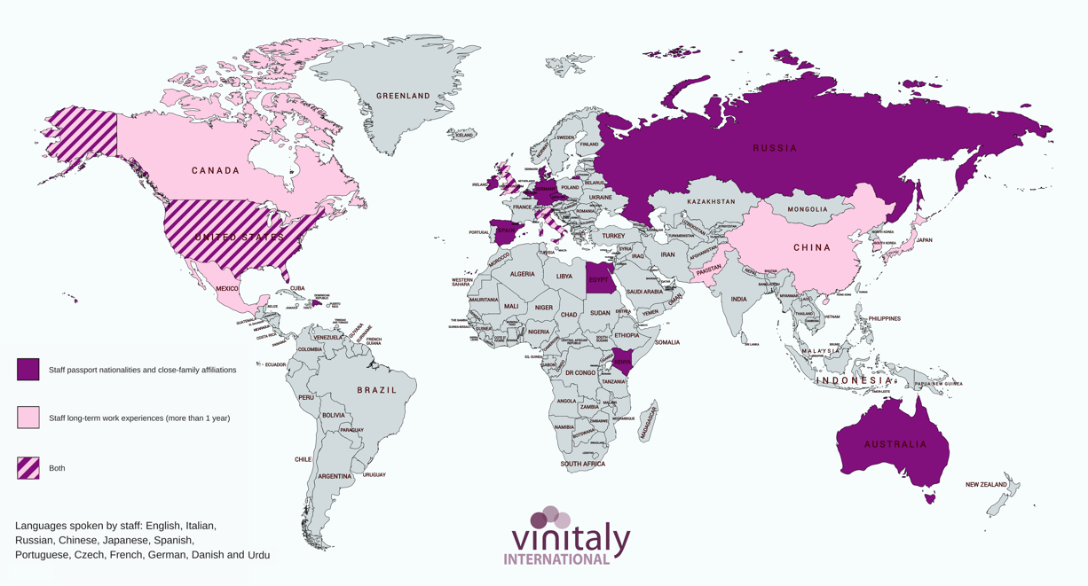
[Infographic 2: This “We are international” infographic maps language, origin, cultural, and family affiliations of Vinitaly International diverse staff]
In the global trajectories of the wine industry, Vinitaly International works to connect the dots for Italian wine, embracing international markets with an international team, leveraging its internal mosaic of cultures and languages brought together by the same passion for Italian wine.

Sources:
Evans, Adam, and Harika Suklun. "Workplace Diversity and Intercultural Communication: A Phenomenological Study." Cogent Business & Management, Vol. 4, no. 1, 2017. https://doi.org/10.1080/23311975.2017.1408943.
Hunt, Vivian, Lareeina Yee, Sara Prince, and Sundiatu Dixon-Fyle. “Delivering through diversity” McKinsey & Company January 2018 Report,” https://goo.gl/vAWHNq.
Ravazzani, Silvia. "Understanding approaches to managing diversity in the workplace: An empirical investigation in Italy", Equality, Diversity and Inclusion: An International Journal, Vol. 35, no. 2, (2016) pp.154-168. https://doi.org/10.1108/EDI-08-2014-0062.

About:
Veronafiere is the leading organizer of trade shows in Italy including Vinitaly (www.vinitaly.com), the largest wine and spirits fair in the world. During its 51th edition Vinitaly counted more than 4,270 exhibitors on a 100,000+ square meter area and 128,000 visitors from 142 different countries with more than 30,000 top international buyers (up by 8%). The next edition of the fair will take place on 15 - 18 April 2018. The premier event to Vinitaly, OperaWine (www.operawine.it) “Finest Italian Wines: 100 Great Producers,” will unite international wine professionals on April 14th in the heart of Verona, offering them the unique opportunity to discover and taste the wines of the 100 Best Italian Producers, as selected by Wine Spectator. Since 1998 Vinitaly International travels to several countries such as Russia, China, USA and Hong Kong thanks to its strategic arm abroad, Vinitaly International. In February 2014 Vinitaly International launched an educational project, the Vinitaly International Academy (VIA) with the aim of divulging and broadcasting the excellence and diversity of Italian wine around the globe. VIA this year launched the fourth edition of its Certification Course and today counts 130 Italian Wine Ambassadors and 9 Italian Wine Experts.

