Classic Black was Texas’ Number 1 Plate in 2018!

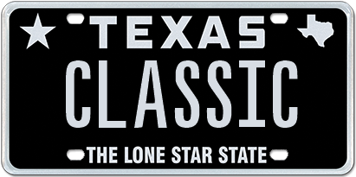

December 31, 2018 (Austin, TX) – It’s official; the number one specialty license plate design in Texas for 2018 is the full black background design, Classic Black, from My Plates.com. This is now the third consecutive year this retro design has held the position as Texas’ most popular plate since its official launch in 2016.

There were 11,000 Texans who purchased the Classic Black design in 2018, 1000 more than what was sold in 2017. The popularity of this design harkens back to 1968, which was the last time a full black Texas license plate was available, back then it was a general issue pattern.

The second most popular design is Lone Star Black, exceeding 7,000 plates sold during this past year. The Lone Star Black design first hit the streets of Texas in 2008 and can still boast having sold the most plates of any design within the My Plates program, over 88,000 since its debut, and has now delivered over $14M to the Texas general revenue fund.

Rounding out the Top 3 plates is the Texas Black 1845, holding off the fourth-place getter Carbon Fiber and Small Star Black in fifth. In fact, the Top 5 selling plates in Texas account for 56% of total sales, and are all black and white.

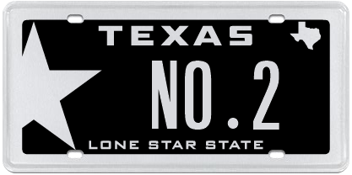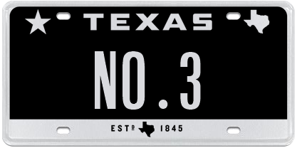

My Plates - Top 5 Selling Plates 2018
- Classic Black 11,025
- Lone Star Black 7,249
- Texas Black 1845 3,523
- Carbon Fiber 2,290
- Small Star Black 2,140

“Black and white plates are very popular in Texas, they look sleek, cool, and compliment every vehicle color,” said Steve Farrar, President of My Plates.com.

If you were wondering what other plates proved popular in 2018, like which plate was the top College or Sports plate, My Plates also released the rankings for these and other plate categories such as Flags & Texas Themes, Colors and Charities.

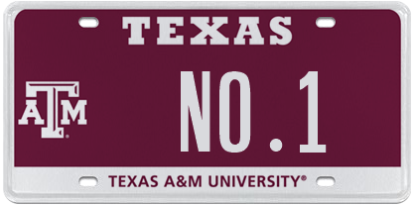 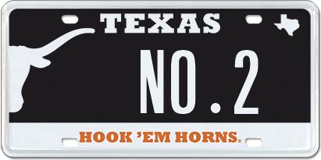 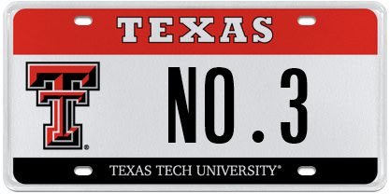’
My Plates - Top 5 College Plates (In-State)
- Texas A&M University
- University of Texas
- Texas Tech University
- Texas Christian University
- University of Houston

My Plates - Top 5 College Plates (Out-of-State)
- Louisiana State University
- University of Alabama
- University of Oklahoma
- University of Michigan
- University of Georgia

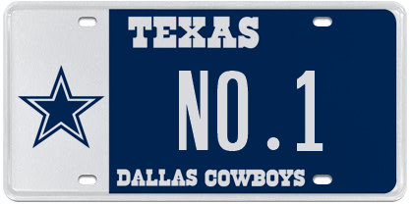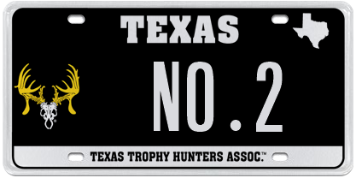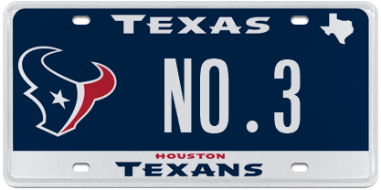

My Plates - Top 5 Sports Themed Plates
- Dallas Cowboys
- Texas Trophy Hunters Association
- Houston Texans
- Houston Rockets
- Dallas Stars

My Plates - Top Charity/Cause Related Plates
- Porsche Club of America
- Calvary Hill
- Protect Wild Animals
- National Breast Cancer Foundation
- Peace Officers Memorial Foundation

My Plates also looked at the regions of Texas and reported the following top ranked plates by region.

Top 5 in Houston
All Trademark/Logo
- Classic Black - Texas A&M
- Lone Star Black - Houston Texans
- Texas Black 1845 - Houston Rockets
- Small Star Black - University of Texas
- Carbon Fiber - LSU

Top 5 in Dallas / Fort Worth (DFW)
All Trademark/Logo
- Classic Black - Texas A&M
- Lone Star Black - University of Texas
- Texas Black 1845 - Dallas Cowboys
- Carbon Fiber - University of Oklahoma
- Small Star Black - Texas Tech

Top 5 in Austin
All Trademark/Logo
- Classic Black - University of Texas
- Lone Star Black - Texas A&M
- Texas Black 1845 - University of Michigan
- Small Star Black - Dallas Cowboys
- Carbon Fiber - Texas Tech

Top 5 in San Antonio
All Trademark/Logo
- Classic Black - Texas A&M
- Lone Star Black - San Antonio Spurs
- Texas Black 1845 - University of Texas
- Carbon Fiber - Dallas Cowboys
- Small Star Black - University of Alabama

____________________________________________________________

My Plates designs and markets new specialty license plates as a vendor for the Texas Department of Motor Vehicles. Texans have bought more than 394,000 My Plates since November 2009, putting more than $70M in the state general revenue fund. My Plates’ goal is to create a long-term, mutually beneficial relationship designed to maximize revenues for the state through the sale of My Plates specialty plates. www.myplates.com.

The Texas Department of Motor Vehicles (TxDMV) serves, protects and advances the citizens and industries in the state with quality motor vehicle related services. For every $1 it spends, TxDMV returns $11 to the state. Each year the agency registers more than 24 million vehicles; issues more than 8 million vehicle titles; licenses approximately 34,000 motor vehicle dealers and distributors; credentials more than 60,000 motor carriers; issues more than 650,000 oversize/overweight permits; investigates approximately 13,000 complaints against dealers and motor carriers; and awards grants to law enforcement agencies to reduce vehicle burglaries and thefts. Learn more at www.TxDMV.gov.
____________________________________________________________

For more information, contact Steve Farrar at (512) 633-7978 or steve@myplates.com

Image downloads:

Classic Plate on car:
https://ce9a9387e1bc258c3cfa-af7906f4e771b24864bbfa3048e4a635.ssl.cf2.rackcdn.com/ClassicCarImage.jpg

Classic Plate
https://ce9a9387e1bc258c3cfa-af7906f4e771b24864bbfa3048e4a635.ssl.cf2.rackcdn.com/ClassicBlack.jpg

Top Three Plates Image Download:
https://ce9a9387e1bc258c3cfa-af7906f4e771b24864bbfa3048e4a635.ssl.cf2.rackcdn.com/My%20Plates%20Top%203%20Plates%202017.png

