My Plates auctions last remaining single-digit plate.
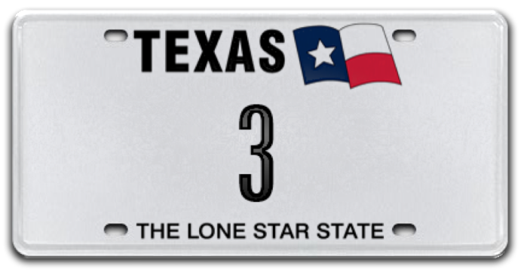
8 April 2019 (Austin, TX) – MyPlates.com, the state’s vendor for marketing personalized and specialty license plates in Texas, is auctioning the last single-digit license plate message in auction inventory. The low-digit number “3” is the only single number plate not already registered to a vehicle in Texas and is currently the only single digit plate available in Texas. An opportunity like this may not be offered again.

In some states, the first three single-digit numbers are reserved for government officials, for example "1" for the governor, "2" for the lieutenant governor, and "3" for the secretary of state, and therefore are not available to the general public. In Texas, My Plates is making the low-digit number “3” available to you!

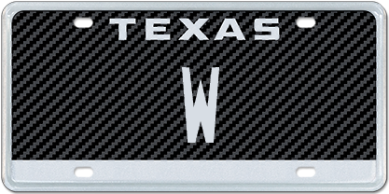

In addition to “3”, My Plates is also auctioning the last auction available single-letter plate, the letter “W”. Owning one of twenty-six of anything is a big deal. And that's what bidding on and winning the single-character plate message "W" will be.

Single-character plate messages are exclusive, unique and clearly extremely limited. Winning either of these single letter/number plates is an incredibly rare opportunity.

Both of these exceptional plate messages are offered for a 5-year term, with first right to renew, and are fully transferable. Winners can display their won message on any of the 100+ eligible plate designs.

“We are truly excited to make available to the market these last two remaining rare single-character plates, this is an outstanding opportunity for someone to secure one of these desirable messages” said Steve Farrar, President of My Plates.

The auction is now active, and bids are being accepted. Texans wishing to bid can register at www.myplates.com/auction. The auction will close on May 1, 2019.

Auction Details:
My Plates Single-Digit Auction dates:
- Begin Bid Date: 03-25-19
- End Bid Date: 05-01-19

Current bids for these two plates as of April 7, 2019 (9pm CST) are:
Lot# 1: Plate message “3” bid was $14,500
Lot# 2: Plate message “W” bid was $5,250

Unlike other Texas license plates, plates sold by My Plates at auction are legally transferable. The plate owner then has the right to sell the plate message to another person with the same ongoing rights or gift it to a family member or friend. Transferability also means these plates could make great investments.

To find out more information about the auction, simply visit the My Plates home page or www.myplates.com/auction.

__________________________________________________________________________________________

Most Expensive License Plate Facts:
- Most Expensive Plate in the World – UAE plate “1” sold for $14.3M, Feb. 2008.
- Most Expensive Plate in U.S.A: Delaware plate “6” sold for $675,000, Feb. 2008
- Most Expensive Plate in Texas: 12THMAN sold $115,000, Sept. 2013.
____________________________________________________________

My Plates designs and markets new specialty license plates as a vendor for the Texas Department of Motor Vehicles. Texans have bought more than 400,000 My Plates since November 2009, putting more than $75M in the state general revenue fund. My Plates’ goal is to create a long-term, mutually beneficial relationship designed to maximize revenues for the state through the sale of My Plates specialty plates. www.myplates.com.

The Texas Department of Motor Vehicles (TxDMV) serves, protects and advances the citizens and industries in the state with quality motor vehicle related services. For every $1 it spends, TxDMV returns $11 to the state. Each year the agency registers more than 24 million vehicles; issues more than 8 million vehicle titles; licenses approximately 34,000 motor vehicle dealers and distributors; credentials more than 60,000 motor carriers; issues more than 650,000 oversize/overweight permits; investigates approximately 13,000 complaints against dealers and motor carriers; and awards grants to law enforcement agencies to reduce vehicle burglaries and thefts. Learn more at www.TxDMV.gov.

For more information, contact Steve Farrar at (512) 633-7978 or steve@myplates.com

Image Downloads

Lot #1 – 3: https://ce9a9387e1bc258c3cfa-af7906f4e771b24864bbfa3048e4a635.ssl.cf2.rackcdn.com/3_TexasWhite.jpg

Lot# 2 – W: https://ce9a9387e1bc258c3cfa-af7906f4e771b24864bbfa3048e4a635.ssl.cf2.rackcdn.com/W_CarbonFiber.jpg

Dual image: https://ce9a9387e1bc258c3cfa-af7906f4e771b24864bbfa3048e4a635.ssl.cf2.rackcdn.com/SingleDigitAuction_PRBanner.jpg

