PRESS RELEASE /JUNE 2019

BREAKTHROUGH IN THERAPY
Contact Name: ECODITION  Phone: 0041 22 534 9327  Email: ecodition@gmail.com  Website: www.ecodition.net | Heal Yourself Unveiling Your Hidden Heritage, Ecodition, 2019, 180 pages, ISBN: 9782940540259 Editor’s price: 15,90 $ (www.ecodition.shop)  Free Kindle ebook from 7 to 8 June 2019
“Those who fail to learn from history are doomed to repeat it.” Winston Churchill

ANNOUNCING A PIONEER BOOK ABOUT HEALING YOUR TRANSGENERATIONAL INVISIBLE HERITAGE
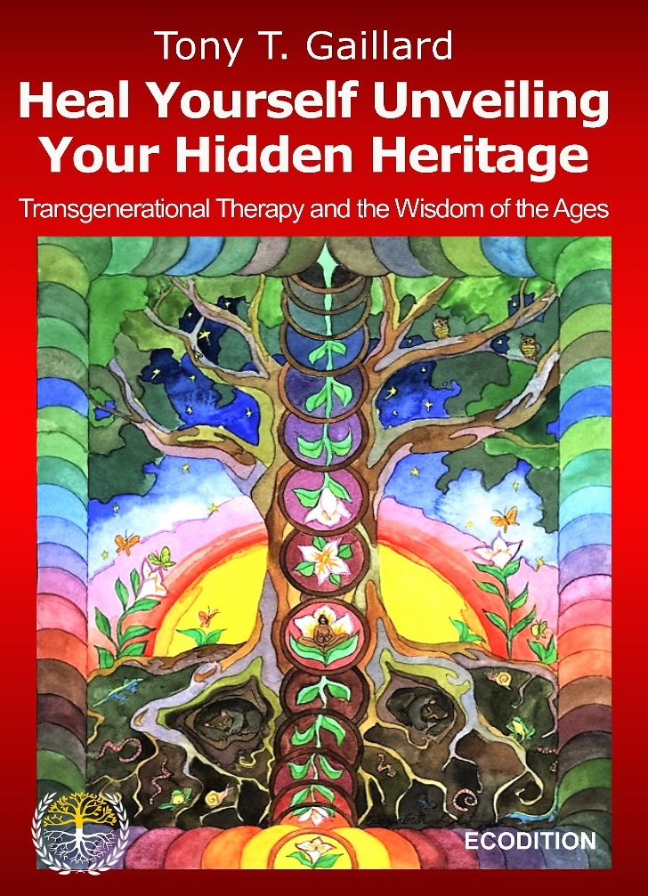
This book refers to both ancient practices and contemporary avantgarde therapies. It presents the psychological side of recent researches in epigenetic (DNA tests) and summarizes twenty years of practices and research, combining therapy, personal development, genealogy and existential analysis.
With many illustrations, Tony T. Gaillard shows how analyzing our ancestors’ lives helps to understand problematic conditions and heals all kinds of symptoms. As Goethe already explained: What we have received from our ancestors, we must assimilate until it becomes a part of ourselves if we want it to be an enrichment instead of a burden.
This book is intended for both professionals and all those who wish to learn more about transgenerational integration. It was first released in French, gaining attention of many Swiss and French journals. “Tony T. Gaillard explains how unhealed trauma can affect descendants! His book is a voyage in the new field of transgenerational psychology.” Marie-Pierre Genecand’s interview for Le Temps, Geneva.

Tony T. Gaillard is an accredited and experienced Swiss psychotherapist (www.gaillard.life). He graduated from University of Geneva, studied developmental psychology at CUNY (New York) and trained in various psychoanalytical schools. He is the director of the Centre Hermès in Geneva and director of collection at ECODITION. He published several books on depth psychology, mythology and transgenerational analysis.

