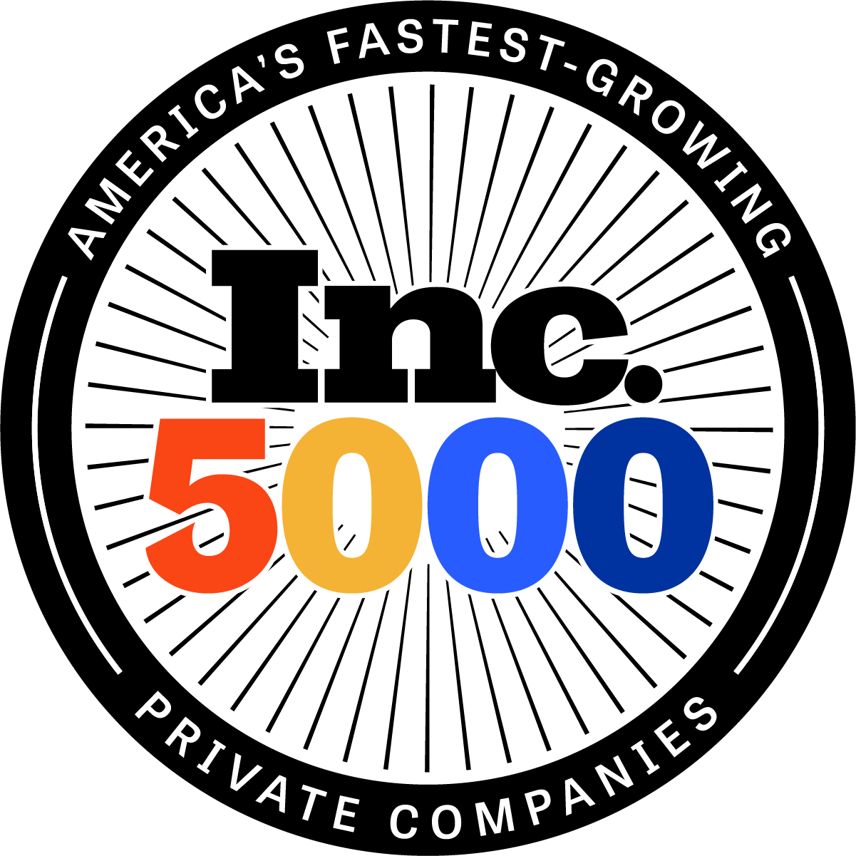
Charleston-based Floyd Lee Locums Named in the Top 1,000 of America’s Fastest-Growing Private Companies

Floyd Lee Locums Ranks No. 925 on the 2021 Inc. 5000
With Three-Year Revenue Growth of 522 Percent

NEW YORK, September 13, 2021 – Inc. magazine revealed that Floyd Lee Locums is No. 925 on its annual Inc. 5000 list, the most prestigious ranking of the nation’s fastest-growing private companies. The company is the highest-ranking healthcare staffing agency on the list and in the top 5 of all those based in Charleston. The list represents a unique look at the most successful companies within America’s most dynamic segment—its independent small businesses.

“Having founded the company four years ago, it’s humbling to be recognized by the Inc. 5000 in our first year of eligibility,” said Floyd Lee Locums CEO Natasha Lee. “As a healthcare staffing firm, dedicated to supporting clinicians and healthcare facilities nationwide, we recognize how challenging the pandemic has been for everyone. I am proud of how our team has handled the past 18 months, truly living by our motto: ‘By connecting clinicians to purposeful work, we impact lives.’”

For Floyd Lee Locums, the stakes of 2020 couldn’t have been higher. Patients, clinicians, and healthcare facilities across our country were looking for direction and support in unprecedented times as the care industry faced crippling changes. While other companies and staffing agencies were cutting pay and/or staff internally, Floyd Lee Locums was building their workforce and executive team. Where others took away benefits or furloughed employees, this agency created a model that had consultants available to hospitals 24/7 through weekends and holidays. This dedication to the healthcare industry is reflected in the financial results recognized by the Inc. 5000 list.

According to Inc. magazine, not only have the companies on the 2021 Inc. 5000 been very competitive within their markets, but this year’s list also proved especially resilient and flexible given the unprecedented challenges of 2020. Among the 5,000, the average median three-year growth rate soared to 543 percent, and median revenue reached $11.1 million. Together, those companies added more than 610,000 jobs over the past three years.

“The 2021 Inc. 5000 list feels like one of the most important rosters of companies ever compiled,” says Scott Omelianuk, editor-in-chief of Inc. “Building one of the fastest-growing companies in America in any year is a remarkable achievement. Building one in the crisis we’ve lived through is just plain amazing. This kind of accomplishment comes with hard work, smart pivots, great leadership, and the help of a whole lot of people.”

Intuit, Zappos, Under Armour, Microsoft, Patagonia, and many other well-known names gained their first national exposure as honorees on the Inc. 5000. Complete results of the Inc. 5000, including company profiles and an interactive database that can be sorted by industry, region, and other criteria, can be found at www.inc.com/inc5000. The top 500 companies are also being featured in the September issue of Inc.

CONTACT:
Kelly Starkey, 435.901.3278, kelly@starkeyconsulting.com

About Floyd Lee Locums
Floyd Lee Locums provides an elite concierge experience to Physicians, Dentists and advanced practice healthcare clinicians in hospitals and healthcare facilities nationwide. Named the 2020 and 2021 “Best Staffing Firm to Temp For” by Staffing Industry Analysts (SIA), their hands-on approach to delivering best-in-class service, personalized career solutions, and coverage that positively impacts patient outcomes is setting a new standard in the locums industry. www.floydleelocums.com

More about Inc. and the Inc. 5000

Methodology
Companies on the 2021 Inc. 5000 are ranked according to percentage revenue growth from 2017 to 2020. To qualify, companies must have been founded and generating revenue by March 31, 2017. They must be U.S.-based, privately held, for-profit, and independent—not subsidiaries or divisions of other companies—as of December 31, 2020. (Since then, some on the list may have gone public or been acquired.) The minimum revenue required for 2017 is $100,000; the minimum for 2020 is $2 million. As always, Inc. reserves the right to decline applicants for subjective reasons. Growth rates used to determine company rankings were calculated to three decimal places. There was one tie on this year’s Inc. 5000. Companies on the Inc. 500 are featured in Inc.’s September issue. They represent the top tier of the Inc. 5000, which can be found at http://www.inc.com/inc5000.

About Inc. Media
The world’s most trusted business-media brand, Inc. offers entrepreneurs the knowledge, tools, connections, and community to build great companies. Its award-winning multiplatform content reaches more than 50 million people each month across a variety of channels including web sites, newsletters, social media, podcasts, and print. Its prestigious Inc. 5000 list, produced every year since 1982, analyzes company data to recognize the fastest-growing privately held businesses in the United States. The global recognition that comes with inclusion in the 5000 gives the founders of the best businesses an opportunity to engage with an exclusive community of their peers, and the credibility that helps them drive sales and recruit talent. The associated Inc. 5000 Vision Conference is part of a highly acclaimed portfolio of bespoke events produced by Inc. For more information, visit www.inc.com.

