

Brought to the United States
Exclusively from Harmony Sweets

DeLafée, imported from Switzerland, brings together the sweet delight of Swiss chocolate and the eternal magic of 24 karat gold. DeLafée's mission is to create the most delicious and most beautiful chocolate creations conceivable.

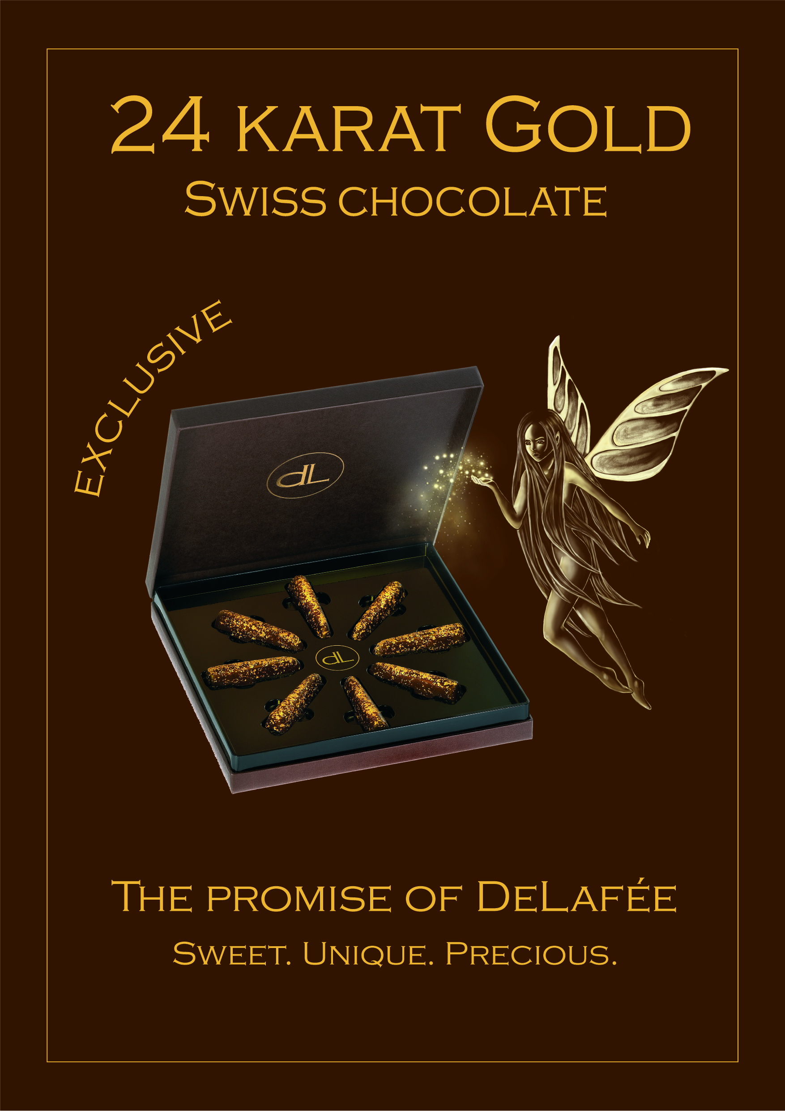

DeLafée chocolates are prepared in Switzerland from the finest cocoa beans available. Precious flakes of 24 karat gold leaf are applied by hand to each praline in order to create the sublime experience that is the signature of DeLafée.

Several world cultures use gold in foods. India is the world’s largest gold consumer of food products, eating over 12 metric tons of gold per year. The best chefs in France, Italy, and Japan adorn their most refined dishes with gold. Many ancient cultures believed that eating gold was beneficial to their health.

Harmony Sweets constantly searches the confectionery world to discover the most desired, upscale, elegantly packaged, and exquisite confections unique to their country of origin. For more information, please visit http://www.harmonysweets.com or call 1-888-73-SWEET.

