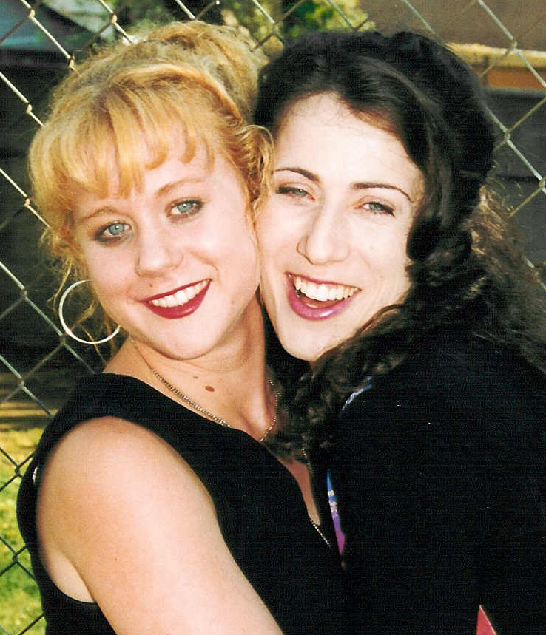
About "Purgatory House”
A note from director Cindy Baer

Celeste Davis, the 14 year old writer of Purgatory House, and I were matched through The Big Sisters of Los Angeles program in 1997, when Celeste was 11 years old. On the day we met, we were amazed to discover that we both had cats named Cali. As time would unfold, we came to realize that it was no coincidence at all that our lives were brought together, and that this would be the start of something much larger than just the two of us.

Celeste had little interest in school, and struggled to get good grades. She also struggled with her home life and friendships. Time was slowly dragging by. She was waiting for the days to pass, to grow up, and to be free. She liked to do artistic things like paint, draw and write. She began to write a story, which paralleled her own life in certain ways; her search to fit in, to avoid drugs, drinking and cigarettes, to get along with people, to find meaning for her life, and to find her Higher Power. In other ways it was an uncensored look at what a teenage girl would fantasize about; being powerful, boys liking you, people being sad if you were gone, feeling wanted, and the fear of making wrong choices. I was amazed at how clearly I could see the influence of the society we live in today reflected back at me through this newly 13-year-old girl. It was shocking.
When Celeste came to me with the first version of her story called Purgatory House I was astonished. Never having learned story structure, she had created her own. She was effortlessly telling a story by means of four time-lines--and it worked! The subtext leaped off the page, and the symbolism was profound. As shocking and saddening as I found the content, I encouraged her to continue her writing uncensored; not thinking of how it might be received and judged by others, but from her soul- as a true expression of what was inside. She would come to me every now and then and we would brainstorm a plot point. A few months later, I typed it up for her- and low and behold- with a little twist here and a tuck there, we had a feature length screenplay.

In the summer of 2001, an amazing cast and crew came together for an 18-day shoot, and turned Celeste's screenplay into a real movie. As the director I had 2 main goals: First was to keep Celeste’s voice (and script) completely intact. Second was to make it so the audience would be continually aware of our young writer’s voice while watching the movie. A mini-DV approach was taken, no dialogue was improvised, and I cast Celeste in the lead role.

Purgatory House is a living, breathing snapshot of how it feels to be a teen in a fast-paced, media-saturated world – undiluted by adult sensibility. I see this film as an amazing opportunity for all of us. It's a wake-up call.

Purgatory Houses are here on earth. Can we help our kids find the way out?



THE SPIRIT OF TODAY’S TEEN

Digging Deeper
At its core, Purgatory House is about a lonely teen searching for a connection to a higher power. It is a philosophical, thought-provoking movie that inspires conversations about the choices we make in our lives, and the results that come from those choices. Beginning where most stories end, Purgatory House chronicles the after-life spiritual journey of Silver Strand, a 14-year-old girl who tries to escape her life of drug addiction in search of unconditional love. Instead she finds herself caught somewhere between Heaven and Hell, where she must finally decide if she will accept her drab existence or find within herself the power to change.

Purgatory House focuses on a topic that is seldom addressed in today’s fast paced world: Teen Spirituality. While many films dramatize the symptoms, this film focuses on the root causes.

What is the spiritual state of today’s American teen?
Sometimes it seems like today’s American society can value “things” more than people. We worship beauty and violence, and then wonder why our kids are expressing themselves through mind-numbing drugs and eating disorders, and by showing up at schools with guns. Are we losing touch with each other? Have we forgotten what is meaningful? More and more parents are absent (literally or figuratively), and the media has become our children’s babysitter, role model and higher power. Many kids don’t feel important or valued, and are left too often to television, movies, video games, and the Internet for companionship and character development. And then to perpetuate the problem, many films about teens today offer sexy, shocking and idealistic images without depicting realistic consequences to actions.

When Celeste Davis first came up the idea for Purgatory House at the age of 13, which professed the premise of “maybe I’d be happier if I killed myself” I was taken back. Her story felt like she was speaking not just for herself, but for an entire generation of kids who felt lost in the same way she did.

It is our hope that this young writer’s reflections on life (and death) might open some doors that could bring us all a little closer.

