Contact: Kim Klietz
PR Coordinator
Chief Manufacturing
952-277-3867
kim.klietz@chiefmfg.com



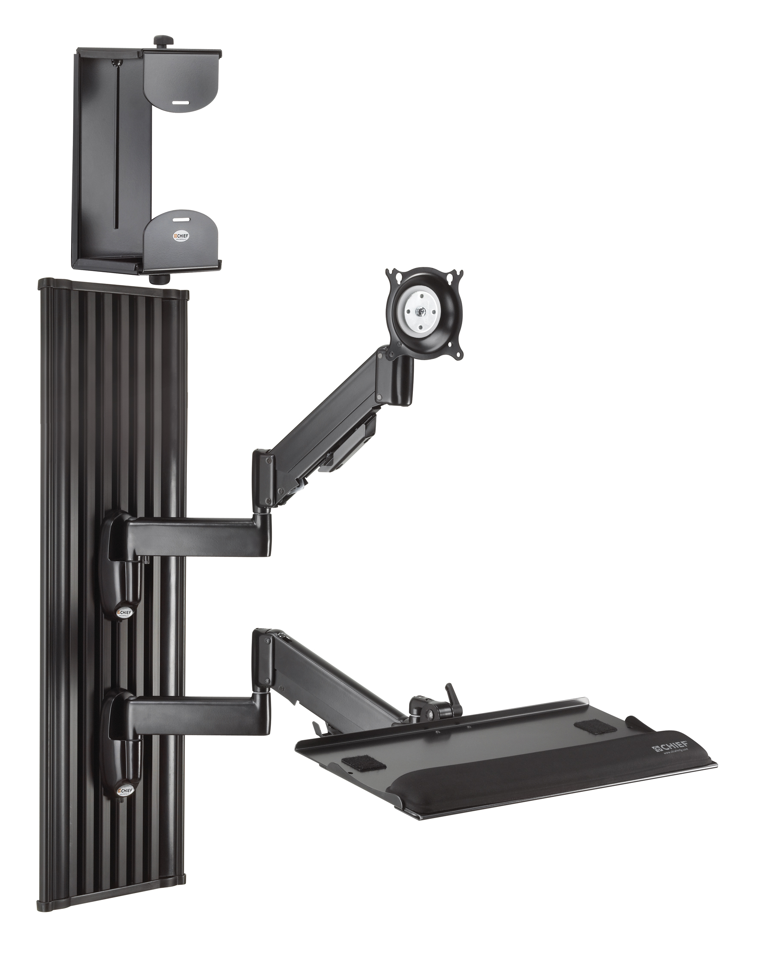

FOR IMMEDIATE RELEASE

Subject: Chief Releases All-in-One Monitor Workstation

Chief® Introduces All-in-One Monitor Workstation, Ideal For Healthcare and Wall-Mounted Applications
The KWT110™ includes a versatile Wall Extrusion, Height-Adjustable Monitor Wall Mount, Height-Adjustable Flip-Up Keyboard Tray and CPU Mount that provide flexibility and ultimate space savings for multi-user environments.

Minneapolis, MN. -- (October 2008) – www.chiefmfg.com – Chief Manufacturing, the industry leader in projector and flat panel TV mounts, is excited to announce the launch of the KWT110 All-In-One Wall Workstation. KWT110 includes Chief’s flexible KWG110™ Height-Adjustable Monitor Wall Mount, KWK110™ Height Adjustable Flip Up Keyboard Tray, and KSA1020™ CPU Mount. The combination of these ergonomic, space-saving mounts creates the perfect suite for Healthcare or related wall-mounted applications.
Flexible Wall Extrusion
The KWT workstation can be installed vertically or horizontally on the wall, depending on space requirements. Vertical installation can be installed directly on sheetrock, without the need for a stud. Components can be easily installed and infinitely positioned anywhere along the entire length of the extrusion for easy customization of the workstation. The unique cable channels keep cables clean and tucked out of the way – ideal for sterile environments.
.

KWG110 Height-Adjustable Monitor Arm
KWT110 includes Chief’s KWG110 state-of-the-art ergonomic swing arm mount. The KWG110 provides up to 13.25” (336.5 mm) of fluid height adjustment and 180º of swivel to achieve the perfect viewing placement. The teardrop hole pattern, available in standard VESA® patterns, makes monitor connection quick and easy. Chief’s exclusive Centris™ Technology uses the center of gravity to balance the monitor, providing effortless fingertip tilt. Cables are concealed through a channel located on the underside of the arm for a clean appearance.

KWK110 Height Adjustable Flip Up Keyboard Tray
The KWT110 also includes Chief’s new KWK110 Flip-Up Keyboard Tray with integrated mouse surface and storage. The height-adjustable swing arm design provides extension and fluid positioning for the user, with a stable surface when the keyboard is in use. A gel wrist rest promotes ergonomic comfort and support, while left/right flip-out mouse surfaces provide flexibility for a variety of users. The flip-up design provides a low-profile appearance, and includes mouse storage. Cable management is consistent with the KWG110 for a clean, concealed appearance.

KSA1020 Flexible CPU Mount
With the new KSA1020 CPU mount, you get universal fit and universal function. Compatible with a wide range of CPU sizes, the KSA1020 fits 95 percent of CPUs used in today’s commercial environments, from ultra small to larger tower units. The adjustable design expands and collapses to get the perfect fit, regardless of CPU model, providing longevity for advances in technology. The mount can be installed on the wall or under a desk, keeping it tucked neatly out of the way. Desk mounting offers both vertical and horizontal CPU placement along with 360º of swivel to aid in cable connections and servicing. Other innovative features include Q-Latch™ Technology for easy installation, removal and service, as well as tool-less adjustments. The mount supports up to 40 lbs (18.1 kg).

The Extrusion, Monitor Mount, Keyboard Tray, and CPU Mount all work together to provide a truly unique, ergonomic solution that is ideal for multiple users. Components collapse to less than 2.5” (63.5 mm) in stow away position for ultimate space savings.

Custom Wall Systems
Chief’s Flexible Wall Extrusion is compatible with a variety of other Chief wall-mounted solutions. Custom systems can be built depending on the requirements of the application, including the addition of multiple monitors.

About Chief
Chief Manufacturing is a division of Milestone AV Technologies, a Duchossois Group Company, and has more than 30 years of proven product and service excellence. Committed to responding to industry needs in the Pro AV, Residential and Office markets, Chief offers a complete line of mounts, lifts and accessories for flat panel displays and projectors.

Chief continues to design innovative mounting solutions that complement the technology they support. With multiple product awards and patented designs, Chief provides unique mount features, and is recognized for delivering not only quality products, but knowledgeable, helpful customer service.

U.S. and Europe sales offices support a global network spanning the Americas, Europe, the Pacific Rim and beyond. Chief distribution centers are located in Minnesota and the Netherlands. www.chiefmfg.com.

-###-

