Contact: Jo Nichols  Calame Jewelers  Phone: (214) 528-2866 | 11 Highland Park Village  Dallas, TX 75205 | Calame Jewelers

Press Release

Jewelry Calame Jewelers Announces Partnership with Kelly Mitchell Fine Jewelry
Kelly Mitchell Brings A Variety of Upscale Designs and Watches to the Park Cities’ Oldest Family Owned Jewelry Store.
Dallas, May 10, 2010: Calame Jewelers announced today a new partnership with Kelly Mitchell Fine Jewelry. Located in the prestigious shopping center of Highland Park Village, Calame Jewelers has enjoyed a reputation for fine quality personal service since 1942. Sixty Eight (68) years of exceptional customer service and a “can-do-attitude” has put Calame Jewelers in a class of its own for custom jewelry, repairs, and personal customer care.
“We have a great location and the number one custom jewelry and repair service in the Park Cities,” says Jo Nichols, one of the current three owners of Calame Jewelers. “What we were looking for is a partner that can bring fresh ideas and access to the highest quality upscale designs and pre-owned watches at very attractive prices. We believe we have found that with Kelly Mitchell.”
“I am very excited about working with the Nichol’s,” says Mitchell. “I have operated a private jewelry service for more than 15 years serving wealthy clients all over the globe. The affiliation with Calame Jewelers allows me a quality retail presence in the most attractive community in Dallas.”
About Calame Jewelers: Calame Jewelry was founded by Paul Calame, a Swiss watchmaker and has built a reputation synonymous with craftsman ship and quality providing such services as watch and jewelry repair. From 1942 until 1980, Calame was owned by the Calame family. In 1980 Joe, Jo, and Steve Nichols decided to combine their years of experience in the Guild Division of Zale Group and become the new owners of Calame. For 30 years, the Nichols have continued the vision of Paul Calame, and satisfied customers from all over the city proudly advise their friends and family to “Go to Calame’s” for quality service and merchandise. The store is located at 11 Highland Park Village.

About Kelly Mitchell
Kelly Mitchell has twenty four years of experience in the jewelry industry. She began her career working for a high-end jewelry designer in Los Angeles, traveling the country selling the designer’s line of jewelry to the trade.
Next she worked special event shows directly in jewelry stores, such as Bailey, Banks & Biddle, Helzburg and Marshal Fields. She then was responsible for the American operation of a South African Site Holder that specialized in working with clients who came to Africa on Safari. While in this role, Kelly provided highly personalized service by travelling the world to meet private clients to create custom designs or deliver requested pieces.
For the past 15 years Kelly has operated her own business providing custom design pieces and watches to private clients. Her clients continue to include members of the Safari community as well as senior executives, affluent couples, and young cosmopolitans that have all come to her through referral. Kelly is a member of the International and Watch Jewelry Guild (IWJG) and Rapaport Diamond Association. She is also a member of the The Dallas Safari Club & Safari Club International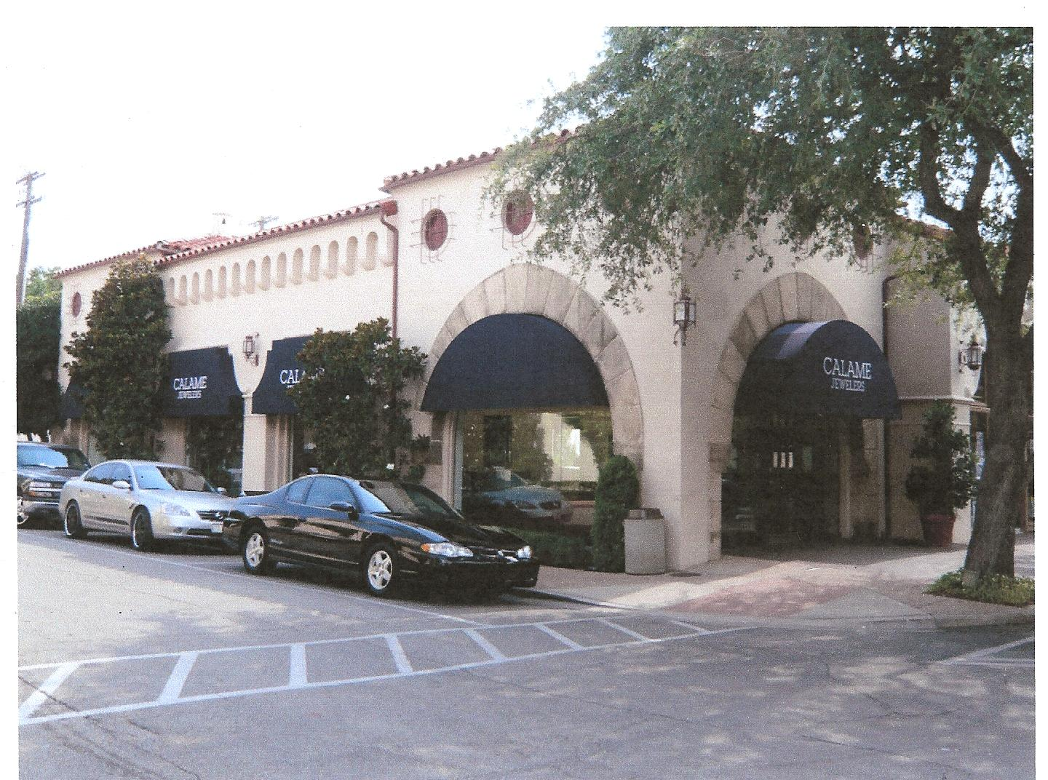.
www.kellymitchelljewelry.com

