
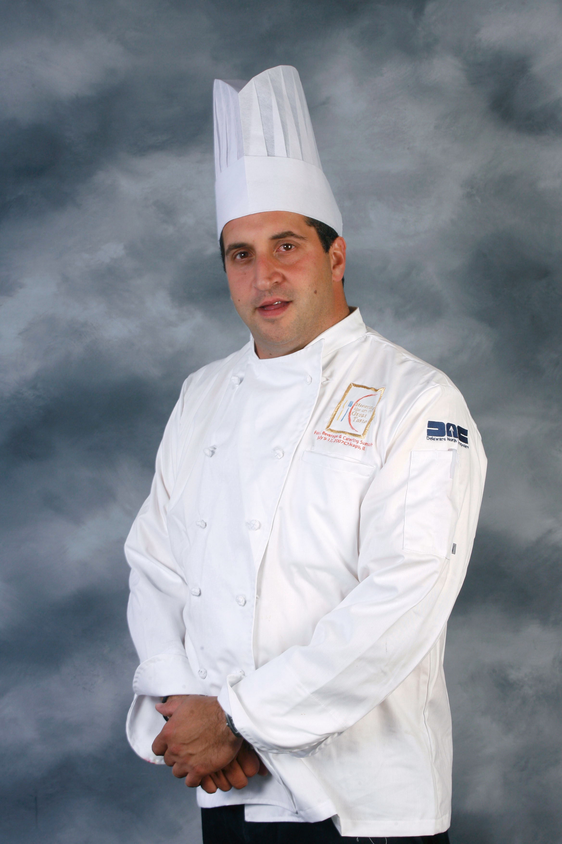

Eric Borgia
Executive Chef
New Meadowlands Stadium
Delaware North Companies Sportservice

Eric Borgia serves as executive chef for Delaware North Companies Sportservice at the New Meadowlands Stadium, the newly opened home of the New York Jets and New York Giants of the National Football League.

Sportservice was selected as the $1.7 billion stadium’s food, beverage and retail provider by the New Meadowlands Stadium Co., the joint venture that developed the signature venue for the two teams. Sportservice began operations at the stadium in April 2010 for a number of events and concerts leading up to the inaugural football season that begins in September.

In his role as executive chef, Borgia oversees all culinary operations at the stadium, the New York-New Jersey region’s pre-eminent sports and entertainment venue. It seats 82,000 and features concessions throughout the complex and premium dining in 218 suites and several state-of-the-art clubs.

A native of the region, Borgia and other Sportservice culinary officials have developed a unique food experience for the concessions at the New Meadowlands Stadium called the "Home Food Advantage," featuring the best New York and Northern New Jersey fare. Among the unique concessions fare will be Italian roast pork with aged provolone and roasted red peppers, and a meatball hoagie featuring his grandmother’s heirloom meatball and sauce recipe.

Prior to becoming executive chef at the New Meadowlands Stadium, Borgia was Sportservice’s executive chef at PETCO Park, home of the Major League Baseball’s San Diego Padres. Borgia oversaw all culinary operations at the ballpark’s concessions, suites and seven restaurants, creating his own brand of Italian cooking, as well as plenty of other tasty dishes, to serve to thousands of baseball fans at each home game.

Since joining Delaware North in 2002, Borgia has also served as executive chef at the Atlantic City Convention Center and as club and suites chef at the Cleveland Indians’ Progressive Field.

Borgia has had many opportunities with Delaware North to cook for an array of popular celebrities. He once served as a private chef to several National Basketball Association players and catered to movie sets, including The Sixth Sense with Bruce Willis. He has also been at the core of Delaware North’s culinary team during such events as the 2005 and 2009 Major League Baseball All-Star Games, the World Baseball Classic, and the 2006 World Series.

At the 2006 Super Bowl, again on behalf of Delaware North, Borgia was tabbed to serve as private chef to VIPs, including rock legends the Rolling Stones, who performed at halftime.

Borgia is certified by the American Culinary Federation as a chef de cuisine and has trained at the Culinary Institute of America in Napa Valley. He has also attended Delaware North’s annual chef summits, which are led by the company’s chief corporate chef, Roland Henin, a rare certified master chef and well-known culinary educator.

