2012
Your Total 10 Perfect Match - Workbook
Your Total 10 Perfect Match

2012 WORKBOOK

“I think self-awareness is probably the most important
thing toward becoming a champion. “
BILLIE JEAN KING

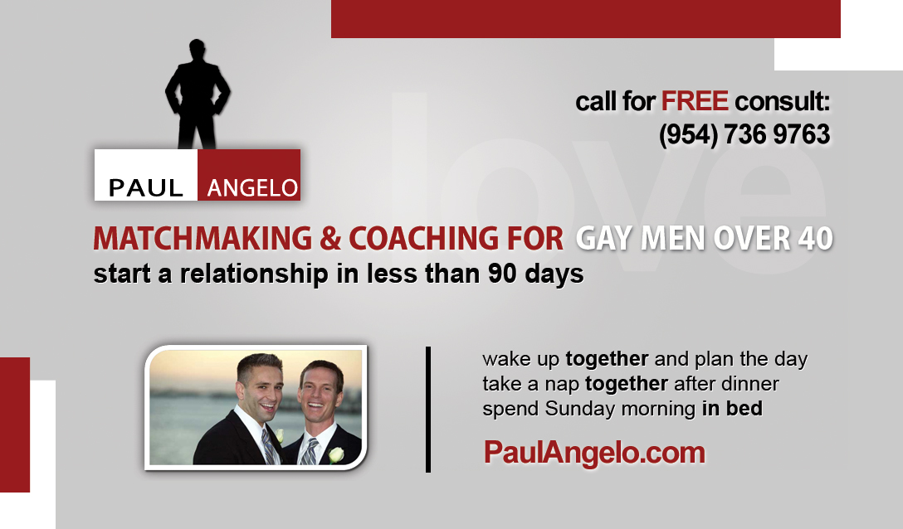
Coaching Questionnaire
Please answer the following questions and email this document back to PaulAngelo33@gmail.com

What are the 10 benefits of being gay?
1.
2.
3.
4.
5.
6.
7.
8.
9.
10.
What are the 10 amazing things about me?
1.
2.
3.
4.
5.
6.
7.
8.
9.
10.

Self-Analysis Questions
Below are sentences that need an ending. Please finish the sentences by adding your own 7 different versions of the ending. The endings should be grammatically correct when connected to the beginning of the sentence.
1. One of the things I want from people and don’t know how to get is…
Example: to be understood.

1.
2.
3.
4.
5.
6.
7.

2. One of the ways I make it difficult for people to give me what I want is…
Example: being at the wrong place and looking for the wrong thing.

1.
2.
3.
4.
5.
6.
7.

3. One of the ways I contribute to my own frustrations is…
1.
2.
3.
4.
5.
6.
7.

4. If any of what I am saying above is true then…
1.
2.
3.
4.
5.
6.
7.

