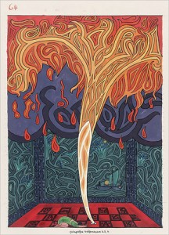
innerQuest is a psychiatry and counseling practice in Asheville, NC. Founded by 2 psychiatrists, Dr. Steven Buser and Dr. Leonard Cruz, it offers comprehensive treatment for those seeking personal growth or relief from symptoms such as depression, anxiety and other psychiatric illness. They assist clients in optimizing their health through psychotherapy, medication, spiritual growth and behavioral treatments.
We look forward to assisting you in your inner journey. (Ph 828-333-5240)
Current innerQuest Providers:
Steven Buser, MD
Leonard Cruz, MD
Richard Smoot, PsyD
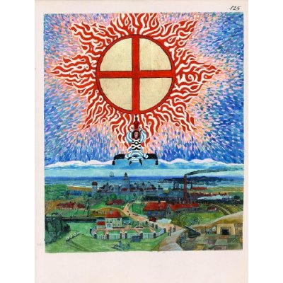 |  | Welcome to the Asheville Jung Center! Our primary focus is to offer world-class Jungian seminars through internet technology. During these live seminars, international participants can ask questions of our speakers from live audio-video connections, e-mail or online chat. Seminars can be watched live or recorded. Individuals without high speed internet can also participate by watching recorded DVD’s of the seminars, usually available a few months later. Continuing Education credit for professionals is also available.sss  sss  Our center carries forward the pivotal work of Carl “C.G.” Jung, the founder of Analytical (“Jungian”) Psychology.

