Solution Brief
Gladinet Cloud Access Solutions
Despite the potential benefits of adopting cloud storage, many businesses are faced with concerns about security, data control and the ease of migrating existing data and users. They must ensure data security and accessibility data while making the cloud migration as seamless as possible. Enterprise IT admins are looking for a solution to this problem: Secure cloud storage with a simple access model and non-disruptive migration path.

Cloud Storage Access
Before a business can successfully offer a cloud storage solution, it must either build or buy a simple online storage access platform with support for the BASIC use cases. These include backup, access, synchronization, identity management and collaboration. A reasonable migration strategy must be implemented to move existing data to online storage without disruptions. For instance, a common problem is that large data sets combined with relatively small amounts of bandwidth often leave an IT administrator facing days or weeks of uploads to complete the migration to online storage.

Cloud Storage Access with Gladinet Cloud Team Edition
Gladinet Cloud Team Edition addresses concerns about security, data control and the ease of migrating existing data and users by providing a simple, secure access model for online storage. It further simplifies the process of moving existing data to online storage, works with most popular public cloud storage services and can be configured to leverage any pre-existing cloud storage account. In addition to support for the use cases listed below, it avoids vendor lock-in and makes it easy to change storage service providers, if so desired.

Anywhere Access
Gladinet Cloud Team Edition provides users with familiar access methods (mapped drives, file shares, etc…) from a web browser, desktop client, mobile device or file server. For example, Remote users can leverage the desktop, mobile and web clients while on-premise users have the additional option of clientless access through their file server.

Online Collaboration
Gladinet Cloud makes it easy for teams to work collaborate on the same content from multiple locations. For example, globally accessible team folders may be defined with Active Directory based access controls and distributed file locking.

Seamless Migration
Gladinet Cloud simplifies cloud migration by integrating existing access paradigms with the cloud. It provides a unified namespace across multiple

locations, allows immediate migration of existing data and integrates existing file servers with online storage.

Backup, Synch and Sharing
Gladinet Cloud allows team members to securely share files and folders with anyone, as permitted by the administrator. It automatically creates versioned

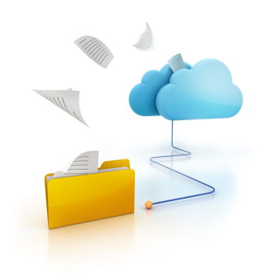
backups of attached folders or can create snapshot backups. Folders can also be synchronized with the cloud so that changes made anywhere are readily available. Unlike other solutions, you are not limited to a single synchronization folder which forces reorganization.

User Management
Gladinet Cloud provides its own user management or users can be managed through tight integration with Active Directory. Multiple team members may be designated as delegated administrators.

Gladinet Branding Services
For large enterprises and service providers, Gladinet offers custom development services to create branded access solutions. For more information, send an email to partner@gladinet.com.

