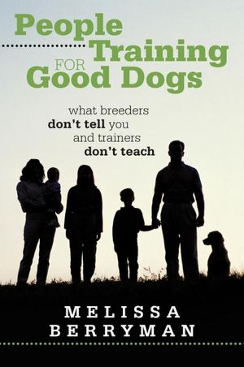
From The Dog Owner Education and Community Safety Council
www.doecsc.org
508-563-3886

Promoting Safe Interactions with Dogs
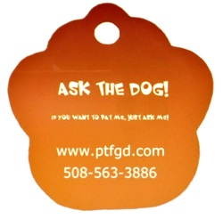
Let a dog decide if it wants you, a stranger, to touch it.
Just TAP the side of your leg repeatedly, relax and act friendly.
Talk to the dog in a higher pitched voce so it knows you are a friend, not its foe or its prey!
If it wishes to be patted it will relax too, wag its tail and come over and nuzzle.
If it stiffly sniffs you or stays away, keep talking and tapping but AVOID touching when it says NO THANKS!

Avoid patting a held dogs or trying to pick up a small dog. They are stuck, unprotected and can’t tell you no thanks. Nipping is a way to to keep you back.

Dogs have POOR EYESIGHT. When greeting, remove sunglasses and hats first, avoid sudden movements or outbursts and talk to them reassuringly.
Happily keep your eyes on a dog when you leave.

!!!NO HUGGING!!!
Protect a child and save dogs!
Dogs do not hug each other to convey love, affection or support. Dogs hold onto each other to convey superior position and rank.
Kids are often bitten in the face because they hugged a dog, often when not in the presence of an adult.

Dogs are individuals and not breed stereotypes. Their behavior towards you depends on how both you and their owner acts. Act like a FRIEND!

Avoid tug o’war. It’s not a game but a battle for possession of resources. Resources (toys, food, places to sleep, attention) belong to you, the leader not the subordinate which should always be the dog. Dogs should back away from resources not fight you for them.
NEVER PULL A DOG BY THE COLLAR
NOT YOUR DOG?
LET THE OWNER DO IT.
Whether it’s a tick, something stuck in their fur, they have debris or food-let the owner remove it from their dog. Your hands and fingers are too important.

