Women Dedicate 50% More Effort To Expressing Themselves Appropriately, Versus Men, As Per 123Greetings Analysis, Especially For Women’s Day
Summary: This Women’s Day, 123Greetings suggests everyone to reciprocate and spend the time and effort needed, in expressing themselves to the women they care about in their lives. 123Greetings.com offers over 350 free ecards across 10 categories exclusively for International Women’s Day to help people select just the right expression for this special occasion.
New York, NY, March 5, 2013: Women form an integral part of the 123Greetings.com community, and the company mined some numbers, on this important occasion of Women’s Day, to understand how women differed from men as far as expressing themselves is concerned. The results were not startling but the magnitude of difference was.
Given that Women’s Day 2013 is just a few days ahead the finding that women spend 50% more effort expressing themselves is worth noting. In 2012, women spent more time and effort viewing and sifting through cards by as much as 50% versus men. Contrarians might argue that men are more decisive or efficient at searching. While the analysis does not necessarily explain causation, it does seem plausible that women would be more careful about the expressions they send to their counterparts on occasions special to them.
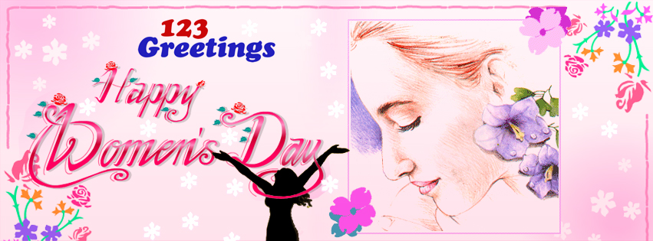
Happy Women’s Day from 123Greetings.com

This Women’s Day, it would be important for us as a mature community to understand, appreciate and learn from women. Thomas Hardy himself wondered – “Why is it that a woman can see from a distance what a man cannot see close?” The finding from 123Greetings.com goes to show the importance women give to emotional bonds and relationships, therefore spending more time and effort in ensuring that the relationship is nurtured and developed in the best way.
This international women’s day, 123Greetings.com urges all, especially men, to express their appreciation to the women in their lives, be it their mothers, friends, teachers, siblings, daughters or their partner. Appreciation, recognition and reciprocation to women perhaps goes that extra bit more in building space within their hearts.
123Greetings.com has over 350 free Women’s Day ecards across 10 categories only for women’s day for people to choose the perfect expression for the women in their lives.
About 123Greetings.com:
123Greetings.com is the world's leading online destination for human expressions reaching over 95 million visitors annually. Drawing from its tag line "Free Greetings for the Planet" the service exemplifies the notion that the best things are free in our planet and so should wishes, greetings and personal expressions be. Its offering of over 37,500 greeting cards covers a mix of 3,000 seasonal & everyday categories.
For details visit www.123greetings.com.

