Nonsurgical fat removal, the 'next frontier' in cosmetic surgery
Originally published: March 13, 2013 10:25 AM
By JANENE MASCARELLA

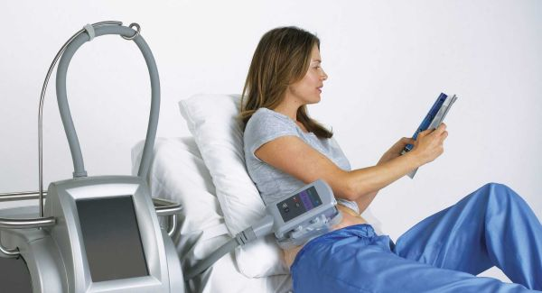

There's a pretty cool way to get rid of body fat these days. In fact, techniques now exist to get rid of stubborn fat and cellulite with no cuts, needles, scars or downtime.

"The best candidates should be at or close to their ideal weight, have a good diet and exercise program, and have pockets of fat that have not responded to their hard work," said Dr. Marina Peredo, a dermatologist and founder of Spatique Medical Spa in Smithtown.
Nonsurgical fat removal is the next frontier in cosmetic surgery, says Dr. Cameron K. Rokhsar, an assistant professor of dermatology at the Albert Einstein College of Medicine and medical director of the New York Cosmetic Skin & Laser Surgery Center, with offices in Garden City and Manhattan.

"Up to now, we were focused on various ways to fill in the face and tighten skin . . . but now the new push is to find ways to get rid of fat without surgery like liposuction," Rokhsar said.
That might mean freezing the fat or using ultrasound, vacuum and massage, or low-level laser treatment to shrink fat cells.
"Fat freezes at a higher temperature than water does, so you can selectively freeze the fat without injuring anything else," Rokhsar explained. The fat cells die and the body clears them away -- a process that takes about three months before you'll see the final results.

Called CoolSculpting, the in-office treatment was developed by Harvard scientists who found that fat could be destroyed by lowering its temperature. Approved by the U.S. Food and Drug Administration about three years ago, it's used on the abdomen, love handles, arms or most any area with pockets of unwanted fat.
Someone getting the treatment sits for about an hour with an applicator on a part of the body where unwanted fat has been identified. In that hour, the machine brings down the temperature in that area.

The first few minutes are uncomfortable, Rokhsar said, but once the area gets cool, it becomes numb and you won't feel anything. There may be some swelling for a few days in the area that was treated, but that almost always goes away, he said.

Cost depends on the size of the area treated, but Rokhsar said a session generally ranges from $700 to $1,500. Those who want a more dramatic change may decide to do it again, with at least three months between treatments.

Robin Amante, a bookkeeper from Malverne, said she got a boost from CoolSculpting, which she described as the best choice she could have made to get rid of excess belly fat. "Although the hour with the apparatus was a bit uncomfortable, the results were well worth it," she said. "The aftereffects were minimal. My belly was a little tender to the touch for a couple of weeks, but just eight weeks after the treatment, my stomach was flatter than it had been in 25 years."

There is no need for a procedure afterward to tighten the skin; the body slowly gets rid of the fat cells as waste.
Realistic expectations are important, however, Rokhsar stressed. "This is not something you do and you walk out and see immediate results," he said. "You have to wait."
Other noninvasive fat-reducing options available on Long Island include:

Liposonix
This treatment, approved by the FDA about a year ago, uses ultrasound energy to penetrate the fat cells in a focused manner, said Dr. Cameron K. Rokhsar. Ultrasonic waves injure the fat cells, and the body clears them away, taking about three months for final results to be apparent, he said. Similar to fat-freezing, Liposonix treatment takes about an hour per area and involves slight discomfort. He said cost depends on the area treated and usually starts at $1,500.

VelaShape
This FDA-approved treatment uses patented technology along with vacuum and massage to target and shrink fat cells and reduce the appearance of cellulite. The mechanical rollers and vacuum suction act to increase circulation to the treatment area and massage the skin to achieve a smoother, less-dimpled appearance. It usually involves four treatments, spaced about a week apart, with results visible within about 30 days. It's described as a painless treatment that feels like a warm deep- tissue massage. Each treatment costs about $250 to $400.

Erchonia's Zerona Laser
This noninvasive, low-level laser treatment, also approved by the FDA, emits neither heat nor cold, and the recipient feels nothing. Rather, the laser creates a pore in fat cells through which fat leaks out and is then processed by the body as waste. It requires six treatments: a 40-minute treatment every other day for two weeks. Cost of the six-session treatment typically ranges from $1,500 to $1.700.

