The Forest Festival 2013
August 14th to August 18th, Haliburton Forest and Wild Life Reserve
For Tickets: http://www.madeinhaliburton.ca/brands/The-Forest-Festival.html

Wednesday, August 14 - 8:00 pm at the Bone Lake Amphitheatre
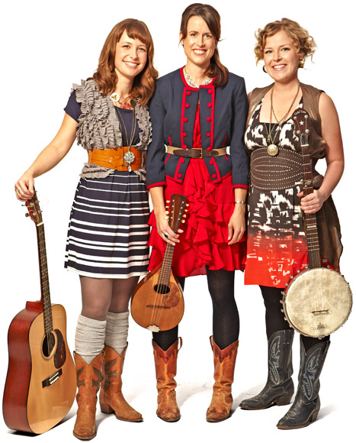
KISS ME IN THE KITCHEN
The Good Lovelies http://www.goodlovelies.com/site/
http://goodlovelies.blogspot.ca

On a recent trip to Australia The Good Lovelies laughingly told reporters that while out for a walk they’d been “almost hit in the face by a flock of cockatoos.” That won’t happen in Haliburton, but we do have a very well-mannered family of ducks that swims across the lake for our shows. They’re real music lovers.
The aptly named Good Lovelies are Caroline Brooks, Kerri Ough and Sue Passmore, all of them best friends and refugees from solo careers. Described as folk-roots and western swing, the Toronto-based trio relies on unerring three-part vocal harmonies and clever songs with just a pinch of sass. Their constant instrument swapping and witty on-stage banter have enlivened the folk music landscape since they joined forces in 2006 for their first show at Toronto’s funky Gladstone Hotel. The ladies immediately realized they had something special, so they hit the road on a mission to charm Canadian audiences coast to coast.
Lighthearted songwriting and irresistibly buoyant dispositions have made them the darlings of the summer festival circuit, including spots at the storied Mariposa and Hillside Festivals and the Montreal Jazz Festival. They have toured with Stuart McLean and Vinyl Cafe and appeared on stages and in studios with Broken Social Scene, Kathleen Edwards and Jill Barber. The Good Lovelies took home a 2010 Juno Award for Roots Album of the Year, and their Let the Rain Fall release was nominated for 2012 Juno honours. Their latest, Live at Revolution, takes things further.
The Lovelies’ light-hearted songs will put a spring in your step for days. And our ducks will hum as they dabble:
Kiss me in the kitchen, take me to bed.
There’s lots to do but I’d have you instead.
Kiss me in the kitchen, take me to bed.
I think I love you...

Grind me up a coffee, fry me an egg,
Put on a record, and I’ll shake a leg,
Grind me up a coffee, fry me an egg,
I think I love you.

Thursday, August 15 - 8:00pm at the Bone Lake Amphitheatre
BEAT IT
The Heavyweights Brass Band
www.heavyweightsbrassband.com

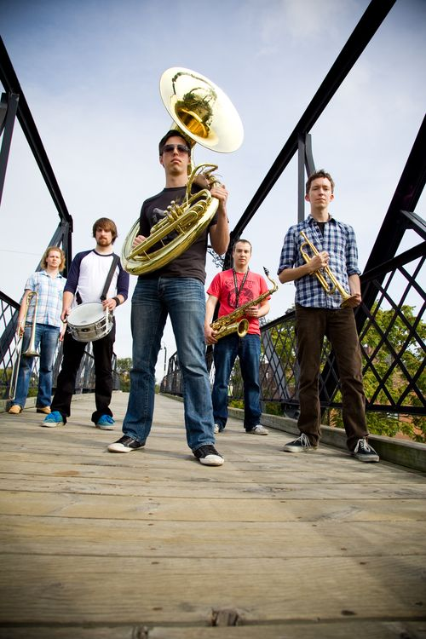
These young guys are so heavy we’ll be adding extra flotation to our floating stage. Their shows are equal parts jazz gig and dance show, from polka to Lady Gaga, so be prepared for a major party vibe out at Bone Lake. The beavers will be slapping their tails in time.
Trombonist Chris Butcher was inspired to form the Heavyweights after visiting New Orleans and experiencing brass band music firsthand, but the Heavyweights are unafraid to incorporate influences from pop hits of the day (Justin Bieber!?) to original compositions, and from R&B throwbacks to the infectious rhythms of Latin America. The band is rounded out with Jon Challoner (trumpet), Paul Metcalfe (saxophones), Rob Teehan (sousaphone) and Lowell Whitty (drums).
JAZZFM.91’s Jaymz Bee describes the Heavyweights as “destined for big things any minute now.” Despite their youth, the band’s members (which includes a JUNO-nominated composer) have already performed with the likes of Hilario Duran, Robi Botos, Don Thompson, Jane Bunnett and Rex Hotel Orchestra, and performed at jazz festivals in New Orleans, Montreal (opening for Herbie Hancock and Kool and the Gang), Italy and Switzerland.
2011 saw the release of the Heavyweights’ debut recording Don’t Bring Me Down, rated #3 Canadian jazz album of the year by Ejazznews.com and going to #1 on Earshot’s national campus and community radio jazz chart. The disc was placed in heavy rotation on JAZZFM.91 and CBC radio.
This spring they played Toronto’s prestigious Koerner Hall, with special guest Giovanni Hidalgo, virtuoso percussionist of Dizzy Gillespie’s United Nations Orchestra and Paul Simon’s sublime Rhythm of the Saints album.
This might be the first you’ve heard of The Heavyweights, but it won’t be the last, because these guys have a singular focus – putting the “fun” in funky.
Just ask the beavers.

Friday August 16th at 8 pm at the Historic Logging Museum
ONE FINE EVENING
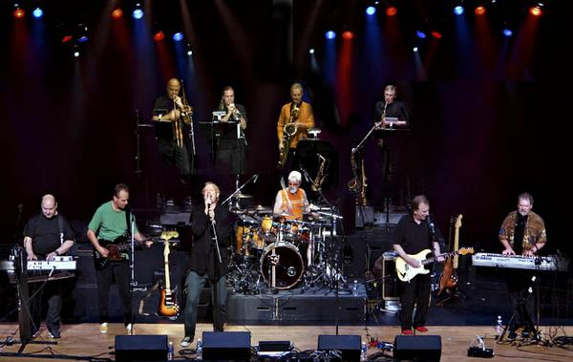
Lighthouse
www.lighthouserockson.com

And yet there's nothin' better for your soul,
Than lyin' in the sun and listenin' to rock 'n' roll.
Sunny Days, by Skip Prokop

Lighthouse was part of the soundtrack to the lives of a generation of Canadians, its freewheeling and high-spirited music a mirror of the times, so be here when they blow the doors off our historic Logging Museum. It’ll be cosmic.

Starting in 1971, Lighthouse won the first of three successive Juno Awards for Best Group of the Year. Album sales soared resulting in four gold albums and Canada's first platinum album - Lighthouse Live! The band could be seen on television, in newspapers and magazines, even on Coca Cola bottle caps.

The band was on a roll, releasing more than a dozen charting singles, including radio mainstays Sunny Days, Pretty Lady, Hats Off To the Stranger and One Fine Morning (chances are, as you're reading the titles of these classic Lighthouse hits, you’re singing them in your head and smiling). Each one is still heard daily on radio, television, and home sound systems after almost forty years of continuous play. And today they’re being re-recorded, by the likes of Shoba, rock legend Carlos Santana and Akon. The music, it seems, is indestructible…

Lighthouse’s current line-up has been together 21 years. It features the original founders, drummer Skip Prokop, Paul Hoffert on keyboards and guitarist Ralph Cole leading an all-star band that includes original members trombonist Russ Little and Steve Kennedy (saxophones and flute) with lead vocalist Dan Clancy, Don Paulton (keys), Doug Moore (bass), Simon Wallis (saxophones and flute) and Chris Howells (trumpet).

Last year we had to enlarge the audience area of the Logging Museum, because our festival was growing so quickly. For Lighthouse, we’ve had to enlarge the stage!

You’ll be so bummed out if you miss this…

And now the sun's about to fade away
I'm feelin' better than I've felt for days,
You know, there's nothin' better for your soul
Than lyin' in the sun and listenin' to rock 'n roll

Saturday August 17th at 2pm at the Historic Logging Museum
LUXURY MOTEL
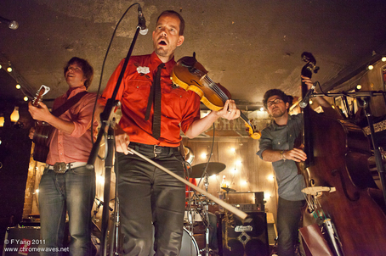
New Country Rehab
http://newcountryrehab.com
Q. What is “rehabbed” country music, exactly?
A: The band calls its modern, high-voltage, alt-country project an antidote to new country and a rehabilitation of old country.
Q: OK, what else?
A: Their press kit says that the band, “combines powerful originals with innovative reinventions of classic tunes from Hank Williams and Bruce Springsteen. Their unorthodox instrumentation, passionate delivery, and repertoire of songs—from yearning slower numbers to hard-driving barn burners—make for an exciting live act.”
Q: OK, what else?
A: Spearheaded by lead singer and fiddle player John Showman, joined by Champagne James Robertson on guitar, Ben Whiteley on double bass and Roman “Yard Sale” Tome on drums and backing vocals, the Toronto-based collective is growing audiences in Canada, the U.S. and Europe. Audiences are responding to New Country Rehab’s infectious love and enthusiasm for the music they are playing. One U.K. critic writes that, "They have the heart, soul and energy of a rock and roll band but the subtlety of country with poetic lyrics.” Another calls the band, “Canada’s answer to Mumford and Sons.”

Q: Hey, this is starting to sound good, but what does rehabbed country actually sound like?
A: Robertson says, “It’s an interesting combination of a bizarro percussionist/ drummer, and you combine that with upright bass, and my guitar is tuned kind of like a banjo, and then I put it through all these pedals and it sounds really weird, and then John plays fiddle like something that’s got broken in a really beautiful way, and then he sings like a bird.”
Q: Uh huh…
A: And Maverick magazine characterizes the band’s sound as”Successfully merging the old and new in a rambunctious way,” adding that, “their feet planted firmly on the ground; they have the right intentions and there is to be no stopping them.”
Q: OK, I’m in. And I’m staying to hear Natalie and Donnell at the lake. I hear that place is unbelievable.

Saturday August 17th at 8pm at Bone Lake Amphitheatre
CAPE BRETON GIRL and LAKEFIELD LAD
Natalie MacMaster, with Donnell Leahy
www.nataliemacmaster.com

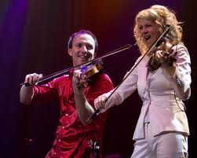
Have you been wondering when our little festival nestled deep in the Haliburton Highlands would get around to showcasing some authentic Highlands music, with toe-tapping jigs and reels and step-dancing? And have you been really, really hoping we’d get Natalie MacMaster?

We heard you. And as a super bonus, Natalie will be joined onstage by handsome hubby Donnell Leahy, a great fiddler and leader of Leahy (which also boasts 7 of Natalie’s sisters- and brothers-in-law, some of whom may cram onstage too).

Juno Award-winning fiddler Natalie MacMaster is, of course, a Cape Breton girl. She has established herself as an electrifying performer all over the world, thrilling Carnegie Hall audiences and Massey Hall crowds, captivating radio audiences on CBC and NPR’s A Prairie Home Companion, and warming TV viewers with guest spots on memorable Holiday specials.
Natalie has earned multiple Grammy nominations (and a win for her contribution to Yo-Yo Ma’s Songs Of Joy & Peace); a Best Instrumental Album Juno Award, eight Canadian Country Music Awards and 10 East Coast Music Awards. She has contributed to albums by The Chieftains, banjo prodigy Béla Fleck, Dobro specialist Jerry Douglas and former Doobie Brother Michael McDonald. Turning up on Natalie’s own projects are stellar names such as Grammy-winning fiddlers Alison Krauss and Mark O’Connor, bassist Edgar Meyer and many others.
But fame has not caused Natalie to forget her fans, family or roots. From a home base of Lakefield, Ontario, she and Donnell still champion the timeless Cape Breton traditions. “I like being on stage even more,” enthuses the mother of four. “When I appear onstage, that’s my departure from Momhood – and I transform into Natalie MacMaster: the entertainer, the fiddler, the performer.”
Whatever happens, everything will come out with an irrepressible Cape Breton groove. So don’t be surprised if you find yourself step-dancing around the kitchen next morning, because, as Natalie herself says: “Culture and tradition never go out of style!”

Sunday August 18th at 11:00 am at the Historic Logging Museum
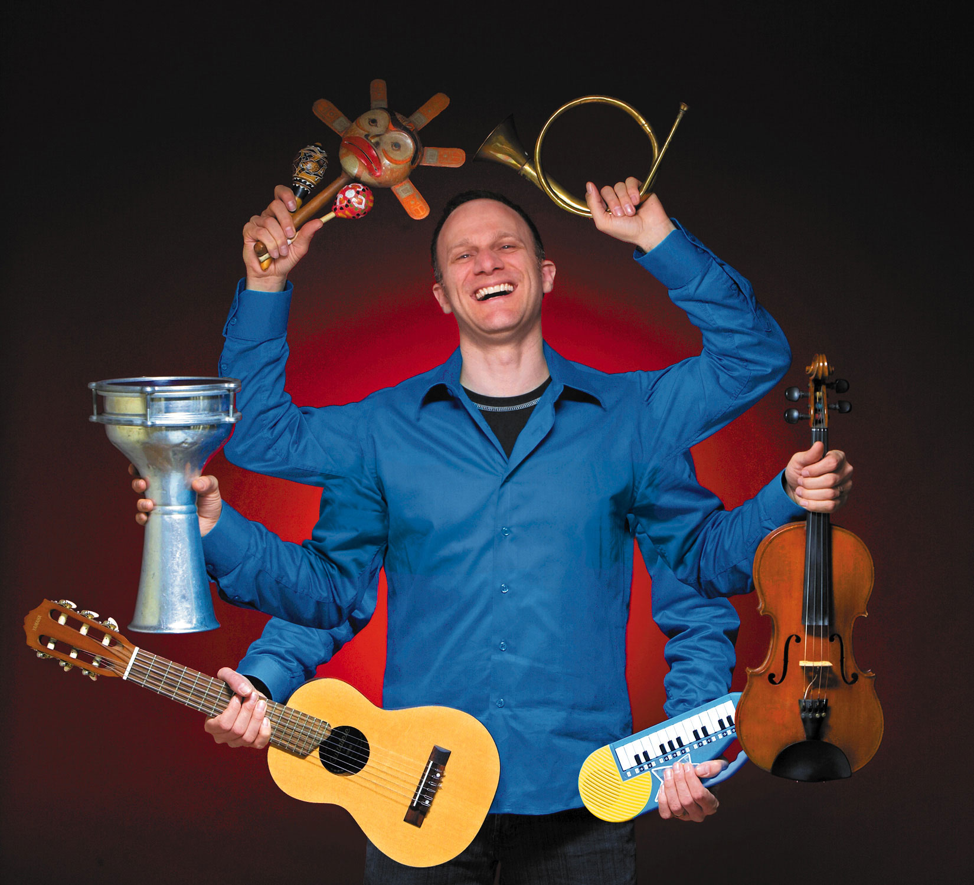
SCAT-IN-THE-HAT
Fiddlefire
www.fiddlefire.com

There’s a type of singing where you don’t use words,
When you first hear it, it seems absurd.
You just make sounds like “ooh” and “ahh,”
Doo-wop zee bop and zippidee-dah.
Scat-in-the-hat… Cool cat!

Fiery fiddler Chris McKool has been delighting audiences with his infectious songs and exotic world instruments for over ten years, reaching almost 1 million children in the process. He’s been featured on Mr. Dressup, YTV’s Treehouse, TVOntario’s Crawlspace and CBC television and radio, so why not bring the kids down for an inter-active Sunday morning treat? Come as you are but come prepared for fun.
Forest Festival fans who appreciate fabulous musicianship (isn’t that everybody?) fondly remember fiddler Chris, bassist Drew Birston and guitarist Kevin Laliberte’s performance here with the sensational world music group Sultans of String, and Drew and Kevin performed last year with Amanda Martinez’s killer band. Make no mistake – these are virtuoso musicians at the top of their game.
So come on down. The one-hour concert will be over before you know it, but your family will remember it for years. And you can all leave humming:
If you’ve got friends that play a little,
Piano, guitar, bass or fiddle,
They can join you too and you can have some fun.
Or you can scat alone and be a band of one.
Scat-in-the-hat… Cool cat!

Sunday August 18th at 2 pm at the Historic Logging Museum
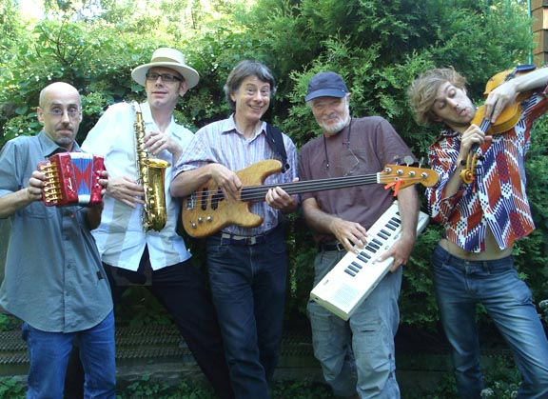
COFFEEHOUSE DAYS
David Woodhead’s Confabulation
www.davidwoodhead.com/confabulation

Confab’ul/ate, v.i.
1: engage in conversation: talk.
2: fabricate imaginary experiences...

If you just happened to be in your favourite coffee house when the creative musicians of this band started up a musical conversation, you might call the result a confabulation. And listening to their amalgam of folk, jazz and world music it might also occur to you that confabulation just happens to rhyme with sophistication, exhilaration, communication and electrification. And “standing ovation.”

Best known for his melodic style on the fretless electric bass, David Woodhead’s creative instrumental work has appeared on over 200 albums in the contemporary folk field, and he was worked with artists such as Perth County Conspiracy, Garnet and Stan Rogers, Don Ross, James Keelaghan, Oliver Schroer, Loreena McKennitt, Gil Scott-Heron and Valdy.

It was a natural move for David (who also plays a mean ukulele) to combine key players from the various worlds he inhabits, and record some of the most original “between the cracks” instrumental music to be heard in quite a while. Somewhere, Frank Zappa is smiling.

Confabulation also features guitar whiz Bob Cohen (Jesse Winchester, Alan Fraser), keyboardist Doug Wilde (Manteca, Nancy White), and drummer Rich Greenspoon (Njacko Backo, Stewed Tomatoes). And just like skilled baristas, these folks do their work right in front of you.
So bring an open mind and a thermos of coffee to our historic Logging Museum, which is a wonderfully warm and acoustically sound concert space as well as the repository of a great collection of artifacts associated with the early history of Haliburton Forest. And if you hang around for Murray McLaughlin’s evening show at Bone Lake you will have experienced two concerts in utterly different venues in one memorable day.
Confabulitious!
Sunday August 18th at 8 pm at the Bone Lake Amphitheatre

SWINGING ON A STAR
Murray McLauchlan
www.truenorthrecords.com

I went down to the Henry Moore
Skated all in the Square
Just the moon above my shoulders
And the ice was in my hair
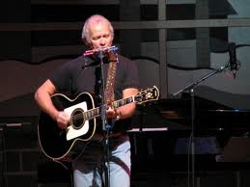
How many bush pilots have won 11 JUNO Awards? And how many have also been radio and television hosts, written books and musicals, become accomplished watercolour painters and been appointed to the Order of Canada?
Just one.
Murray McLauchlan clearly enjoys sharing his music and experiences with an audience. His passion for celebrating Canadian culture through art found an outlet with “Swinging on a Star,” his weekly CBC radio program. For five years, every Saturday over 750,000 listeners tuned in, making it the top rated music show in the country in the mid-80s. He’s a Canadian treasure, whose talent was recognized early on beyond our borders when artists such as Tom Rush, Kris Kristofferson and Waylon Jennings picked up on his songs. And how many times have Farmer’s Song and Down By the Henry Moore been performed?
McLauchlan’s passion for Canada and love of aviation were combined when he made a circumnavigation of the entire country, from Atlantic to Pacific to Arctic, in a Cessna 185 floatplane, followed by a film crew. The result was the special “Floating over Canada” starring Murray, Gordon Lightfoot, Buffy Ste. Marie, Levon Helm and Edith Butler.

Murray won’t be landing his floatplane on Bone Lake for his concert with us, but you certainly have our permission to imagine him doing so. We’re guessing he’d land at sunset, taxi up close, then jump right out onto our floating stage with his guitar, singing:

Don't you want to keep on moving
Don't you want to get undone
Don't you want a change from losing
Don't you want to have some fun?

