The Savoy Group Names Former U.S. Secretary of Energy Bill Richardson as Senior Chairman
BOCA RATON, April 11, 2013 - Bill Richardson, former Secretary of the U.S. Department of Energy and former Governor of New Mexico, was appointed as the Senior Chairman of The Savoy Group, bringing together a leading investment and advisory firm with one of the most recognized figures in both the Energy market and on Capitol Hill. Savoy seeks to create positive economic impact and long-term value for its investors and the companies it seeks to collaborate with and invest in as well as the governments it seeks to advise.
“We are delighted to welcome Governor Bill Richardson as the Senior Chairman of The Savoy Group,” said Michael Doran, Co-Founder and Chairman of The Savoy Group, in a statement. “The Savoy Group has achieved management’s objectives since its inception and is in the process of launching two investment funds: a Real Estate Fund and an Energy Fund.”
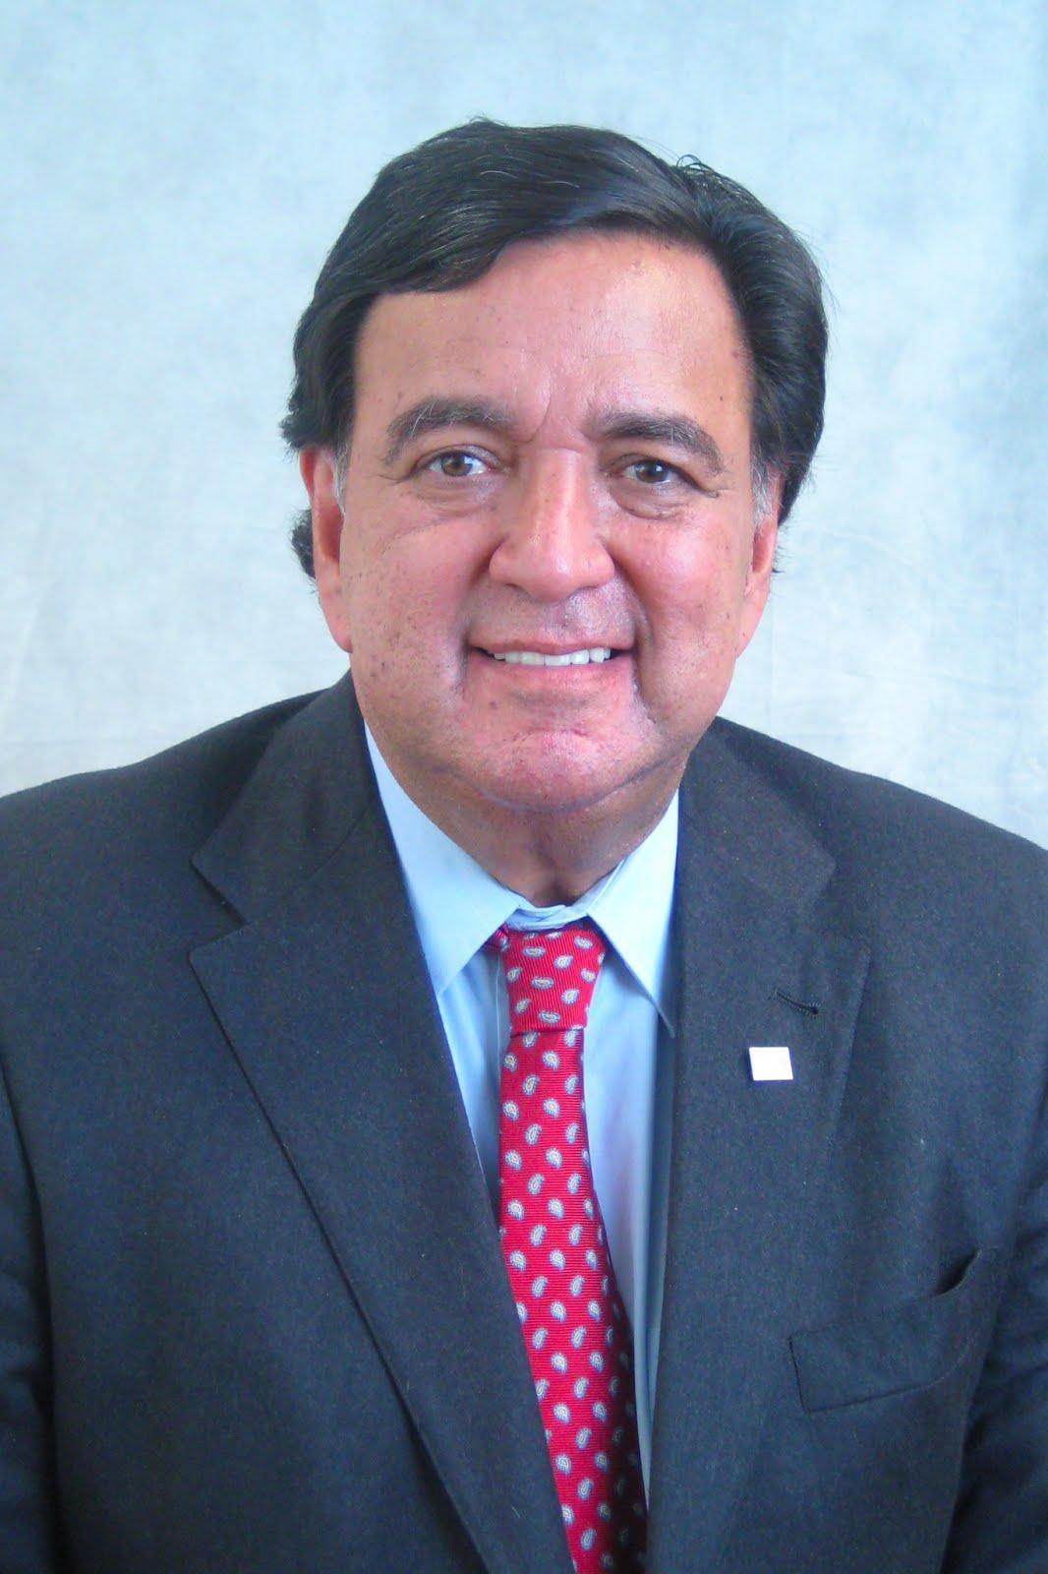

“Issues such as market liberalization, sustainability, and infrastructural changes pose challenging issues for all parties involved in the energy industry and their governments alike, and we are confident that the Governor’s vision, leadership, and experience will help bridge the issues between these parties to the benefit of our constituents.” During his career in public service, Richardson also served as an Ambassador to the United Nations and was nominated for the Nobel Peace Prize on several occasions. Richardson has also served on the Board of Directors for major energy companies in the past.

“I am pleased to join The Savoy Group and to serve as their Senior Chairman and Chairman of Savoy Energy Partners,” Richardson said in a statement. “I look forward to working with Savoy’s management’s collective decades of experience within the energy sector. Their team of energy analysts and associates provide unique and specialized insight into key investments in the energy sector to support the reliance on fossil fuels to meet our energy needs, coupled with the infrastructural changes required to move to a low carbon emission society. This likely means a long transition to dependence on renewables.”
The Savoy Group's proposed upstream energy investment portfolio assesses some of the macro issues, competitive landscape, and regional market outlooks that will shape the future of global upstream energy.
“The Savoy Group’s investment approach will be to partner with successful management teams and operators to identify oil and gas properties that can demonstrate attractive economics while managing risk and providing a managed economic transition to a balanced U.S. energy economy comprised of traditional fossil fuels and renewables.” said AJ Van De Voort, Co-Founder and Senior Managing Director Energy of The Savoy Group. “As the need for capital grows to fully develop North American energy production, we believe now more than ever that our strategy of identifying niches where we can bring the combination of disciplined financing with knowledge and sourcing advantages, as well as technical expertise, to capital-constrained opportunities gives us an enormous advantage.”

Headquartered in Boca Raton, FL, The Savoy Group ("Savoy") seeks to create positive economic impact and long-term value for its investors and the companies it seeks to collaborate with and invest in, the governments and the companies they plan to advise and the broader global economy. Savoy will do this through the commitment of their extraordinary people and flexible capital. Savoy’s alternative asset management businesses are expected to include the management of private equity funds, real estate funds, hedge fund solutions, credit-oriented funds and closed-end mutual funds. Savoy also plans to provide various financial advisory services, including financial and strategic advisory, restructuring and reorganization advisory and fund placement services. The company has offices in Boca Raton, FL; Toronto, Canada; Budapest, Bulgaria and Hong Kong.

The press release does not constitute an offer to sell or a solicitation of an offer to buy any securities in any future fund of Savoy.
This press release contains certain forward-looking statements within the meaning of Section 27A of the Securities Act of 1933 and Section 21E of the Securities Exchange Act of 1934, which reflect Savoy’s current views with respect to, among other things, Savoy’s operations and financial performance. You can identify these forward-looking statements by the use of words such as “outlook,” “believes,” “expects,” “potential,” “continues,” “may,” “will,” “should,” “seeks,” “approximately,” “predicts,” “intends,” “plans,” “estimates,” “anticipates”, “proposes” or the negative version of these words or other comparable words. Such forward-looking statements are subject to various risks and uncertainties. Accordingly, there are or will be important factors that could cause actual outcomes or results to differ materially from those indicated in these statements. Savoy undertakes no obligation to publicly update or review any forward-looking statement, whether as a result of new information, future developments or otherwise.
Contact:

Public Affairs
The Savoy Group
One Boca Place
2255 Glades Road
Suite 324A
Boca Raton, Florida 33431
Main: +1 561.962.0063
Toll Free: +1 855 SAVOYGR
Email: info@savoygrouplp.com
Web Site: www.savoygrouplp.com
Facebook Page: www.facebook.com/savoygrouplp

_____________________________________________________________________________

