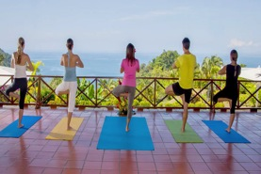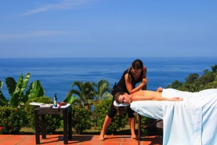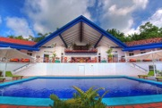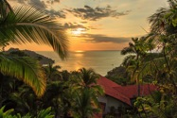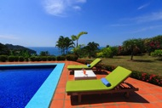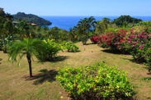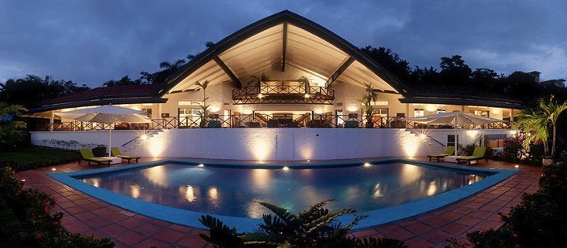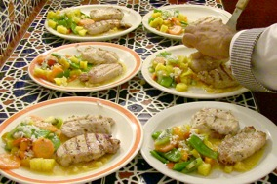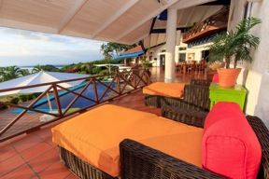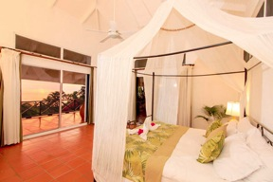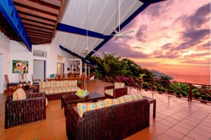

## 4 Bedroom - $4900 - $6400 / week

## 6 Bedroom - $5900 - $7400 / week

## 8 Bedroom - $6400 - $7900 / week

## Holidays – (Inquire…)

Yoga Classes & Retreats

Spa Services On-Site

# **Features:**

* **8 Bedrooms**
* **7.5 Baths**
* **Sleeps up to 24**
* **10,500 square feet**
* **5-Acre Private Estate**
* **30-foot x 40-foot pool**
* **Chef Included**
* **Daily Housekeeping**
* **Concierge**
* **Night Security**
* **Ideal for Weddings & Events**
* **Sunset Ocean Views**
* **Good times!**

VP Private Resort

Manuel Antonio, Costa Rica

# **Pricing:**

Who wants to cook and clean for the whole group when you’re on vacation? VP comes with a private chef, who is ready to cook up all of your favorite dishes, as well as introduce you to some new ones. Perhaps some Costa Rican ‘patacones’? Or banana-leaf mahi-mahi? How about some fresh mango for dessert, taken from the gardens outside?

Within the Main Villa are 4 spacious master bedrooms, each with a large, private bath, terrace and ocean-views. Each is vivaciously decorated in the style of a Mexican hacienda, and with creative names: the Grand Master Suite, the Ocean Master Suite, the Tropic Master Suite, and the Mango Master Suite.

With 5 acres and 10,500 square feet—there is plenty of space at VP. The open, covered terraces and living areas alone constitute over 4000 square feet! The Outdoor Living Area in the Main Villa is the ideal place to host an event, and can seat up to 80 comfortably. Garden paths lead into the rainforest, and around the gardens, lined with mango trees, cacao, starfruit, and other tropicals.

# Privacy and Space:

# Chef Included:

# The Experience

When you stay at VP Private Resort, you get an experience more than a vacation. We’ll take all of your troubles and responsibilities away, so you can fully experience all of the wonders and beauties of Manuel Antonio, Costa Rica. Whether you or looking for a family getaway, an idyllic wedding venue, a yoga retreat, or simply a fantastic place to spend your stay in Costa Rica, the VP Private Resort staff is here to give you the best experience possible!

# 4 Master Bedrooms: