The Parsley Patch eEvolution . . .

`````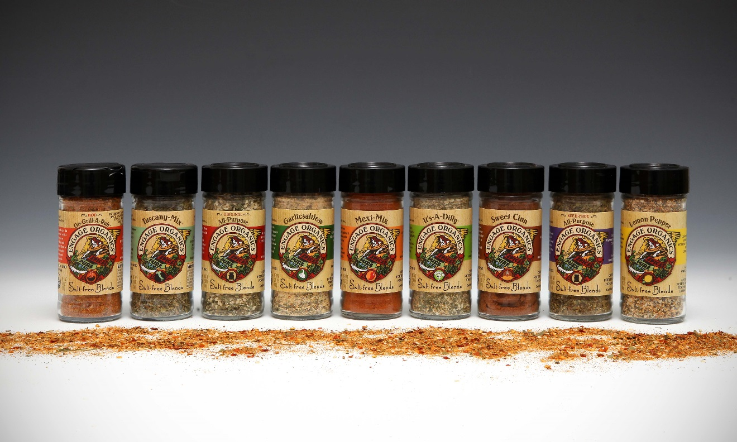

Remember Parsley Patch, the little salt-free seasoning company with panache that burst into the salt-free market in 1980 on the wings of an angel?
It’s back. But this time, it’s in an eEvolution called Engage Organics.
Fans begged over the years to bring back the salt-free blends that had become a secret ingredient in favorite recipes, lamenting they couldn’t cook without them.
For those who are unfamiliar with the original Parsley Patch Salt Free Seasonings, let me fill in the blanks for how the popularity of these blends remained strong over 30+ years.
As co-founders of Parsley Patch in 1980, my partner, Elizabeth Bertani, and I created a line of seasonings in our kitchens. At the time we were both mothers and students at a local Northern California state university.
Despite the fact we had no previous business experience, we had a dream of bringing our line of seasonings to other women, who were also balancing the growing demands for how to cook healthier foods in less time.
However, getting our blends from our kitchens into the kitchens of other women was a puzzle. How could we begin to manufacture and distribute our seasonings, let alone finance our vision?
I still remember the day the light bulb went off. “Let’s get student loans and use it for seed money,” I said as my eye caught the word “Financial,” dangling outside the Financial Aid office at Cal State Sonoma. That was the beginning of a life-altering journey for both of us.
Like most new start-ups, our new business partnership was fraught with funding challenges from the beginning. However, call it synchronicity or luck; we were blessed with people, who believed in our product and became valuable mentors in guiding the direction and focus of the company.
In hindsight, it’s clear how influential Chris Blum’s vision and atypical logo and package design was to the initial acceptance of the product at its debut in 1981, at the San Francisco Fancy Food & Confection trade show. (Blum is famous for the Walking Levi’s Commericals now in the Smithsonian) Blum’s creation of a 4-color, die-cut label of an angel harvesting herbs on a cork-topped jar, was unlike any other food product at the time.
This little company had panache and got noticed by Chapman Tait Brokerage, one of the largest Specialty Foods & Confection brokerage firms in the western states. Subsequently, Chapman Tait became the firm who would market the Parsley Patch brand to the public from the first trade show on.
From his first encounter with Parsley Patch seasonings, Jon Gage, co-owner of Chapman Tait, recognized the trend-setting elements in this little startup as a potential innovator in the salt-free market.
So, Gage pushed for a package redesign of the decorative cork jars into standard 4oz. glass spice containers, with a focus on “salt-free,” to make Parsley Patch more competitive on grocery store shelves.
However, Gage was unaware I had recently mortgaged my house to finance the first label design. The idea of redoing the labels was unrealistic. I didn’t want to hear reasons why we needed to “redo” what we had just “done.” Rather, I simply wanted to see sales results on what we had.
Undeterred, and despite our gourmet packaging, Gage placed Parsley Patch into key stores in southern California. He further directed the marketing efforts to embrace a “salt-free” niche, by applying “salt-free” stickers to the label. As a result of these minor tweaks, Parsley Patch began to attract loyal following, willing to pay for a decorative jar, in the growing salt-free market, at a time when salt was being demonized.
After only 3 years of building Parsley Patch’s market share, Parsley Patch was approached by Lawry’s Seasonings with a buy-out offer. At this juncture, the business partnership with Bertani became strained over the decision to sell or not sell the business. Bertani had grown weary of the financial worries and strain of balancing long work hours with family responsibilities. She wanted to sell. I did not. (I did not want someone else to finish what I started.)
Consequently, raising funds to buy-out a partner, rather than using the capital to build the business, put the fledgling start-up at peril. Few people were interested in investing in a company yet to make a profit.
However, because Jon Gage had developed a strong commitment to Parsley Patch and had been integral to the growth of the company via his marketing efforts, Gage made an offer to buy Bertani’s share in the company.
So, instead of selling to Lawry’s, Gage bought Bertani’s half of the business, (equivalent to what she would have received from Lawry’s), despite warnings from his accountant that he should “run” in the opposite direction. The company was yet to make money. (This was well before the dot com buyouts changed all the buyout rules.)
Faced with a steep uphill battle in 1984, our newly formed partnership added 4 blends, bringing our total to 11 salt-free seasonings. It was at this juncture we added Garlicsaltless, (the recipe which came in a dream and never had to be changed).
Remarkably, Garlicsaltless finally turned the company financials from red to black. We celebrated our victory by blending our business and family life with our marriage at the end of 1984. It had been a very good year.
The next 4 ½ years were busy, building the brand with the help of our children, who became entrepreneurs-in-training, by filling sample bags, manning trade shows, and making deliveries. Our synergistic efforts allowed our little company to capture Gage’s vision of a significant market share in the salt-free category.
It was long before the demand for these high-quality, healthful blends became the go-to secret of famous chefs and everyday cooks alike.
As a result, the cult following in natural and gourmet foods spread the demand to supermarkets, where Parsley Patch garnered shelf space next to big players like McCormick, Lawry’s, Schillings, and Mrs. Dash, who had paid high slotting allowance dividends for the supermarket shelf space.
As Parsley Patch encroached upon the expensive supermarket real estate, without paying for slotting allowances for the shelf-space, larger companies took notice. At that point in 1987, McCormick approached Parsley Patch with yet another buy-out offer.
Despite my initial opposition to the idea of selling Parsley Patch, the belief that the company would have a stronger chance of becoming a household name with McCormick’s muscle inched me onto the precipice (shall I? shall I not? Let someone else finish what I started?). That question haunted me, as the reality of having to pay for shelf-space in the supermarkets hit home and raised doubts about our ability to compete on the shelf.
So, with grave reservations, Jon and I moved to the negotiation table with McCormick, with one caveat: McCormick commit to funding our Parsley Patch Charitable Foundation from a portion of Parsley Patch sales. The charitable foundation was a cornerstone of our business and a mission we were committed to. Our desire to continue this commitment to fund our charitable donations was a bargaining chip that delayed the negotiation for months.
In 1987 the idea of including charitable-funding language into a long term contract was not popular. McCormick negotiators were concerned about negative feedback from stock holders who would balk at an ongoing charitable commitment.
Despite the stockholder doubts, the details were finally resolved. McCormick committed to donating a percentage of the sale of each jar to our foundation. We sealed the deal with McCormick in December 1987 and continued to run the operation until June of 1988.
However, during the transition period with McCormick, the precipice creaked again. (Shall I? Shall I not? Let someone else finish what I started?)
Ironically, my mother faced bypass surgery for her heart disease. And during her hospital discharge briefing, she was required to watch a video about how to create a healthier lifestyle. I sat horrified, watching an American Heart Association ad, which we had initiated in a promotional campaign with the Heart Association years earlier, recommending Parsley Patch Salt Free Seasonings as a healthy alternative for heart disease patients. My heart cried.
Parsley Patch was no longer mine. Now it was too late for precipices.
Now fast forward to 2012—to a new time—after starting and selling 3 businesses in between—to new opportunities for ecommerce in the Information Age Economy. Yes, the time has come to jump from the precipice (Shall I? Shall I not? Let someone else finish what I started?) once and for all. To make a final decision.
FINALLY, after watching the death of each cherished blend from the McCormick line, despite the fact our valued Parsley Patch Manager, Phyllis Usina, had stayed on with McCormick for six long years to shepherd the brand, Jon and I made the decision to reincarnate the abandoned seasonings and recreate them into an online, ORGANIC eEvolution version of Parsley Patch. The new company is called Engage Organics.
As a result, our commitment to finish what we started couldn’t be stronger. The need for high-quality, organic salt-free spice blends have never been as important. Americans are facing serious, health issues exacerbated by unhealthy food choices.
Fortunately, healthier, organic alternatives that were not available to include in our blends in the 1980’s are now in high demand, as “organic” has gone mainstream.
Our organic eEvolution from Parsley Patch to Engage Organics wouldn’t be complete without another revision of our angel logo. Now our angel is swinging her cycle on the McFadden Farm in Potter Valley, California, where we produce 100% organic blends.
As a result of the name change, we hired Michael Fitzpatrick (the artist who transformed the original Parsley Patch label to fit a standard spice jar) to create the logo redesign. Fitzpatrick is now a much sought-after artist in the Napa Valley, michaelfitzpatrickpainter.com
Now that you know the story of this little company with panache, I’d like to share one last snippet that makes the corners of my mouth turn up, thinking about the irony.
In January 2012, I placed an ecommerce order for Parsley Patch Garlicsaltless with Amazon.com (Yes, I was still able to purchase Parsley Patch after 23 years). Much to my chagrin, the Garlic & Herb blend (which was changed from the name Garlicsaltless), arrived in a Lawry’s bottle. I called Amazon, asking what happened to my order. The representative laughed, telling me everyone was calling to complain. They wanted Parsley Patch, NOT Lawry’s.
Ironically, the precipice I’d been standing on for 29 years, which began with the Lawry’s buyout offer in 1983, rumbled again (Shall I? Shall I Not? Let someone else finish what I started?)
The Garlicsaltless Blend had finally DIED, under a Lawry’s label!
The death of our beloved blend, Garlicsaltless, awakened an obligation in me to give it life again. (Yes, to finally finish what I started)
But with this rebirth, our son, Jason Sherwood, who filled the Parsley Patch sample bags as a young boy and is a fabulous cook in his own right, became excited about the prospect of bringing back some of his favorite seasonings.
Jason is now intricately involved in the startup phase of Engage Organics. His mission is to help finish what was started in 1980 and to carry-on the tradition for his generation and his children’s generation; so they, too, can enjoy the healthful blends in an organic rendition of Parsley Patch.
We hope you enjoy this new Engage Organics version of our blends as much as we do. May it bring the wealth of organic health and balance to your life. Our wish is that every time you use the blends you are reminded to NEVER GIVE UP and follow your life’s purpose with determination and perseverance.
It’s never too late to keep promises to yourself!

