

**HEARING*Life®*  PARTNERS WITH DR. ALEXIS ABRAMSON, A LEADING GERONTOLOGIST**

**HEARING*Life* Strives to Fully Understand the Holistic Needs of the Mature Adult**

[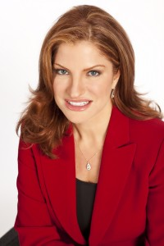](http://www.alexisabramson.com/wp-content/uploads/2012/07/Abramson-2.jpg)

Alexis Abramson, Ph.D.

[HEARING*Life*](http://www.hearinglife.com) is committed to providing high quality, patient-centric hearing health care. “Our goal is to be the #1 organization people think about when they need to make a choice about their hearing health”, said Amir Hadar, CEO and President. “We want to be known as an organization that has taken the necessary time and fully invested in the resources required to understand the needs of the mature adult.”

To uphold these standards, HEARING*Life* has partnered with a nationally known gerontologist, [Dr. Alexis Abramson](http://www.alexisabramson.com/). Doctor Alexis™ is a researcher, internationally recognized speaker and Emmy award winning journalist who has authored four highly acclaimed books. She regularly contributes content about mature adults, baby boomers, and caregivers in magazines and blogs such as *Forbes*, *Time*, *Wall Street Journal*, *Huffington Post*, and *ShareCare.*

HEARING*Life*’s plan is to be as “50+ friendly” as possible in order to accommodate the growing demands of the mature adult. “I am extremely excited to partner with HEARING*Life* to provide them with expert guidance as they achieve their goal of becoming #1 in their business,” said Dr. Abramson.

**About HEARING*Life***

HEARING*Life* is a patient-centered, professional hearing instrument and care provider with clinics in Florida, Arkansas, Alabama, Colorado, Michigan, Oklahoma, Idaho, Utah, and Montana. The HEARING*Life* website is [www.hearinglife.com](http://www.hearinglife.com).