 **MODEL A1-XL**

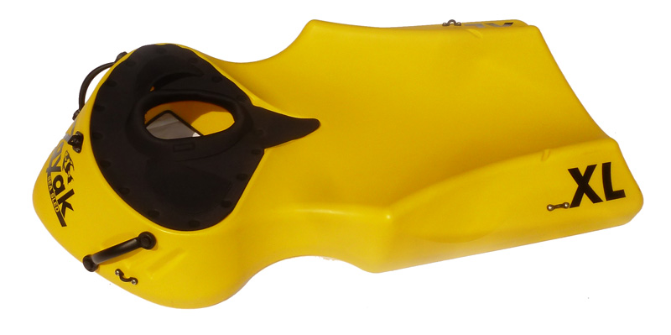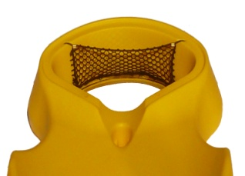

**CONSUMER MODEL**

FEATURES:

*Sturdy and Stable Molded Platform

*Ventilated Neoprene ‘Dry’ Mask

*Cargo Net for Personal Items (See above)

*Clear Panoramic Window on Bottom

*Carry Handles Molded Into Bottom

*Five Eyelets for Securing Accessories

*Recommended Capacity: 220 Lbs. / 100 Kg

Retail $325.00, plus freight

Packed nested, two per carton

TROPICAL PARADISE PLASTICS, LLC

SARASOTA, FL 34241

<http://www.zayakseasled.com>

[info@zayakseasled.com](mailto:info@zayakseasled.com)

Thomas Mulvihill, 941-441-8627 direct

U.S. and International Patents Pending

(SEE OTHER SIDE FOR RESORT RENTAL MODEL)