"Dear Dennis,
I would like to commend you and your staff for the customization you performed on my 65 Hatteras SF FINALE. The yacht looks and runs like a brand new boat from the factory. I never imagined my 65 to ever look like this. Every little item that you all worked on was completed not only in a timely fashion but came out as close to perfect as one could ever imagine! I could not find a single issue with any of the work completed. The interior work, especially the High Gloss Cherry finish, appears as if the wood was a mirror.
I was completely blown away with the look and overall attention to detail your staff paid to this Yacht, they are true professionals. The Electronics you recommended and the layout on the bridge was terrific. The training your staff provided and the installation of all the equipment was again unreal!
What really made the Yacht a masterpiece was the exterior paint finish, the Yacht Paint Shines, Day and Night. I maybe the most anal Boat owner you will ever meet. I am crazy about the Boat staying clean and looking brand new. What you did with the Paint and non-Skid is the cleanest job I have ever seen. Working with Foster's Marine Group was the best find for my 65 Hatteras FINALE and my family.
You have always been very fair and kept me in the loop about even the smallest change order! I only can say one thing to you; that is THANK YOU ALL SO MUCH! You made my Boat, a dream come true! From me and my Family, We Thank You All! I am forever indebted to you!
Sincerely,"
Gil Romano & Family
D.M.G.T. TELECOMMUNICATIONS, INC.
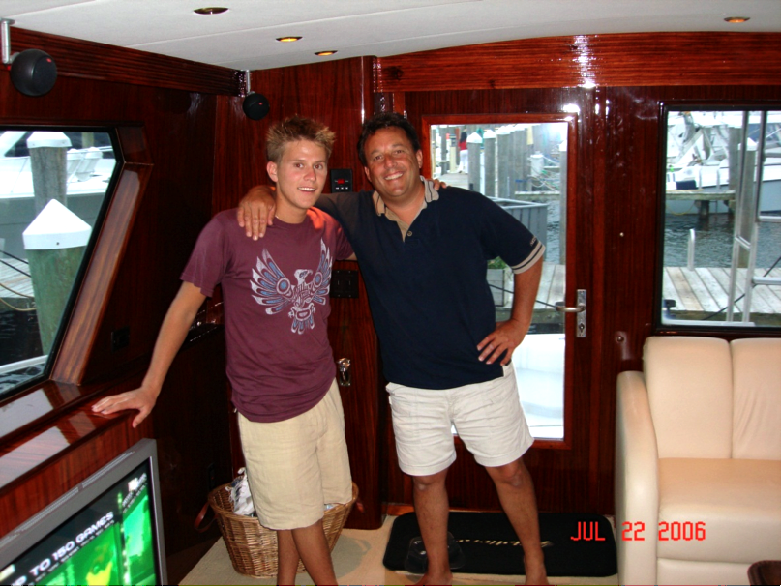
Finale

