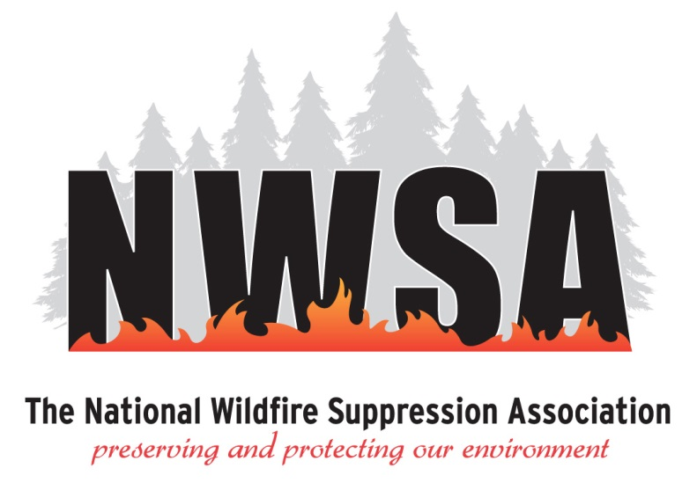
The National Wildfire Suppression Association (NWSA) represents over 250 private wildland fire services companies who operate on an as needed basis to provide federal/state/local agencies with a variety of resources for wildland firefighting and emergency response to national disasters.

NWSA provides training certification for wildland firefighters, and support to help its member companies field highly trained, safety-focused resources’ that meet or exceed the agency standards.
When lives are on the line the agencies must have confidence in any resources that are part of the fire community. Since 1991, the mission of NWSA is to ensure that its members earn that confidence.
NWSA advocacy includes working as a cooperator in wildland fire services to build positive relationships with agency personnel and to advocate for programs like Best Value Contracting that provide the agencies with cost effective, professional resources.
You can learn more about us by contact our Executive Director, Deborah Miley at 1-877-676-6972 or emailing us at info@nwsa.us
You can also visit our website at www.nwsa.us

