MEDIA CONTACTS
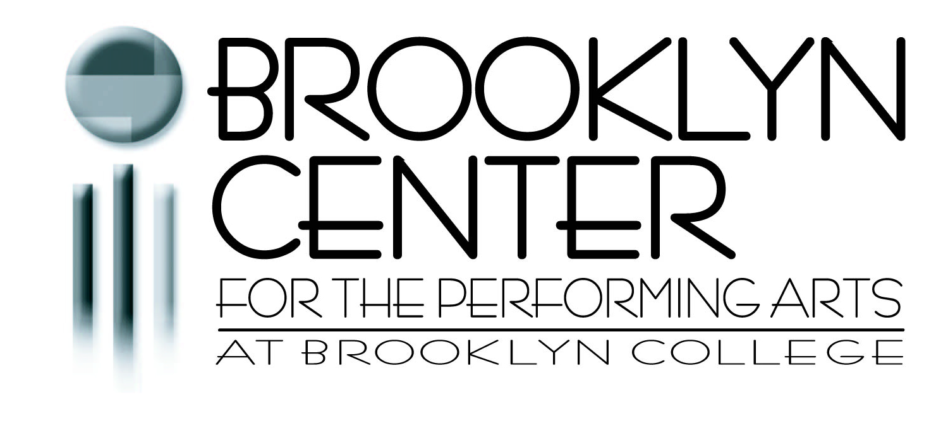
Michelle Brandon Tabnick, Publicist, 646-765-4773
Rick Berubé, Director of Marketing and Communications, 718-951-4600 x3331

FOR IMMEDIATE RELEASE
July 8, 2013

Brooklyn Center for the Performing Arts
announces its 2013-2014 Season

Tickets now on sale for Savion Glover, Cirque Ziva,
The Russian National Ballet Theatre, and more!

Brooklyn Center for the Performing Arts at Brooklyn College announces its 59th season of music, dance, theater, and family programming reflecting the multicultural diversity of Brooklyn. The outstanding line-up features performances from Jamaica, Russia, Canada, and China, as well as the United States, and includes both Brooklyn premieres and returning favorites.

“The 2013-2014 season at Brooklyn Center will take audiences from jazz to tap, comedy to drama, and musical theatre to family shows, with healthy doses of adventure and familiarity along the way,” says Jon Yanofsky, the new Director of Brooklyn Center. “The dazzling array of performances will bring the Walt Whitman stage alive with great entertainment and inspiring arts and culture.”

Brooklyn Center for the Performing Arts’ 2013-2014 Season includes:
- Savion Glover’s STePz
- ArtsPower National Touring Theatre’s The Little Engine That Could™ Earns Her Whistle
- Steve Solomon in My Mother’s Italian, My Father’s Jewish & I’m Home for the Holidays
- Dance Theatre in Westchester’s The Colonial Nutcracker
- An R&B Christmas featuring The Coasters, Charlie Thomas’ Drifters, Blue Magic, and Shirley Alston Reeves
- СНЕГУРОЧКА (The Snow Maiden)
- Alexander and the Terrible, Horrible, No Good, Very Bad Day
- Nai-Ni Chen Dance Company
- Krasnoyarsk National Dance Company of Siberia
- The Beauty of Ballet (co-presented with the School of American Ballet)
- The Golden Dragon Acrobats in Cirque Ziva
- A Brown Bear, a Moon, and a Caterpillar: Treasured Stories by Eric Carle
- Russian National Ballet Theatre’s The Sleeping Beauty
- Jamaican jazz artist Monty Alexander in concert
- Sid the Science Kid – Live!
- Seventh Annual National Grid Earth Day Celebration
- The Smithsonian Jazz Masterworks Orchestra presents A Tribute to Ella Fitzgerald
- American Family Theater’s The Wizard of Oz

Savion Glover’s STePz
Saturday, November 2, 2013 at 8pm
From his Broadway debut at age 12 to his 1996 Tony Award for Best Choreography, Savion Glover has single-handedly revitalized and redefined the art of tap dancing. In his latest production, STePz, this international superstar and his ensemble of dancers (TLHS) fuses traditional music selections of the past with Glover’s self-proclaimed tap style and energy of the future. Experience the infinite versatility and virtuosity of Savion Glover’s genius as Brooklyn Center opens its 59th season.
Tickets: $45 orchestra, $36 mezzanine

ArtsPower National Touring Theater’s
The Little Engine That Could™ Earns Her Whistle
Sunday, November 17, 2013 at 2pm
Little Blue Engine dreams of someday leaving the train yard to pull the big cars on the main line track. But can she convince Big Silver that she is worthy of being a main line engine? ArtsPower’s dynamic, song-filled adventure portrays Watty Piper’s timeless tale about hard work, determination, and the meaning of true friendship. A Target Storybook Series presentation for ages four and up.
Tickets: $7

Steve Solomon in
My Mother’s Italian, My Father’s Jewish & I’m Home for the Holidays
Sunday, November 24, 2013 at 3pm
Peace on Earth? Joy to the World? Not with this dysfunctional family! In the sequel to his Off-Broadway hit comedy My Mother’s Italian, My Father’s Jewish & I’m in Therapy!, master comedian Steve Solomon returns to Brooklyn to regale us with stories of Christmases and Hanukkahs past, complete with bickering parents, motherly guilt trips, and teenage daughter drama. Honest and hilarious, this one man tour-de-force yields an afternoon full of side-splitting laughter!
Tickets: $30

The Colonial Nutcracker
Sunday, December 15, 2013 at 2pm
An annual holiday favorite, Dance Theatre in Westchester performs its family-friendly, full-length version of Tchaikovsky’s ballet set in wintry colonial Yorktown, complete with a red-coated mouse army, an enchanted nutcracker prince, and simultaneous narration to help young audience members enjoy this timeless classic. Recommended for ages four and up.
Tickets: $10

An R&B Christmas
Saturday, December 21, 2013 at 8pm
Celebrate the holidays with this concert of chart-topping R&B artists as they perform their biggest hits, as well as some Christmas favorites! You’ll enjoy the tight harmonies and smooth vocals of Charlie Thomas’ Drifters (“Under the Boardwalk,” “Up on the Roof”), The Coasters (“Yakety Yak,” “Poison Ivy”), Blue Magic featuring original lead singer Ted “Wizard” Mills (“Side Show”), and Shirley Alston Reeves, original lead singer of The Shirelles (“Will You Still Love Me Tomorrow”).
Tickets: $45 orchestra, $36 mezzanine

-- more --
СНЕГУРОЧКА (The Snow Maiden)
Presented in association with Anton Krylov
Sunday, December 22, 2013 at 4pm
Enjoy this magical Christmas musical in which a worthy young girl is transformed by Grandfather Frost (the Russian Santa Claus) into the beautiful Snow Maiden. Traditional Russian songs, dances and elaborate costumes create a winter wonderland in this delightful children’s extravaganza. Performed in Russian with English subtitles. Recommended for ages six and up.
Tickets: $35-$50

Alexander and the Terrible, Horrible, No Good, Very Bad Day
Sunday, January 12, 2014 at 2pm
Have you ever had a really rotten day? Alexander has. There’s no dessert for lunch, there’s lima beans for dinner, and worst of all, there’s kissing on television. It’s enough to make you want to move to Australia! Laugh and sing along with Alexander’s misadventures in this hilarious musical, featuring book and lyrics by best-selling author Judith Viorst. A Target Storybook Series presentation for ages four and up.
Tickets: $7

Nai-Ni Chen Dance Company’s
Lunar New Year Celebration
Sunday, January 26, 2014 at 3pm
Celebrate the Year of the Horse with this colorful performance that weaves the grace and splendor of traditional Chinese arts with the contemporary freedom of American modern dance. Recipient of China’s prestigious Golden Lotus Award, choreographer Nai-Ni Chen and her company will take you on a visually delightful, culturally rich tour of this dynamic 3,000-year-old civilization.
Tickets: $30

Krasnoyarsk National Dance Company of Siberia
Saturday, February 1, 2014 at 8pm
Like a Russian fairy tale come to life, this company of 55 dancers and musicians incorporates colorful folkloric costumes, thrilling choreography, and an orchestra of national folk instruments as it celebrates the rich cultural heritage of its native Siberia.
Tickets: $45 orchestra, $36 mezzanine

In collaboration with the School of American Ballet
The Beauty of Ballet
Saturday, March 8, 2014 at 2pm
Join students and faculty of the world-famous School of American Ballet (the official academy of New York City Ballet) in this program illustrating the process by which talented youngsters develop into accomplished classical ballet dancers. Your children will watch a “class” where training exercises and steps are demonstrated, and also enjoy excerpts from famous ballets. A free event recommended for ages four and up. General admission, no tickets issued.

Cirque Ziva
Sunday, March 9, 2014 at 3pm
Performed by the internationally-celebrated Golden Dragon Acrobats, this fast-paced, technically-innovative performance showcases traditional Chinese acrobatics, dance and costumes, ancient and contemporary music and modern theatrical techniques. The renowned acrobats dazzle with amazing feats of athleticism, daring heart-stopping stunts and the grace of their centuries old art form.
Tickets: $35
-- more --

Mermaid Theatre of Nova Scotia’s

A Brown Bear, a Moon, and a Caterpillar: Treasured Stories by Eric Carle
Sunday, March 16, 2014 at 2pm
The Little Caterpillar with the big appetite returns to Brooklyn! Featuring evocative music, stunning visual effects and innovative puppetry, this triple-bill brings to life three of Eric Carle’s most beloved tales: The Very Hungry Caterpillar; Brown Bear, Brown Bear, What Do You See?; and Papa, Please Get the Moon For Me. A Target Storybook Series presentation for ages four and up.
Tickets: $7

Russian National Ballet Theatre’s
The Sleeping Beauty
Sunday, March 23, 2014 at 3pm
With its fairy tale story and sumptuous score by Tchaikovsky, The Sleeping Beauty is undoubtedly one of the most popular full-length ballets of all time. Under the artistic direction of legendary Bolshoi principal dancer Elena Radchenko, this internationally-acclaimed company recreates Petipa’s masterful choreography in a lavish production.
Tickets: $45 orchestra, $36 mezzanine

Monty Alexander in concert
Saturday, March 29, 2014 at 8pm
From Sinatra to Ska, Jamaican jazz virtuoso Monty Alexander has played it all. Equally at home with classic American jazz and with the infectious rhythms of the West Indies, his trio blends the two to create a singular style unlike any other. With a career that spans five decades and more than 70 albums, this Grammy-nominated pianist brings his swinging interpretations of the classics to the Walt Whitman stage.
Tickets: $40 orchestra, $30 mezzanine

Sid the Science Kid – Live!
Sunday, April 6, 2014 at 2pm
In this new musical adventure based on the popular PBS Kids series, Sid and his friends set off on a day of scientific exploration, asking curious questions and discovering why things work the way they do. Full of audience participation, great music, and content based in national science learning standards, Sid the Science Kid – Live! will have your kids laughing and learning at the same time! A Target Storybook Series presentation for ages four and up.
Tickets: $10

Seventh Annual National Grid Earth Day Celebration
Sunday, April 6, 2014 at 3pm
Children and adults alike will enjoy live music, arts and crafts, and street performers at this free community festival, where interactive family activities highlight the need for creating a more sustainable future and caring for the earth.
General admission, no tickets issued.

-- more --

The Smithsonian Jazz Masterworks Orchestra presents

A Tribute to Ella Fitzgerald
Sunday, April 27, 2014 at 3pm
Dubbed “The First Lady of Song,” Ella Fitzgerald was the most popular female jazz singer in America for more than half a century. This special tribute concert, performed by the 17-member Smithsonian Jazz Masterworks Orchestra featuring vocalist Kim Nazarian, will include original arrangements pulled from the Smithsonian and Ella Fitzgerald Charitable Foundation archives, many of which haven’t been heard by live audiences for over 40 years.
Tickets: $35

The Wizard of Oz
Sunday, May 18, 2014 at 2pm
American Family Theater, one of the nation’s leading producers of musicals for young audiences, presents everyone’s perennial favorite story about Dorothy’s adventures over the rainbow as she follows the yellow brick road with the Scarecrow, the Tin Man and the Cowardly Lion towards the Emerald City and the mysterious Wizard who can help her get home. A Target Storybook Series presentation for ages four and up.
Tickets: $7

Multibuy (three or four shows) and Megabuy packages (five or more shows) save up to 15% off individual ticket prices (not applicable to The Colonial Nutcracker, The Snow Maiden, Sid the Science Kid – Live!, or Target Storybook Series shows). Discounts available for seniors, students, Brooklyn College faculty/staff/alumni, and groups. $10 student rush tickets available day-of-show.

About Brooklyn Center for the Performing Arts at Brooklyn College
Founded in 1954, Brooklyn Center for the Performing Arts at Brooklyn College presents outstanding performing arts and arts education programs, reflective of Brooklyn’s diverse communities, at affordable prices. Each season, Brooklyn Center welcomes over 65,000 people to the 2,400 seat Walt Whitman Theatre, including up to 45,000 schoolchildren from over 300 schools who attend their SchoolTime series, one of the largest arts-in-education programs in the borough. In 2014-2015, Brooklyn Center will celebrate its 60th anniversary season, which will correspond with the opening of the new Leonard and Claire Tow Center for the Performing Arts at Brooklyn College.

Brooklyn Center for the Performing Arts
Walt Whitman Theatre at Brooklyn College
2/5 trains to Brooklyn College/Flatbush Avenue

Online orders: www.BrooklynCenterOnline.org
Box Office: (718) 951-4500, Tuesday – Saturday, 1pm – 6pm
Groups of 15 or more: (718) 951-4600 x3331

Brooklyn Center for the Performing Arts’ programs are supported, in part, by public funding from the New York City Department of Cultural Affairs in partnership with the City Council. Major support for the 2013-2014 season is provided by: Brooklyn College; Target; Con Edison; TD Bank; National Grid; Macy’s Foundation; Mertz Gilmore Foundation; TD Charitable Foundation; the Herman Goldman Foundation; and The Harkness Foundation for Dance. Additional support provided by CNG Publications and The Brooklyn Eagle. The Sheraton Brooklyn New York Hotel is the official hotel of Brooklyn Center’s 2013-2014 season. Backstage catering is graciously provided by Applebee’s.

-- more --
Brooklyn Center for the Performing Arts gratefully acknowledges generous support from New York State Assemblywomen Rhoda Jacobs and Helene E. Weinstein, New York City Councilman Albert Vann and the Department of Youth & Community Development, New York City Council Speaker Christine C. Quinn, and Commissioner of Cultural Affairs Kate Levin.

# # #

