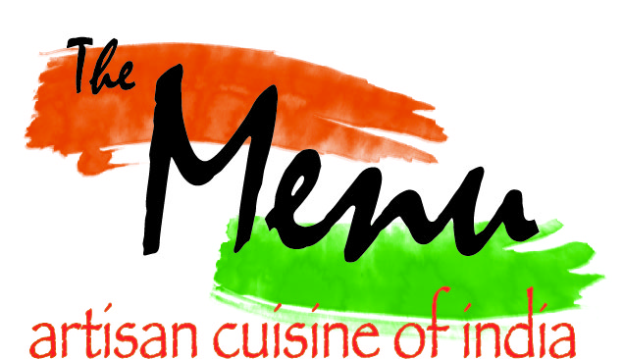

HAPPY HOUR SPECIAL
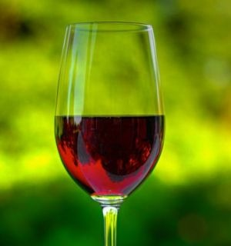
Red Wines
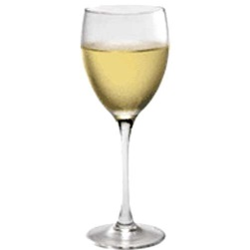
Fidelity Red (Merlot / Cab Blend) 3.50
Sobon Zinfandel 3.50
Brassfield Eruption 5.50

White Wines
Sonoma Oaks Chardonnay 3.50
Matua Valley Sauvignon Blanc 3.50

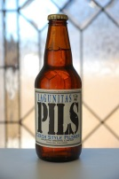
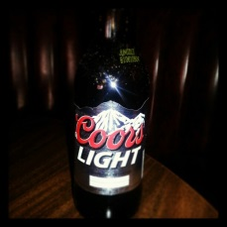
Bottled Beers
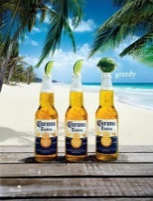
Coors / Coors Light 2.50
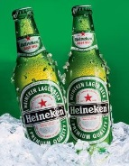
Corona and Corona Light 2.50
Samuel Adams 2.50
Newcastle Brown Ale 2.50
Rampant & Heineken 2.50
Lagunitas IPA 2.50
Guiness Stout 3.00
Duvel 3.50
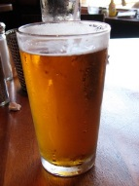
Draught Beers 2.50
Kingfisher, Blue Moon, Windmere Hefe, Anchor Steam, Firestone DBA, Lagunitas
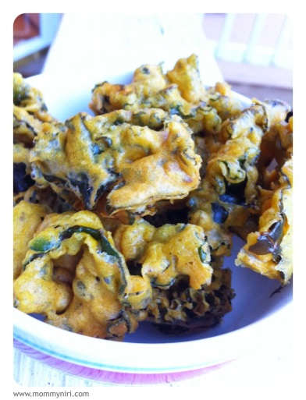
IPA

Well Drinks $4.00

Premium Drinks $1.00 Off

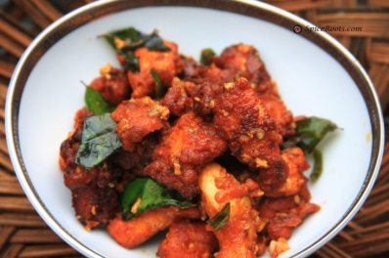
Appetizer Specials
Kale Pakoda 5.00
Gobi Manchurian 5.00
Fish Pakoda 6.00
Chicken '65' 5.00

