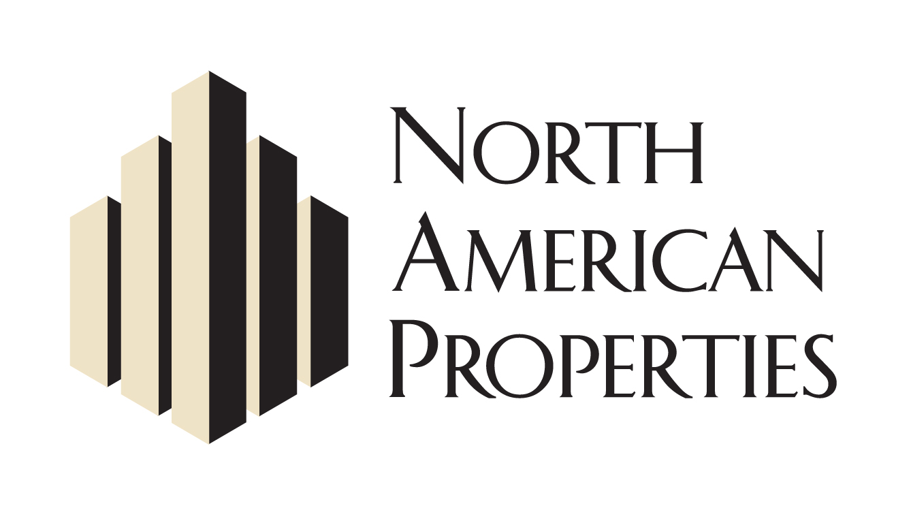
News Release
FOR IMMEDIATE RELEASE

Full list of Avalon retailers and restaurants with executed leases:

Giovanni Di Palma's Antico Napoletana, Bantam + Biddy by Chef Shaun Doty, Tommy Bahama, Vineyard Vines, Exhale Spa, West Elm, Kinnucan’s Specialty Outfitter, Sage Boutique, Free People, Janie and Jack, C. Wonder, L’Occitane, Anthropologie, Arhaus, Athleta, Banana Republic, Bocado Burger Bar, Cru Food and Wine, Destination Maternity, Dry Bar, Everything But Water, Fab’rik, a new Chef Ford Fry concept, Flywheel, GAP, Gymboree, Kona Grill, Lululemon, Luxury Nail Spa, Marlow’s Tavern, Mitchell Gold + Bob Williams, Orvis, Paper Source, Pinkberry, PNC Bank, Regal Cinemas, Ted’s Montana Grill, Van Michael Salon and Whole Foods.

