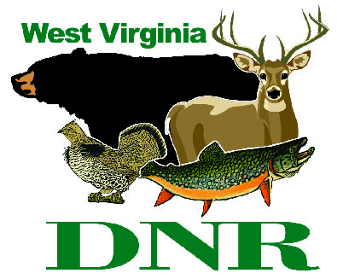 | West Virginia Division of Natural Resources www.wvdnr.gov  Earl Ray Tomblin, Governor Frank Jezioro, Director  News Release: Aug. 26, 2013  Facebook: WV Commerce - State Parks  Hoy Murphy, Public Information Officer, 304-957-9365; hoy.r.murphy@wv.gov  Contact: Joey Herron, wvsawwhet@yahoo.com  Tygart Lake State Park, 304-265-6144, www.tygartlake.com
Birding and banding set for Oct. 11-13 at Tygart Lake State Park

GRAFTON, W.Va. – Novices and avid birders alike are invited to Tygart Lake State Park’s birding and banding weekend Oct. 11-13. Banding practices in October focus on fall migration and observation of species making their way to South America or moving northward.

The event is open to both overnight guests and day-only visitors. Activities will be led by Joey Herron, master bird bander; and Stephanie Bailey, park activities director. Attendees will learn by sight and sound many of the birds in the area. Some birds will be traveling through; others will be here to stay for the winter.

Birds banded in October 2012 included migrating Swainson’s thrush and magnolia warblers. Participants also witnessed an impressive show of a bald eagle diving on a raft of American coots on the lake, Herron said.
“Each day brings more migratory species through the Tygart Valley area and an opportunity to see birds that may only pass through West Virginia on their way to wintering destinations,” he said. Herron also will conduct saw-whet owl banding at Valley Falls State Park on Nov. 1, 2, 8 and 9. For more information or to register for these sessions, email wvsawwhet@yahoo.com.
Call Tygart Lake Lodge at 304-265-6144 about lodging and meal specials. To learn about Tygart Lake State Park, visit www.tygartlake.com.
About Joey Herron
A Lewis County native, Herron has more than 41 years of birding experience, by sight and sound. He is retired from a federal government job with more than 23 years of service. Herron graduated from Glenville State College (’80) with a B.S. in biology and art minor. He is a licensed bird bander with the U.S. Geological Service bird banding lab, and is affiliated with numerous birding organizations such as Cornell Laboratory of Ornithology, Bird Banders Association of North America, Bird Banding Laboratory (master permit, 1997), West Virginia Partners in Flight (working group member), Brooks Bird Club, and an instructor for Pierpont Community College Lifelong Learners group/classes spring and fall sessions on birding and banding (2008–present).
Herron is a licensed coach with NFIAC 1998 and coaches girls’ middle school basketball. He is an avid runner participating in more than 10 road running races annually. His many published papers on birding include reports on saw-whet owl banding conducted at Valley Falls State Park in October and November over the past several years.
State Parks birding poster:
http://www.wvstateparks.com/Tygart%20Area%20Birding%20Poster.pdf
**DNR**

