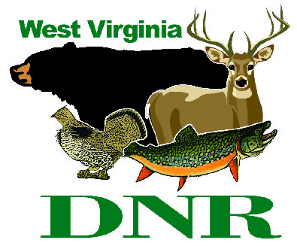 | West Virginia Division of Natural Resources www.wvdnr.gov  Earl Ray Tomblin, Governor Frank Jezioro, Director  News Release: Aug. 26, 2013  Facebook: WV Commerce - State Parks  Hoy Murphy, Public Information Officer, 304-957-9365; hoy.r.murphy@wv.gov  Contact: Stephanie Bailey, 304-256-6148; www.tygartlake.com

Scraps, Scraps, Everywhere! Scrapbooking weekend
at Tygart Lake State Park set for Sept. 6-8

GRAFTON, W.Va. --- There is no better place to scrap the day and night away than Tygart Lake State Park the weekend of Sept. 6-8. The state park in Grafton, W.Va. has organized a weekend of cropping, gluing and laughing.

“It’s a fun-filled weekend working on scrapbooking projects and generally sharing great moments attendees have experienced in life,” Activities Coordinator Stephanie Bailey said.

The weekend includes a “meet and greet” on Friday, Sept. 6 with snacks, workshop discussion and project work. Saturday the workshops begin at 9 a.m. with freestyle scrapping, followed by a luncheon. The afternoon includes crop, clip, glue and stick ideas and specific techniques, with dinner and more scrapping in the evening. Sunday includes brunch and continued project work through the afternoon.

The weekend event rate is $194.99 per person based on two people in the room. Walk-in attendees not taking advantage of overnight accommodation rates are $110. All packages include Friday and Saturday evening snacks, breakfast, lunch and dinner on Saturday and Sunday brunch prepared by The Boston Beanery. The overnight package includes lodge room reservations on Friday and Saturday nights.

To learn more or to make reservations, call Stephanie Bailey at 304-265-6148 or visit www.tygartlake.com.

***DNR***

