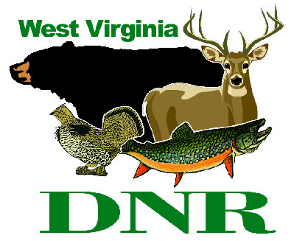 | West Virginia Division of Natural Resources www.wvdnr.gov  Earl Ray Tomblin, Governor Frank Jezioro, Director  News Release: Aug. 26, 2013  Facebook: WV Commerce - State Parks  Hoy Murphy, Public Information Officer, 304-957-9365; hoy.r.murphy@wv.gov

September is for camping and cabin getaways
at West Virginia’s state parks and forests

SOUTH CHARLESTON, W.Va. -- With students returning to school, September finds weekends busy with sports and parks generally a little more relaxed for camping, a round of golf or to stay in a cabin.

“Fall foliage begins to turn in mid-September in higher elevations, and temperatures, particularly in evenings, are crisp and perfect for campfires or walks,” said Paulita Cousin, naturalist at Blackwater Falls State Park. Cousin has organized SeptemberFest on Sept. 17-20, an event that takes advantage of mid-week opportunities at this Tucker County destination.

Parks state-wide encourage visitation and overnight consideration in September. Promotions to encourage park stays include:

Cabin and cottage September ideas

Receive 20 percent off two or more nights’ cabin rental Sunday-Thursday, Sept. 3-30. Parks and forests offering the September discount in cabins include:

Cass Scenic Railroad: 304-456-4300
Blackwater Falls: 304-259-5216
Bluestone: 304-466-2805
Canaan Valley Resort: 304-866-4121
North Bend: 304-643-2931
Pipestem Resort: 304-466-1800
Seneca State Forest: 304-799-6213
Tygart Lake: 304-265-6144
Watoga: 304-799-4087
Twin Falls Resort: 304-294-4000
Bluestone State Park also offers a “Boatin’ the Bluestone” rate package that includes pontoon boat use. Lost River State Park offers a “Retreat to Relax” rate package of three nights for the price of two in fall and winter.
Camping in September
Camping rates for two or more nights are 50 percent off at the following park areas from Sept. 3-30. Sites are first-come, first-served and parks may offer a mid-week only discount option or any day options. Please ask for the “September camping 50 percent rate reduction.” There is no coupon or form needed to take advantage of the incentive to get outdoors and camp in September. A minimum of two consecutive nights is required. The discount cannot be combined with any other discounts or packages
Sunday-Thursday nights extending 50 percent off include:
Canaan Valley Resort
North Bend State Park
Watoga State Park
Any two or more consecutive nights, including weekends, is extended at:
Moncove Lake State Park
Kanawha State Forest
Audra State Park
Bluestone State Park
Plum Orchard WMA
Seneca State Forest
Tygart Lake State Park
Twin Falls Resort Park
Pipestem Resort State Park
Information about cabins, camping, activities and events is maintained on the website www.wvstatepark.com. Click “Find a Park” and use the online map or dropdown screen with park, forest and wildlife management area names.
State parks operated by the State of West Virginia do not collect an entrance fee. There are no fees to hike or bike, picnic or to access fishing waters as a licensed angler. Recreational activities such as golf, camping, miniature golf, aerial tram rides and other amenities generally are fee based with a reasonable user cost. Support your state parks by being active outdoors; visit a state park or forest every chance you get.
***DNR***

