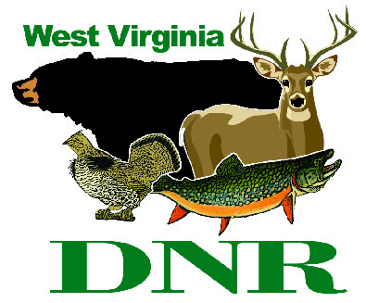 | West Virginia Division of Natural Resources www.wvdnr.gov  Earl Ray Tomblin, Governor Frank Jezioro, Director  News Release: Aug. 26, 2013  Facebook: WV Commerce - State Parks  Hoy Murphy, Public Information Officer, 304-957-9365; hoy.r.murphy@wv.gov  Contact: Brennon O’Sullivan, 304-265-6148; tygartlakesp@wv.gov

Tygart Lake State Park adds sightseeing and dinner cruises
to its on-the-water options

GRAFTON, W.Va. -- Tygart Lake is West Virginia’s fourth-largest body of water with 1,750 acres of recreational surface. “The lake is known for bass fishing and with unlimited horsepower for bass and other boats, weekends get busier with fishing and skiing,” said Park Superintendent Brennon O’Sullivan. “With increasing numbers, we are seeing kayakers take advantage of mid-week days when the boats are not as predominate on the water.” Tygart Lake has a marina with boat rental options. The park has recently added sightseeing and dinner cruises for folks looking for a few hours on the lake during their visit.

Sightseeing Boat

Through Sept. 15 and beginning again May 15, the park offers an overnight package of sightseeing boat tour or tours with dinner. The sightseeing-only package includes two nights at the park lodge, two adult tickets for the boat tour, and a gift shop gift certificate. The sightseeing boat tour schedule is Monday-Thursday and Saturday at 2 p.m.; Friday after the Tygart Dam Tour, approximately 2:30 p.m.; and Sunday at 4 p.m. Passengers board the boat 30 minutes prior to departure.

Dinner Boat

The better boat experience includes dinner, O’Sullivan said. The Boston Beanery operates food service at Tygart Lake. “The Beanery is simply a great place to eat and hang out,” he said. “The food and atmosphere are great.” The boat service and tours are conducted by Tygart Lake Cruises. “Together these two businesses have partnered with the lodge to create a very nice dinner cruise,” O’Sullivan said. “It’s an exciting new option for guests making Tygart Lake State Park a destination.”

The dinner boat cruise includes the same components as the sightseeing cruise, but adds dinner with a choice of four selections. Dinner cruises depart on Friday and Saturday at 5:30 p.m. and Sunday at 1 p.m. The boat boards 30 minutes prior to departure.
The sightseeing cruise is aboard a 44-foot Burnscraft boat with indoor and top deck areas. The experience lasts about two hours. Guests should plan for a two-hour trip including dinner.
O’Sullivan reminds visitors that this new service is not limited to overnight guests. “We welcome families from local communities to partake in this relaxing new activity when they visit the park for the day.”
Between the public sightseeing and dinner cruises, Tygart Lake Cruises accepts reservations from groups for private tours or dinner cruises. “This boat is perfect for business groups, family reunions, class reunions, wedding receptions, birthday parties and more,” O’Sullivan said.
Tygart Lake State Park is located near Grafton, W.Va. The park features a 20-room lodge with all rooms overlooking the lake, the Boston Beanery Restaurant, Tygart Lake Marina, cabins, campground, nature programs and trails, picnic shelters and meeting facilities. The lodge offers Wi-Fi access in all rooms and is open year-round. To learn more about Tygart Lake State Park visit www.tygartlake.com or call 304-265-6144.
***DNR***

