

GutCheck Agile Research into Consumers and Health Insurance Reveal Two Core Issues Plague Industry – Cost and Trust

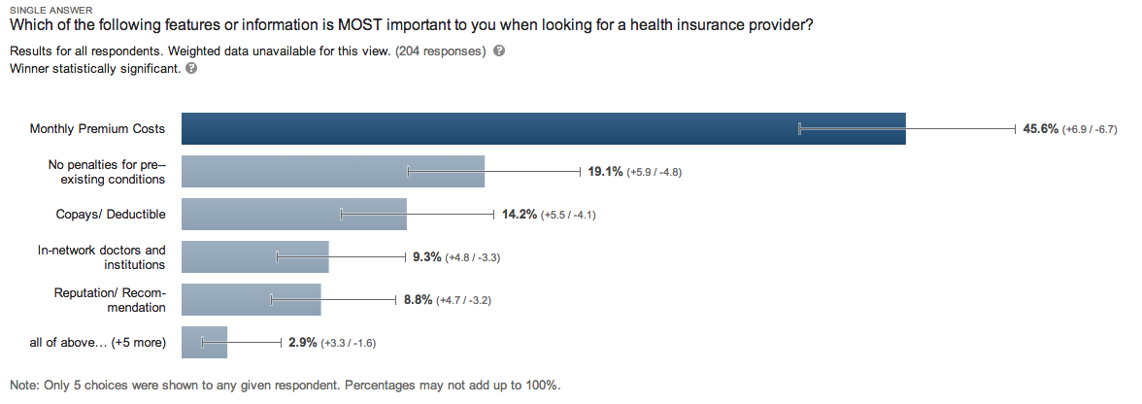

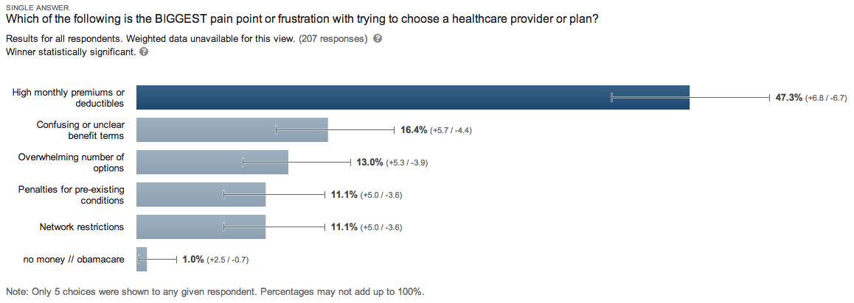

Media Contact:
Laura Taylor
Taylor Strategic Communications for GutCheck
taylor-laura@comcast.net
(303) 346-9149 office
(720) 556-2640 mobile

