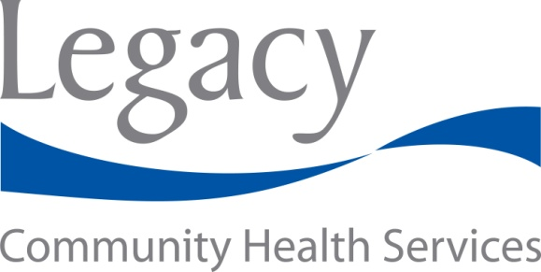MEDIA CONTACTS:

Kimberly Paulus

Chief Marketing & Communications Officer

Legacy Community Health Services

832-374-3954

Lydia Baehr [Lydia@LTBaehr.com](mailto:Lydia@LTBaehr.com)

Lydia Baehr Public Relations

713-208-3421

FOR IMMEDIATE RELEASE: September 11, 2013

**Grant from March of Dimes to Legacy Community Health Services**

**Helps Moms and Babies in Greater Fifth Ward and Northeast Houston**

**HOUSTON ―** The March of Dimes Texas Chapter has awarded a grant to [Legacy Community Health Services](http://legacycommunityhealth.org/) to support “Becoming a Mom,” a program that fills an unmet maternal and child health need in the Houston area.

This program’s goal is to improve the health of mothers and their babies and produce healthy communities by providing maternal knowledge of healthy behaviors, targeting reduced pre-term deliveries and improved infant care practices.

“We found that the “Becoming a Mom – Comenzando bien Program” currently offered by Legacy Community Health Services at their [Southwest Campus](http://legacycommunityhealth.org/Locations/Southwest.aspx) could also serve the Hispanic/Latino, African American, Asian and Caucasian population at their [Legacy Lyons Campus](http://legacycommunityhealth.org/Locations/Lyons.aspx), which serves the Greater Fifth Ward and Northeast Houston,” said Sharyn Malatok, March of Dimes State Director of Program Services. “We are grateful that our successful fundraising efforts, such as March for Babies, make it possible for us to support new programs in the Greater Fifth Ward that can help more babies be born healthy.”

As a full-service, Federally Qualified Health Center, [Legacy](http://legacycommunityhealth.org/OurLegacy/Mission.aspx) provides comprehensive health care and a variety of other programs and services, such as patient education regardless of the patient’s ability to pay.

The “Becoming a Mom Program” provides Legacy an opportunity to promote preventative care and overall well-being to persons who have traditionally faced problems accessing quality health care and empower families to lead a better life.

The March of Dimes is the leading nonprofit organization for pregnancy and baby health.  With chapters nationwide and its premier event, March for Babies®, the March of Dimes works to improve the health of babies by preventing birth defects, premature birth and infant mortality. For the latest resources and information, visit **marchofdimes.com** or **nacersano.org**. Find us on [Facebook](http://bit.ly/8jQgZ4" \t "_blank) and follow us on [Twitter](http://bit.ly/cmKkqo" \t "_blank).

###