Tesselaar plants sweet spot™ ROSES - - THE decorator rose™

Bright colors and contrasting centers offer fun and fashion in the garden.

Plant Profiles:

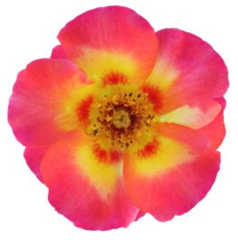
Sweet Spot™ Calypso
Botanical name/cultivar: Rosa L. hybrid var. ‘IntRos01’
Parentage: Cross between two unnamed Rosa L. hybrid seedlings at Interplant Roses
Growth habit: Compact shrub
Plant size: 24” H x 20” W
Flowering period: Long (mid-spring to late summer/early fall)
Fragrance: None
Foliage: Dark green leaves; young shoots are red
Bud color: Pink
Flower color: Pinkish/red and yellow, with a red/pink spot in the center

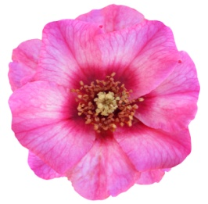
Sweet Spot™ Ruby
Botanical name/cultivar: Rosa L. hybrid var. ‘IntRos03’
Parentage: Cross between Rosa L. hybrid seedlings (unnamed seed parent and pollen parent Eridu Babylon), at Interplant Roses
Growth habit: Compact spreading
Plant size: 20” H x 20” W
Flowering period: Long (mid-spring to late summer/early fall)
Fragrance: None
Foliage: Medium green leaves
Bud color: Pink
Flower color: Ruby pink, with a red/pink spot in the center

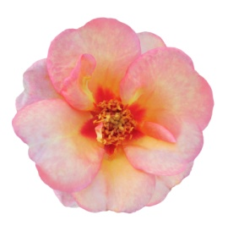
Sweet Spot™ Peach
Botanical name/cultivar: Rosa L. hybrid var. ‘IntRos02’
Parentage: Cross between two unnamed Rosa L. hybrid seedlings, at Interplant Roses
Growth habit: Compact shrub
Plant size: 20” H x 20” W
Flowering period: Long (early spring to late summer /early fall (Peach is an early bloomer compared to the other varieties)
Fragrance: None
Foliage: Dark green semi-glossy leaves
Bud color: Peach
Flower color: Soft peach, with a red/pink spot in the center
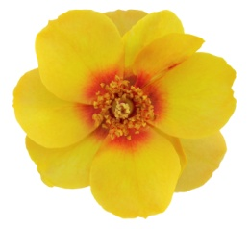
Sweet Spot™ Yellow
Botanical name/cultivar: Rosa L. hybrid var. ‘IntRos04’
Parentage: Cross between 2 Rosa L. hybrid seedlings (seed parent Strabo Babylon and pollen parent Eridu Babylon), at Interplant Roses
Growth habit: Compact spreading
Plant size: 16” H x 16” W
Flowering period: Long (mid-spring to summer/early fall)
Fragrance: None
Foliage: Dark green leaves with light green shoots
Bud color: Red and yellow
Flower color: Golden yellow, with a red/orange spot in the center

