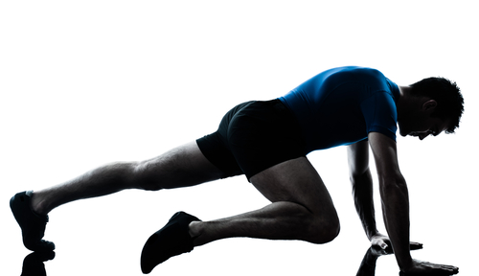
The Critical Importance of Cardio Exercise & How to Add it to Your Pilates Workout
by Bob Hannum
Sept 3, 2013
Hundreds of research articles prove the importance of cardiovascular conditioning, popularly known as cardio exercise, aerobics, or simply cardio.

What Is Cardio Exercise
A cardio workout is anything that elevates your heart rate for at least 30 minutes. Examples include the now popular Zumba as well as traditional exercises such as biking, jogging, hiking, soccer, basketball, and swimming to name a few.
Today in our hectic, time-starved lives, increasingly popular forms of cardio exercise are those that also include the other essential exercises that the body needs – strength training and stretching. A few exercise methods do this including Curves circuit training and Pilates mat exercises - see especially my Cardio Pilates video. Any activity qualifies as aerobic if it elevates your heart rate to your individual target and keeps it there for at least 30 minutes.

Origins of Cardio Exercise
Cardio vascular exercise was first referred to as aerobics. This term and method was developed by two people from the United States Air Force: Dr. Kenneth Cooper, M.D. an exercise physiologist, and Col. Pauline Potts, a physical therapist. Dr. Cooper noticed that there were people who had excellent muscle strength but performed poorly when doing endurance tasks such as bicycling, long-distance running, and swimming. Cooper and Potts were the first to distinguish this different kind of exercise that the body needs.
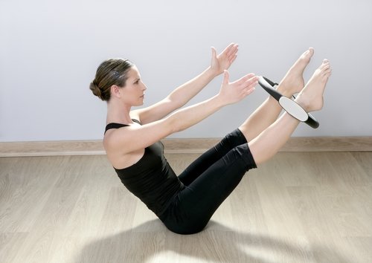

Benefits of Cardio
- Cardio exercise increases the body’s capacity to obtain oxygen, and its ability to use this oxygen to provide energy to the whole body. This in turn increases our energy level and stamina.
- Cardio exercise increases blood flow which heightens the oxygen levels in the body which in turn makes the body function more efficiently. Aerobics improves heart function and lowers pulse rate, bad cholesterol, high blood pressure, and plasma triglyceride, thus lowering the risk of cardiovascular disease and stroke.
- Cardio strengthens our bones, which lowers the risk of skeletal weakening and, consequently, the risk of fracture and osteoporosis.
- Cardio reduces the risks of arthritis and inflammation by lubricating the joints.
- Cardio boosts immunity. A stronger immune system enables the body to ward off infection and sickness. It helps eliminate airborne viruses and bacteria from the lungs before they spread throughout the body. The sweat produced by the body during the workout, as well as the rapid blood flow it promotes, aids in the elimination of carcinogens, toxins, and other wastes from the body. Because aerobics improves circulation, the distribution of the antibodies and white blood cells, which fight invading bacteria and viruses, also improves.
- Cardio improves mood by increasing the brain-derived neurotrophic factor (BDNF) which lengthens the life of neurotransmitters and consequently helps prevent dementia. It promotes feelings of peace and happiness by producing endorphins. Aerobics also increases serotonin levels in the brain which play a role in controlling appetite, decreasing depression, and improving memory, learning, and sleep. Studies have shown that as little as 25 minutes of exercise can affect the neurotransmitters in the brain in a similar way to antidepressants. In relation to this, aerobics helps decrease anger, anxiety, and stress.
- Studies have shown that people who exercise regularly have better cognitive function than those who live sedentary lives. Cardio exercise increases oxygen to the brain which improves brain cell growth and stimulate the production of the substances that repair damaged brain tissue.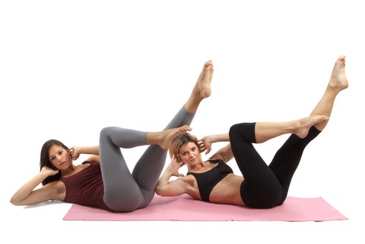

Best Cardio
The latest recommendations for adults are at least 30 minutes of aerobic activity 5 days a week or 75 minutes 3 days a week. Start off with a slow warm-up, then move on to your cardio workout, and then end with a 5-minute cool-down. The 50-plus exercises in the Pilates mat routine provide a perfect workout for the entire body in just 30 minutes – it’s quick and it incorporates all 3 of the exercises that your body needs – cardio, strength training, and stretching.
You can add cardio to your Pilates workout by simply going from one exercise to the next without pause. And you can do it anywhere and anytime without equipment or a gym. Start with my beginners lessons for free, or if you’re an experienced Pilates student take your workout to the highest level with my Cardio Pilates video. Learn more about them in the boxes at the right.

