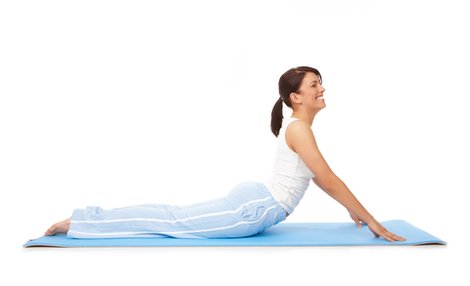

What Is Pilates
by Bob Hannum, PilatesLessons.org
Sept 10, 2013
So what’s all the buzz about Pilates (puh-LAH-teez)? What is it? And what can it do for you? Quite simply it’s a unique exercise method developed by Joseph Pilates, the Einstein of fitness, nearly 100 years ago. It’s so effective that elite athletes include it in their conditioning programs. The benefits are numerous both physically and mentally. In fact, there is no other exercise method that includes so many benefits. Here is a quick review.

Physiological Benefits
- Strengthens 'core' muscles better than any other exercise method
- Creates tremendous strength without bulky muscle tissue
- Combines the 3 exercises that the body requires – strength training, stretching, and cardiovascular conditioning
- A quick and whole-body workout
- Integrates body and mind
- Eliminates most back, neck, and joint pain so effectively that 'core strength', a term coined by Joseph Pilates, is a key principle in physical therapy
- Unlike many exercise methods, Pilates does not harm our joints
- Improves posture, balance, circulation, strength, flexibility, and range of motion
- Improves athletic performance
- Lowers blood pressure
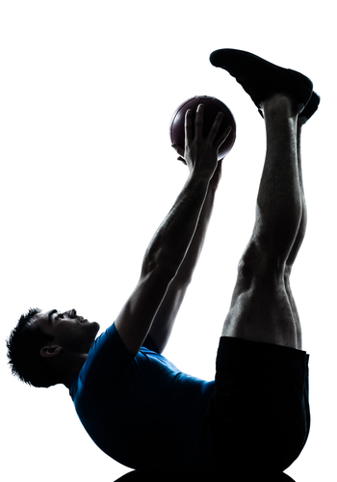

- Increases energy
- You feel invigorated after a workout rather than exhausted
- Safe for any age or fitness level
- Exercise anywhere and anytime without equipment or a gym
- Everyday movement becomes easier, more coordinated, and graceful
- And now it is easier and faster to learn with my new teaching technique

Mental Benefits
Though exercise of any kind has been found to be beneficial for your mental health and cognitive function, Pilates adds additional benefits of increased concentration and body awareness. When you workout with heightened awareness you’re less likely to injure yourself. Here are other mental benefits:
- Improves sleep
- Improves brain function
- Increases self-confidence
- Reduces stress
- Positive outlook on life
- Heightened physical and mental awareness
- Mental and emotional strength
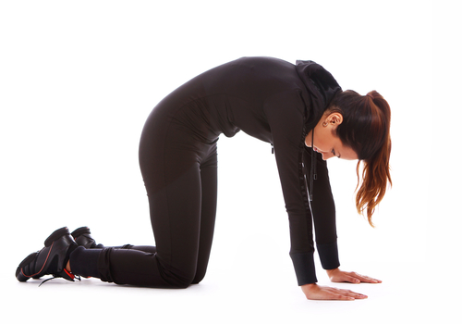

Cosmetic Benefits
Pilates movements condition the body as a whole, and tone muscles. And as with any exercise, Pilates makes weight management efforts more likely to succeed with a reduction in fat buildup in the belly, thighs, and hips. When the body becomes more healthy, it looks more beautiful.

Special Benefits For Older Adults
The core muscles are the main source of our balance and coordination. Pilates focuses on these core muscles like no other exercise method. Improved coordination and balance is particularly important for the older body where falls present increasing risk for serious injury.
Other benefits important for the older adult include reduced joint pain and stiffness, and improved flexibility and range-of-motion. Flexibility improves circulation and makes everyday life tasks easier.
So start your Pilates journey right now with my free beginners video lessons. It’s safe for any age and fitness level. Just sign up in the box at the right and I’ll deliver your first lesson in moments. Exercise in the comfort and convenience of your own home whenever you wish with me as your personal trainer!

