News Release
For Immediate Release
September 13, 2013
Contact:
Michael Sullivan, GOED Communications Director
801-538-8811
mgsullivan@utah.gov

Utah Deepens Bonds with Top Trade Partner
Trade mission delegates well received by Chinese business leaders

Salt Lake City UTAH — Utah’s trade mission to China led by the Governor’s Office of Economic Development (GOED) had a successful opening on Monday, with multiple presentations, press conferences and business matchmaking meetings in Chengdu, a city located in southwest China with a population of over 14 million. As the trade mission continues throughout this week trade bonds between Utah and China will be strengthened.

The trade mission began with an informative briefing by Consul General Peter Haymond, and Benjamin Wang, Chairman of the American Chamber of Commerce in Southwest China. Their presentations centered on China’s current economic and political conditions, industry trends, and best practices. Highlighted were two U.S. companies who have already been conducting business in the area for some time and have seen significant growth in the Chengdu market.

Business matchmaking meetings are a key part of this trade mission, where participating Utah companies discuss business opportunities with potential Chinese parnters. Matchmaking meetings help Utah companies’ grow their business in foreign countries, which in turn helps create jobs in Utah as companies export more products or services.

“In Chengdu each of my meetings were very productive,” said David Utrilla, President and Chief Executive, U.S. Translation Company. “My goal for this trade mission was to explore doing business in China, and I am pleased that these companies are interested in establishing a formal working relationship and that this took such a short time to accomplish.”

Representatives from GOED held a tourism press conference and a foreign direct investment presentation on Monday as well to eager Chinese participants. International investment by Chinese firms is expected to increase dramatically over the next decade. The foreign investment seminar objective was to highlight some current projects and make sure Utah is included in the site selection process as Chinese companies look for opportunities in the U.S.

“Over 30 potential investors attended the foreign direct investment presentation, many of which expressed positive feedback and genuine interest in Utah,” said Brett Heimburger, Asia-Pacific Director, GOED. “Several investors in attendance have recently traveled to Utah to perform due diligence in various investment projects, and I am confident we will see an increase in foreign direct investment in the near future.”

Attendees of the tourism press conference were mesmerized by Utah’s natural landscapes, ease of access to Utah’s recreations areas and the number of national and state parks Utah has to offer.

“I had no idea Utah has such beautiful scenery, I’m very eager to see it with my own eyes,” said General Secretary of Sichuan Chamber of Foreign Oriented Small and Medium Enterprises.

The day culminated with a well-attended reception at which over 175 professionals from business, government, and education communities networked. Present from Utah were State Senators Bramble, Knudson, and Valentine who represented the Utah legislature in meetings with Chinese government officials. Provo Mayor John Curtis was also in attendance and was warmly received as he wowed the attendees by addressing them in Mandarin Chinese.

Utah has one of the largest Mandarin Chinese immersion programs in the country, and many Chinese business leaders were pleased to learn that so many Utahns are learning Mandarin. This development is an indication that Utah not only leads the nation in economic development and job creation, but also is a friendly and welcoming state for international business.

###

About the Utah Governor’s Office of Economic Development (GOED)
Web: www.business.utah.gov

The Governor’s Office of Economic Development (GOED) charter is based on Governor Gary Herbert’s commitment to economic development statewide. Utah’s economic development vision is that Utah will lead the nation as the best performing economy and be recognized as a premier global business destination. The mandate for this office is to provide rich business resources for the creation, growth and recruitment of companies to Utah and to increase tourism and film production in the state. GOED accomplishes this mission through the administration of programs that are based around targeted industries or “economic clusters” that demonstrate the best potential for development. GOED utilizes state resources and private sector contracts to fulfill its mission. For more information please contact: Michael Sullivan, 801-538-8811 or mgsullivan@utah.gov

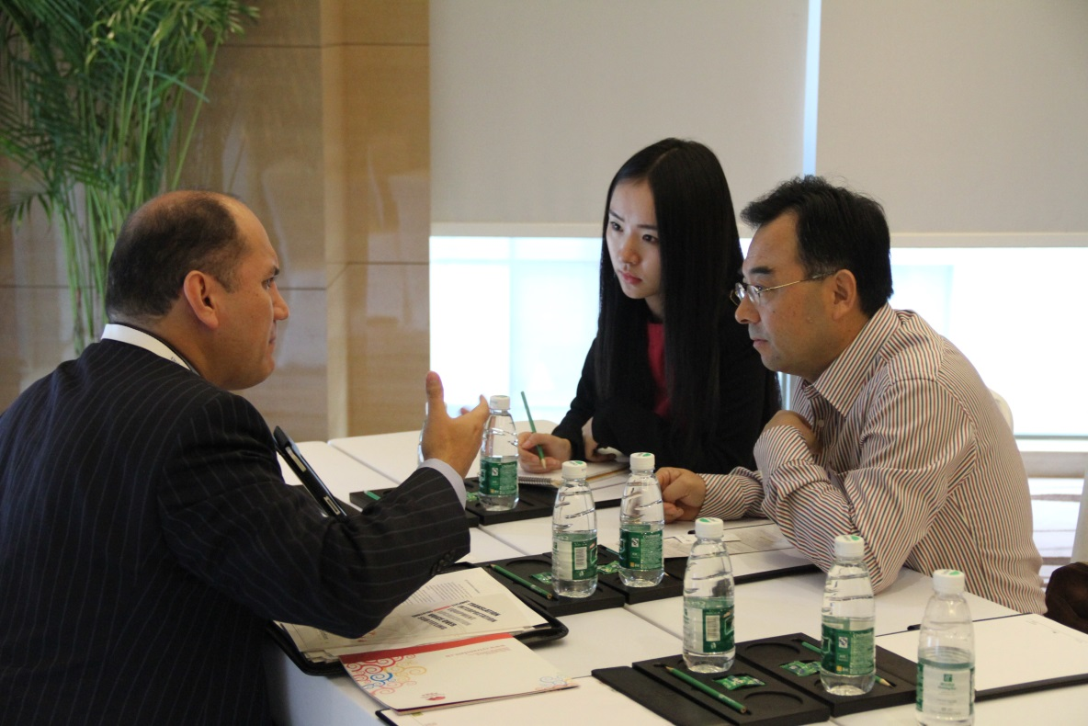
Above: David Utrilla, President and Chief Executive, U.S. Translation Company, meets with potential business partners in Chengdu, China.

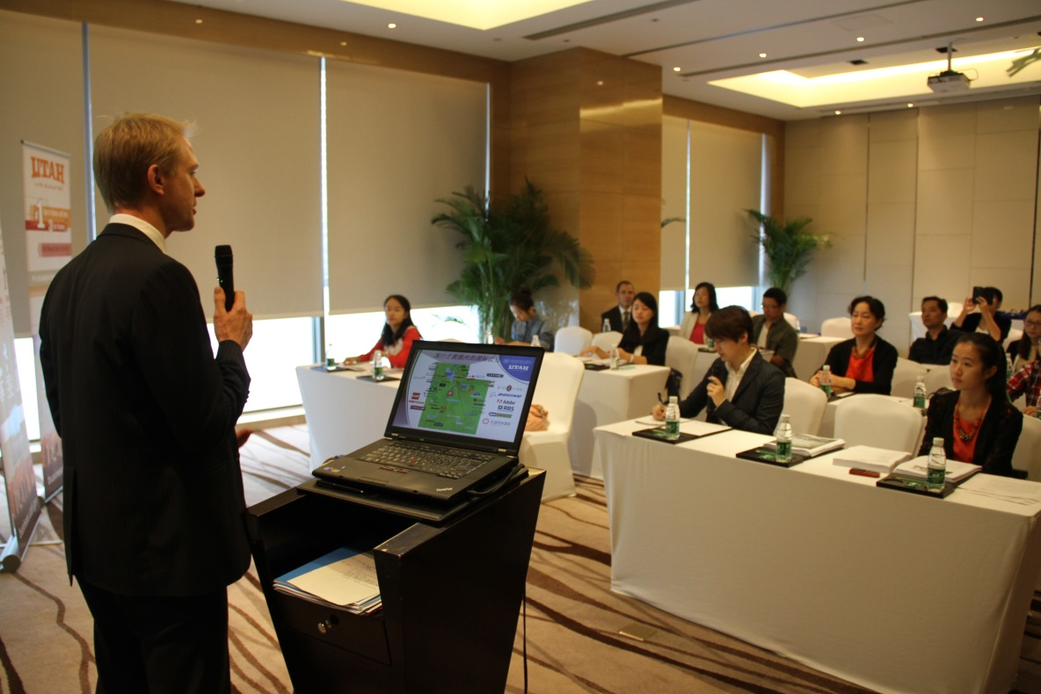
Above: Brett Heimburger, Asia-Pacific Director, GOED, presents on tourism in Utah to tour operators and press officials in Chengdu, China.

