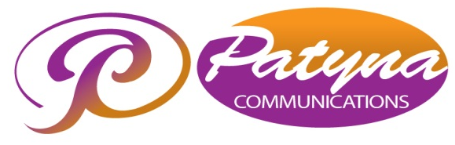  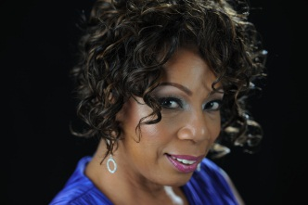 | Media Contact: Pat Thornton  Phone: 301.925.8158  Cell: 202.262.6156, E-mail:  pthornton@patynacommunications.com
Press Release

Coniece Washington Appears at The Blue Dolphin

Crofton, Maryland (September 14, 2013) – Join Coniece Washington as she makes for her debut appearance with The Ashleigh Group’s “Thursdays at the Blue” series at the Blue Dolphin, on October 3, 2013. The Blue Dolphin is located at 1166 State Route 3 South, in Crofton, MD 21054. Doors open at 6:00 p.m., and the show begins at 8:00 p.m. sharp. Tickets are only $20, and can be purchased on The Ashleigh Group’s website at www.theashleighgroup.com

Coniece Washington is a nationally recognized Jazz Vocalist who captivates her audience with her distinctive sultry sweet stylings, comparable to none. Her influences are Sarah Vaughan, Ella Fitzgerald, Nancy Wilson, Billie Holiday, Carmen McRae and numerous gospel artists. Coniece has recently appeared at Optimism Bar and Lounge, Westminster Presbyterian Church, Jazz In Southwest series, and at the Carlyle Club in Washington D.C., at an annual tribute to Veterans.

The Ashleigh Group is a minority owned small business whose primary objective is to provide quality services in the areas of special events, entertainment, meetings and conferences. TAG’s principals, Tammi Adair and Jacquelin Dennis have more than twenty years of professional experience in event planning. Two years ago they collaborated with the owners of the Blue Dophin to provide quality entertainment for mature adults in Crofton, Maryland. Local and nationally renowned performers have graced the stage, from Julia Nixon to Valerie Simpson. Don’t miss your opportunity to witness the debut of a sensational vocalist with an adult crowd on October 3, 2013.

Coniece is a rare talent who will leave you wanting more and more of her gifted voice and presence. Her passion is singing, and her goal is to present the Great American Song Book with integrity.

For more information about Coniece Washington Click Here! or for more information about The Ashleigh Group, or “Thursdays at the Blue” Click Here!
# # # #

