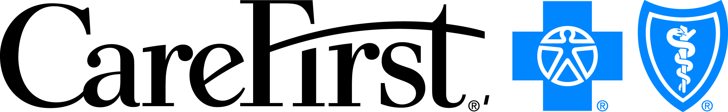 Contact: Maya Newman
1-800-914-NEWS (6397)
mediarelations@carefirst.com

For Immediate Release

Sept. 18, 2013

CareFirst Rolls Out New Mobile Unit
for Open Enrollment
Mobile unit scheduled to make nearly 20 stops in the Baltimore-Washington area

Baltimore — CareFirst BlueCross BlueShield (CareFirst) is taking the open enrollment season on the road with a new mobile unit geared to educate people about the Affordable Care Act (ACA) and inform them of new coverage options the region’s largest health insurer will offer in 2014.
The mobile unit is a 30-foot-long trailer scheduled to travel to nearly 20 sporting events, concerts, marathons and charitable walks in the Baltimore-Washington area during the next four months. The unit will give CareFirst members and prospective customers the opportunity to speak face-to-face with company representatives about the ACA-compliant health plans best suited for them and their family members.

More Information
View: Photos of the mobile unit.

With open enrollment beginning Oct. 1, the launch of the mobile unit is one way CareFirst is helping to answer questions about health care reform and provide affordable and accessible health insurance to individuals shopping for new coverage or looking to purchase it for the first time. The unit will feature a large video screen displaying step-by-step instructions for comparing CareFirst insurance products on CareFirst Connect, the company’s redesigned website for individual customers.
“We want to make direct contact with potential customers and those who want to learn more about the Affordable Care Act and CareFirst’s health plans,” said Rita Costello, CareFirst’s Senior Vice President of Strategic Marketing. “The mobile unit will be a new way for us reach out to and interact with many of the communities we serve and provide individuals with the information they need to make the best decision about their health care coverage.”
The mobile unit also is one piece of CareFirst’s new open enrollment marketing campaign that launched this month. The campaign – “There For You Then. Here For You Now.” – features a mixture of display and broadcast TV advertising in Maryland and the Washington, D.C., area with digital advertising found online and on mobile devices, primarily via social networking sites and mobile apps.
The first scheduled appearance for the mobile unit is the Washington Nationals vs. Miami Marlins baseball game Sept. 20 at the Nationals Park. Other stops include Baltimore Ravens, Baltimore Orioles and D.C. United games and the Baltimore Running Festival. In all, the mobile unit is scheduled to make 17 stops throughout the Baltimore-Washington area by mid-January.

About CareFirst BlueCross BlueShield
In its 76th year of service, CareFirst, an independent licensee of the Blue Cross and Blue Shield Association, is a not-for-profit health care company which, through its affiliates and subsidiaries, offers a comprehensive portfolio of health insurance products and administrative services to 3.4 million individuals and groups in Maryland, the District of Columbia and Northern Virginia. In 2012, CareFirst contributed nearly $57 million to community programs designed to increase the accessibility, affordability, safety and quality of health care throughout its market areas. To learn more about CareFirst BlueCross BlueShield, visit our website at www.carefirst.com or follow us on Twitter: http://twitter.com/CareFirst_News.

###

