C:\Documents and Settings\Administrator\Application Data\Foxmail\FoxmailTemp(269)\21268_Catch8(10-(09-13-10-49-47).jpg

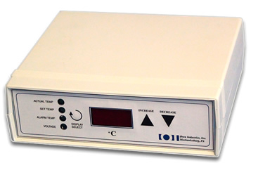FOR IMMEDIATE RELEASE即时发布  
  
Xinmeiya Technology releases their 5C7-195 Benchtop Thermoelectric controller – 新美亚科技开发有限公司发布了他们的5C7-195 台式热电控制器Xinmeiya Technology is the distributor of Oven Industries products in the PRC. Xinmeiya Technologyannounces their benchtop temperature controller. This solid state MOSFET bidirectional desktop model has an internal power supply, full H Bridge and is capable of load currents up to 4A in H bridge mode. It can control resistive heaters or TE modules with load currents up to 5A utilizing the unidirectional output and internal supply. If used in conjunction with an external power supply as heat or cool only 10A can be achieved. User friendly PC programmable via the RS232 com port which has 1500VAC isolation. Once the desired parameters are established the PC may be disconnected and the controller stands alone. All parameter settings are retained in non-volatile memory. The controller has a digital display for control functions.

新美亚科技开发有限公司是Oven Industries 在中国的独家经销商。新美亚公布了他们的台式温度控制器。这种晶体管MOSFET双向台式机有一个内部电源和全H桥，能够在H桥模式下提供负载电流高达4安。利用单向输出和内部电源使负载电流达到5安的时候，它可以控制电阻加热器或TE模块。如果与外部电源相连只加热或只制冷的情况下能达到10安。通过与1500VAC绝缘RS232串口连接的用户友好型PC编程界面。只要设置所需的参数，控制器就可以断开PC独立工作。在非易失性存储器上保留所有的参数设置。该控制器自带数字显示模块。

See our web site for features and specifications 产品特性和规格请参考我们的网站。  
  
Oven Industries has many unique options for customized, industrial quality temperature controllers and sensors. All products are designed by experts and have been used in a wide variety of applications, including commercial, industrial, military, medical equipment and food processing.

Oven公司有很多独特定制的工业质量温度控制器和传感器。所有的产品都是专家精心设计，并被用于各行各业，包括商业，工业，军事，医疗设备和食品加工。

<http://www.xinmeiyatech.com>  
<http://www.ovenind.com/bv/Products/5C7-195-Benchtop-Temperature-Controller__5C7-195.aspx>

Media Contact  
Aileen Sun  
Xinmeiya Technology.  
[aileen.sun@xinmeiyatech.com](mailto:aileen.sun@xinmeiyatech.com)  
+86（27）88161550