Media contact:

Greg Randolph

[greg@visitsunvalley.com](mailto:greg@visitsunvalley.com)

**Wood River Valley Studio Tour**

**New Event Celebrates Local Art Scene by Inviting Visitors Into Artists Studios**

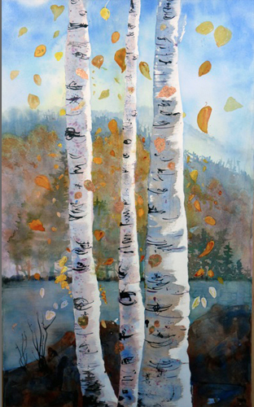Sun Valley, ID (For Immediate Release) To the uninitiated, the Sun Valley area is a special enclave of highly talented and passionate artists. So much so that ArtPlace Magazine named Ketchum as one of its top [12 Small Art towns](http://www.visitsunvalley.com/press-release/artplace-names-ketchum-one-top-12-small-art-towns-us) in the United States. Celebrating this distinct honor and shining the spotlight on the immense amount of creative talent in the Sun Valley region, the Wood River Valley Studio Tour opens the studios of over fifty artists to the general public October 19-20, 2013.

Beth Magee captures aspens in the fall one of many works highlighting the event.

Showcasing the creative community which calls the Wood River Valley home, this collaboration of artists has joined in an extensive effort to attract visitors and art lovers to the area to see close up their work and process in studio. Stretching from Bellevue in the south end of the valley to Ketchum in the north and all parts in between, this two day event is truly worth the visit. An artist reception will be held on Saturday, October 19th from 5:00-8:00 pm at Wood River Fine Arts gallery in Ketchum. Event goers are invited to spend the evening mingling with the artists and fellow art lovers in attendance over drinks and appetizers.

The WRV Studio Tour also offers an artist education series to facilitate the sharing of industry and marketing knowledge and foster relationships between artists. Sessions include “Photographing Your Artwork”, “Heart and Head Marketing of Art”, and “Marketing Your Art Through Digital and Social Media”. A full schedule and details is available on their website.

The Wood River Valley Studio Tour, Inc. is an Idaho non-profit organization celebrating the artistic talent of the Wood River Valley, also known as the Sun Valley region. For more information and tickets for the Wood River Valley Studio Tour please visit [www.wrvstudiotour.org](http://www.wrvstudiotour.org). For lodging, dining, and other area information please visit [www.visitsunvalley.com](http://www.visitsunvalley.com).