Dr. Julie Prutsman, Au.D., FAAA 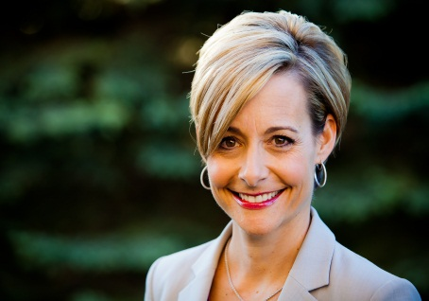
“I am passionate about helping people find the best solution to their hearing needs!”
Education:
1996 - B.A. in Biology from Marietta College, Marietta, OH
1999 - M.S. in Speech, Language and Hearing Sciences from the University of Colorado, Boulder, CO
2003 - Au.D. in Audiology from Pennsylvania College of Optometry’s School of Audiology, Elkins Park, PA
Experience:
- Third generation Board Certified Hearing Instrument Specialist
- Over a decade of fitting analog, programmable, and digital hearing instruments
- Clinic Director at University of Colorado’s Audiology Department in Boulder (1997-1998)
- Internships with Dr. Paul Dragul, Dr. Alan Lipkin, and Dr. Cameron Shaw, ENTs (1998-1999)
- Hearing Instrument Specialist & Director of Audiology for Miracle-Ear Hearing Centers (1996-2002)
- Co-Owner and Director of Audiology for Audiology Associates of Las Vegas (2003-2011)
- Tinnitus Retraining Therapy (TRT) training (2003)
- Neuromonics Tinnitus Treatment training (2005)
- Founder and Owner of Sound Relief Hearing Center (2011-present)
Affiliations:
- American Academy of Audiology (AAA)
- Colorado Academy of Audiology (CAA)
- International Hearing Society (IHS)
- American Tinnitus Association (ATA)
Publications:
Arehart, K.H., Rossi-Katz, J., Swensson-Prutsman, J. 2005. Double-Vowel Perception in Listeners with Cochlear Hearing Loss: Differences in Fundamental Frequency, Ear of Presentation, and Relative Amplitude. Journal of Speech, Language and Hearing Research, 48(1), pp.236-252.

