FOR IMMEDIATE RELEASE
New Precision Temperature Controller with User-friendly software and Data Retrieval
Oven Industries features a Temperature Controller with easy-to-use software.

Model 5R7-388 RoHS Compliant controller is a bi-directional control for independent thermoelectric modules or in conjunction with auxiliary or supplemental resistive heaters for both cooling and heating applications. The “H” bridge configuration of the solid state MOSFET output devices allows for the bi-directional flow of current through the thermoelectric modules. Highly efficient N-channel output devices are used for this control mode.

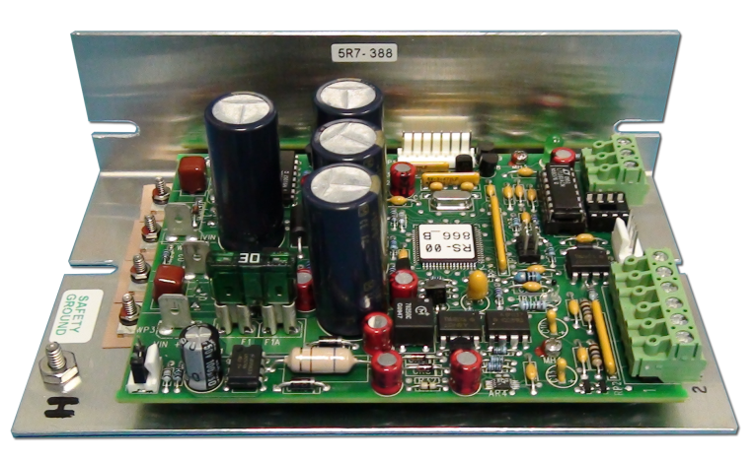
This controller is PC programmable via an RS232 communication port for direct interface with a compatible PC. The easily accessible communications link permits a variety of operational mode configurations. Field selectable parameters or data acquisition in a half duplex mode can be performed. This controller will accept a communications cable length in accordance with RS232 interface speciations. Once the desired set parameters are established, the PC may be disconnected and Model 5R7-388 becomes a unique, stand alone controller. All parameter settings are retained in non-volatile memory.

FEATURES
- Full H-Bridge
- 36VDC Output using split supply
- P,I,D or On/Off Control
- PC Configurable Alarm Circuit
- RS232 Communication Port
- "T" Thermocouple -328°F - 500°F

ACCESSORIES
Display Model 5R6-576: 4 digit temperature read out
Heat Sink recommended for applications using 15A load or greater

Oven Industries supplies custom temperature controllers and sensors that serve an array of clients, from aerospace, automotive, biomedical, defense markets, medical and semiconductor.

From industrial temperature controllers to programmable sensors, Oven Industries creates many detailed and customized solutions for clients, designed by an expertly trained staff of engineers.

For more information about the 5R7-388 controller, visit
http://www.ovenind.com/bv/Products/Temperature-Controller-5R7-388__5R7-388.aspx
Media Contact
Rose Wescott
717-766-0721
r.wescott@ovenind.com

