

FOR IMMEDIATE RELEASE 即时发布
New AC Temperature Controller Announced by Xinmeiya Technology
武汉新美亚科技开发有限公司公布了新款交流温度控制器

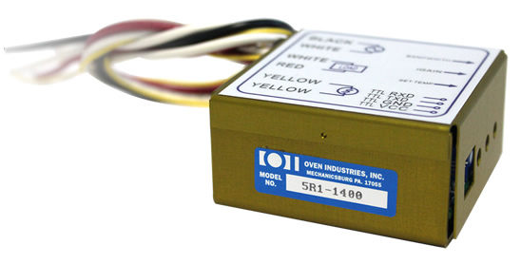
Xinmeiya Technology is the exclusive distributor of Oven Industries in the PRC. Oven Industries features a new AC Temperature Controller with easy-to-use software and data retrieval capabilities.
武汉新美亚科技开发有限公司是Oven Industries在中国的独家经销商。
Oven公司重点推出了其新款交流控制器，此款控制器软件使用简单，且具有数据检索功能。

Xinmeiya Technology announces the new 5R1-1400 AC Temperature Controller with the integrated potentiometers or via a PC through the TTL level UART Communication port. This compact design measuring two and one half inches square can deliver up to 15 AMPS of load current from a zero voltage switched, low noise solid state relay. Operator safety is achieved with 1KV of AC line power isolation for the communication port and sensor input. Specifications: Input Voltage 85 to 265VAC 50/60Hz, temperature resolution 0.1°C and Ambient Temperature Operation -20° to 70°C.
新美亚科技公布了一款新的交流温度控制器5R1-1400,此款控制器带有集成电位计调节，或通过TTL串口与PC连接，进行调节。两个半英寸见方的紧凑设计可以从一个零电压开关的低噪音固态继电器提供高达15安培的负载电流。在通信端口和传感器输入之间使用1KV交流线路电源绝缘，这样来达到操作人员的安全操作的目的。规格：输入电压从85至265VAC 50/60Hz, 温度分辨率0.1°C，环境温度操作-20°至70°C

FEATURES 特性
- Universal AC Input
全电压输入
- Integrated Potentiometers for Set Temp and PI Control
通过电位计调节温度及PI控制设定。
- PC Programmable Set Temp and PID Control
通过PC进行温度设置和PID控制设置。
- TTL Level UART Communication Port
TTL串口通信
- Set Temp Range Determined by Thermistor Type
由热敏电阻决定的温度设定范围
- Open Sensor Protection
开放的温度传感器保护
ACCESSORIES 附件
- USB to TTL Interface Cable Model # OI-TTL-CABLE
USB转TTL接口型号：OI-TTL-CABLE
- Flange Mount Model # 5R1-1400FL
凸缘架型号：5R1-1400FL
- Temperature Sensor
温度传感器

Oven Industries supplies custom temperature controllers and sensors that serve an array of clients, from aerospace, automotive, biomedical, defense markets, medical and semiconductor.
From industrial temperature controllers to programmable sensors, Oven Industries creates many detailed and customized solutions for clients, designed by an expertly trained staff of engineers.
Oven公司为很多客户提供定制的温度控制器和传感器，这些客户来自各行各业，如：航空航天，汽车制造，生物医学，军用市场，医学和半导体。从工业用温度控制器到可编程传感器，Oven公司的专家级水准工程师为客户创造了大量详尽的定制解决方案。

For more information about the 5R1-1400 controller, visit
关于5R1-1400控制器的更多信息，请参考以下网站:
http://www.xinmeiyatech.com
http://www.ovenind.com/bv/Products/5R1-1400-AC-Temperature-Controller__5R1-1400.aspx
Media Contact
Aileen Sun
Xinmeiya Technology.
aileen.sun@xinmeiyatech.com
+86（27）88161550

