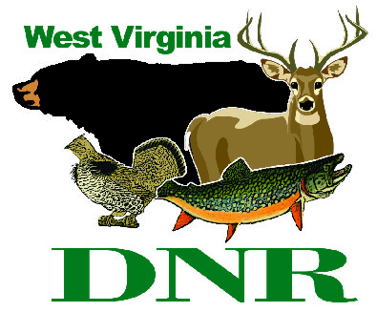 | West Virginia Division of Natural Resources www.wvdnr.gov  Earl Ray Tomblin, Governor Frank Jezioro, Director  News Release: Sept. 30, 2013  Facebook: WV Commerce - State Parks  Hoy Murphy, Public Information Officer 304-957-9365 hoy.r.murphy@wv.gov  Contact: Brennon O’Sullivan, Tygart Lake State Park Superintendent, tygartlakesp@wv.gov 304-265-6144

Tygart Lake State Park Smart Code Yields Reduced Room Rates

GRAFTON, W.Va. – People are using their smartphones for nearly everything, and the latest innovation involves getting an automatic discount when making lodging reservations online at Tygart Lake State Park. It’s called a “Smart Code” and there are two available.
Reservations made online for Tygart Lake Lodge room rentals or cabin rentals and using the Smart Code “Falling Prices” will receive a 25 percent discount for second night rentals at the park lodge through Dec. 23, 2013.
The second code, 3RDNF, is good for lodge rooms or cabins and offers a third consecutive night free through Dec. 19, 2013. The discounts are available through the online reservation system only and accessible through the Tygart Lake State Park website www.tygartlake.com, “Online Reservations.”
Tygart Lake State Park Supt. Brennon O’Sullivan, like other state park superintendents, looks for interesting ways to direct visitor attention to the park – accommodations, history and activities. “Parks never stop reminding residents and visitors that lodges are open year-round and the facilities are wonderful. We encourage people to stay overnight and enjoy themselves,” O’Sullivan said.
Tygart Lake State Park is located near Grafton. The lodge restaurant is operated by the popular Boston Beanery. Tygart Lake Lodge is a 20-room retreat with recent furnishing updates. It overlooks Tygart Lake and has all the amenities of any hotel. Eleven vacation cabins dot the park and are fully equipped with linens, dining and cooking ware and fireplaces. State parks with lodges and cabins, including Cass Scenic Railroad, offer online reservations and they are optimized for smartphone use or via the website.
To learn more about Tygart Lake State Park visit www.tygartlake.com.

**DNR**

Photo Courtesy of the West Virginia Department of Commerce.
Tygart Lake State Park is now open year-round. Smart Code discounts are available when making online reservations.

