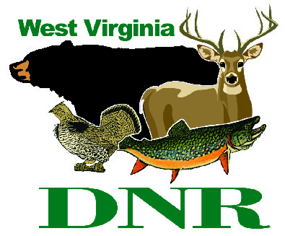 | West Virginia Division of Natural Resources www.wvdnr.gov  Earl Ray Tomblin, Governor Frank Jezioro, Director  News Release: Sept. 30, 2013  Facebook: WV Commerce - State Parks  Hoy Murphy, Public Information Officer 304-957-9365 hoy.r.murphy@wv.gov  Contact: Adam McKeown, Supt. coopersrocksf@wv.gov  304-594-1561

Coopers Rock State Forest Campground remains open until Oct. 31;

Reopens April 1, 2014

BRUCETON MILLS, W.Va. – Fall campers are reminded that Coopers Rock State Forest campground will remain open through Oct. 31, and will reopen for the 2014 season April 1. The campground offers 25 sites with electric hookups. Twelve sites are designated for advance reservations. Children's playgrounds are located in the campground and at various picnic areas.
Located just off US 68 near Morgantown, this popular area is known for rock climbing, camping, hiking and biking, and iconic vistas. Bands of rock cliffs line the Cheat River Gorge and provide numerous overlooks. The centerpiece among these is the main overlook, which furnishes a panorama of the gorge and distant horizons. Hikers enjoy a maze of enormous boulders and cliffs and the trails are lined with rhododendron and mountain laurel. Glade Run is dammed to form a six-acre pond that is regularly stocked with trout.
Coopers Rock State Forest has a gift shop, the “Overlook Trading Post, which offers a variety of souvenirs and apparel for purchase, in addition to an eatery – Eagle Grill – that offers sandwiches, hotdogs and other food.
Numerous picnic sites and three shelters are available, offering tables, grills, drinking water and toilet facilities. The shelters may be reserved by calling 304-594-1561, Monday-Friday, 8 a.m. - 4 p.m.
A very big Eco-Bear stands on a rock surveying Coopers Rock State Forest. The natural materials bear was unveiled on Earth Day in 2013, and has remained in place as nature reduces him to his components of woven twigs, grass, mud, hemlock branches and natural materials. The green hemlock bows have given way to bare limbs. The bear was an art project by WVU student, Ben Gazsi.
Nearly 50 miles of trails wind through the forest. Trail descriptions are posted on the forest website.
“One of the more popular paths, the Henry Clay Iron Furnace Trail, takes you on a trip back in time,” said Forest Supt. Adam McKeown. “Rounding the last bend of the trail you find a huge stone structure used for producing iron in the 1800s. It is located in a grassy glade in an otherwise undisturbed forest.”
Properly licensed individuals are welcome to hunt or fish in-season, in specified areas.
No hunting zones surround all forest recreational facilities.
Established during the Civilian Conservation Corps era, many of the structures and walkways at Cooper Rock remind visitors of the long history of West Virginia state park system, public service and stewardship. To learn more about the forest visit www.coopersrockstateforest.com or call 304-594-1561.
**DNR**
Photos Courtesy of the West Virginia Department of Commerce. Coopers Rock State Forest campground; Eco-Bear at Coopers Rock State Forest

