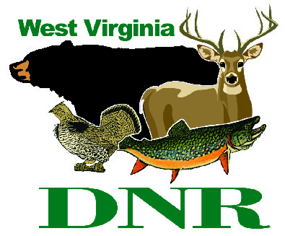 | West Virginia Division of Natural Resources www.wvdnr.gov  Earl Ray Tomblin, Governor Frank Jezioro, Director  News Release: Sept. 30, 2013  Facebook: WV Commerce - State Parks  Hoy Murphy, Public Information Officer 304-957-9365 hoy.r.murphy@wv.gov Contact: Clinton Cochran, Supt., babcocksp@wv.gov 304-438-3004

Leaf peepers find horseback riding at Babcock State Park a fall foliage treat

CLIFFTOP, W.Va. - Horseback riding through the shaded and beautiful trails of Babcock State Park is a pleasant and peaceful journey.
“Riding a horse on the trails is a different experience in the fall than in the summer, because the park’s elevation means the leaves turn color earlier than other parts of the state,” said Supt. Clinton Cochran, who noted that the leaves turn about two weeks earlier at Babcock than in the lower valleys.
Montgomery’s Outdoor Adventures provides this outdoor recreation opportunity at Babcock. The guided trail rides at the park feature a unique creek crossing and nice views of rock formations, peaceful wooded pond settings, and very frequent wildlife sightings.
Guided trail rides are offered for ages 8 and older. Family and child-friendly horse riding experiences range from ½ hour rides to two hours. Fall hours are Friday - Sunday from 8 a.m. until 6 p.m. and reservations are encouraged by calling Montgomery’s at 304-860-7834.
Babcock State Park is located in Fayette County in Clifftop West Virginia and is one of West Virginia’s oldest state parks. The Glade Creek Grist Mill is the well-known iconic feature that attracts tourist to the area. Vacationers at Babcock may select from among 13 standard log cabins located by Glade Creek (trout stream) - (may require access by as many as 65 steps), five standard cabins of frame construction, eight bungalow cabins and two deluxe accessible cabins. Standard cabins feature a wood burning fireplace, fully equipped kitchen and bath with shower.
A 52-site campground, Boley Lake, fishing, hiking and picnicking also are popular with visitors. A webcam focused on the mill showcases the weather and scenery on the parks’ website, www.babcocksp.com. The park is open from mid-April through the end of October.
To learn more about Babcock State Park call 304-438-3004.

**DNR**
Photo Courtesy of the West Virginia Department of Commerce. Horseback riding at Babcock State Park

